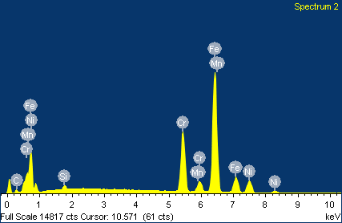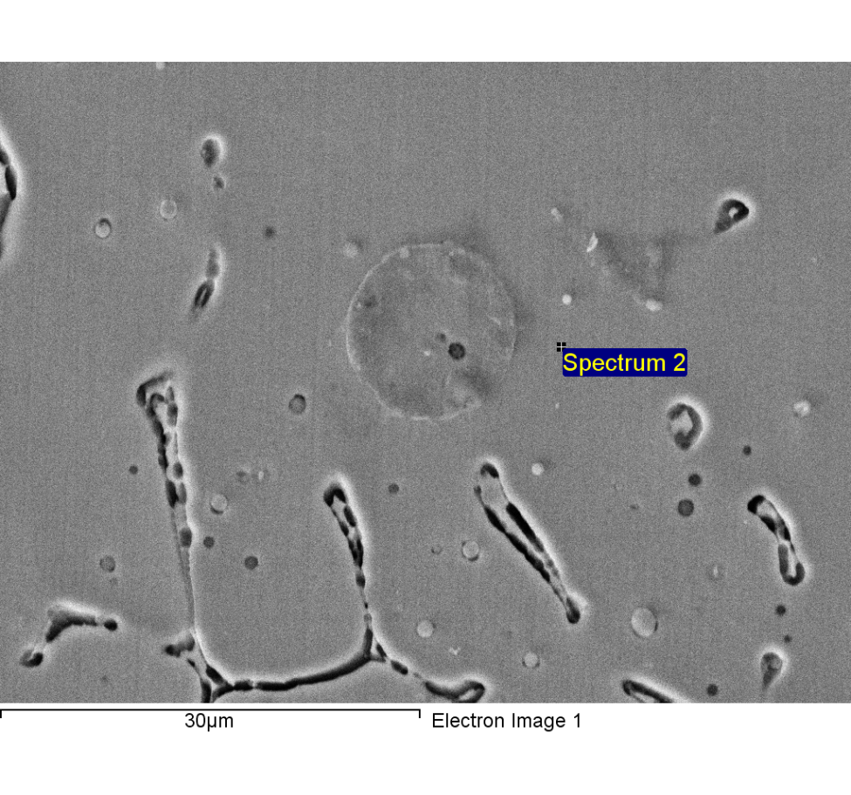

Spectrum processing :

**Peaks possibly omitted : 11.860, 12.792 keV**

Processing option : All elements analyzed (Normalised)

Number of iterations = 4

Standard :

C CaCO3 **1-Jun-1999 12:00 AM**

Si SiO2 1-Jun-1999 12:00 AM

Cr Cr 1-Jun-1999 12:00 AM

Mn Mn 1-Jun-1999 12:00 AM

Fe Fe 1-Jun-1999 12:00 AM

Ni Ni 1-Jun-1999 12:00 AM

|  |  |  |  |
| --- | --- | --- | --- |
| Element | Weight% | Atomic% |  |
|  |  |  |  |
| **C K** | 4.10 | 16.33 |  |
| Si K | 0.81 | 1.38 |  |
| Cr K | 19.70 | 18.13 |  |
| Mn K | 1.67 | 1.46 |  |
| Fe K | 63.25 | 54.18 |  |
| Ni K | 10.47 | 8.53 |  |
|  |  |  |  |
| Totals | 100.00 |  |  |

1/24/2018 6:51:34 PM

**Project 8**

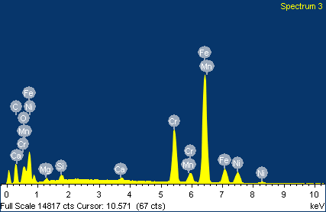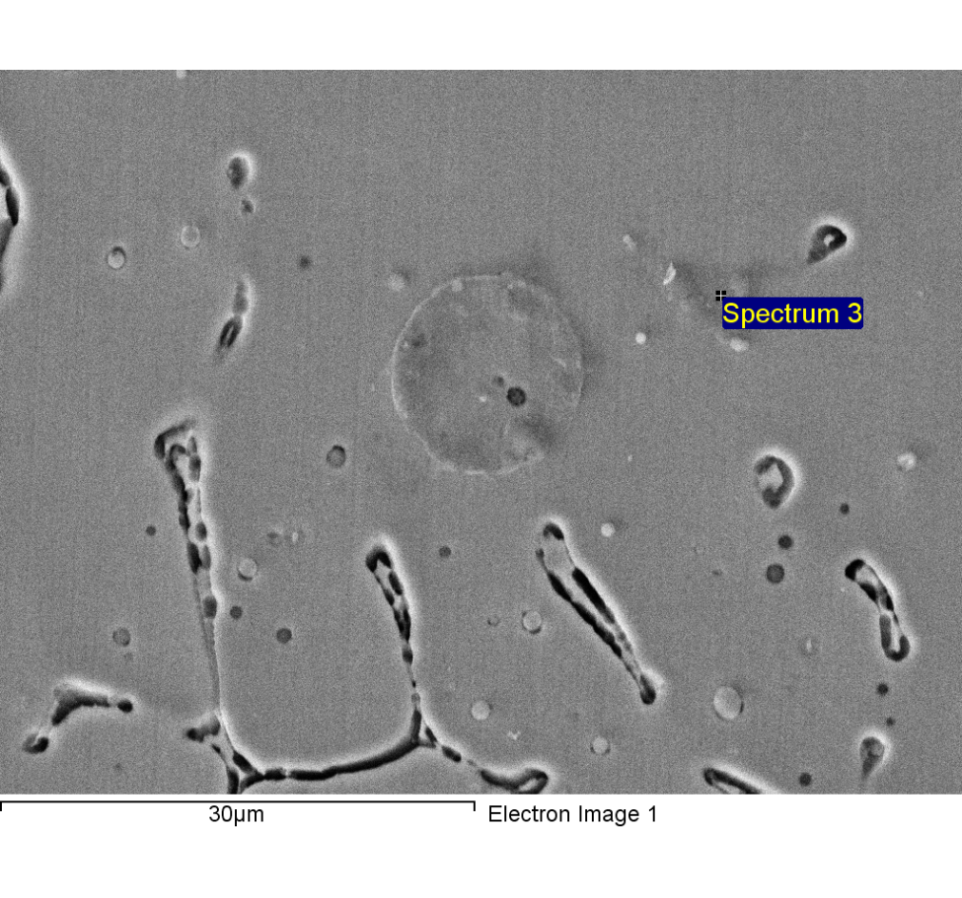

Spectrum processing :

Peaks possibly omitted : 11.770, 12.830 keV

Processing option : All elements analyzed (Normalised)

**Number of iterations = 5**

Standard :

C CaCO3 1-Jun-1999 12:00 AM

O SiO2 1-Jun-1999 12:00 AM

Mg MgO 1-Jun-1999 12:00 AM

Si SiO2 1-Jun-1999 12:00 AM

Ca Wollastonite 1-Jun-1999 12:00 AM

Cr Cr 1-Jun-1999 12:00 AM

Mn Mn 1-Jun-1999 12:00 AM

Fe Fe 1-Jun-1999 12:00 AM

Ni Ni 1-Jun-1999 12:00 AM

|  |  |  |  |
| --- | --- | --- | --- |
| Element | Weight% | Atomic% |  |
|  |  |  |  |
| C K | 19.21 | 48.54 |  |
| O K | 4.55 | 8.63 |  |
| Mg K | 0.73 | 0.91 |  |
| Si K | 0.71 | 0.77 |  |
| Ca K | 0.37 | 0.28 |  |
| Cr K | 15.36 | 8.96 |  |
| Mn K | 1.17 | 0.65 |  |
| Fe K | 49.86 | 27.10 |  |
| Ni K | 8.05 | 4.16 |  |
|  |  |  |  |
| Totals | 100.00 |  |  |

1/24/2018 6:52:22 PM

Project 8

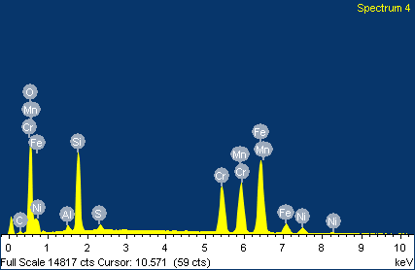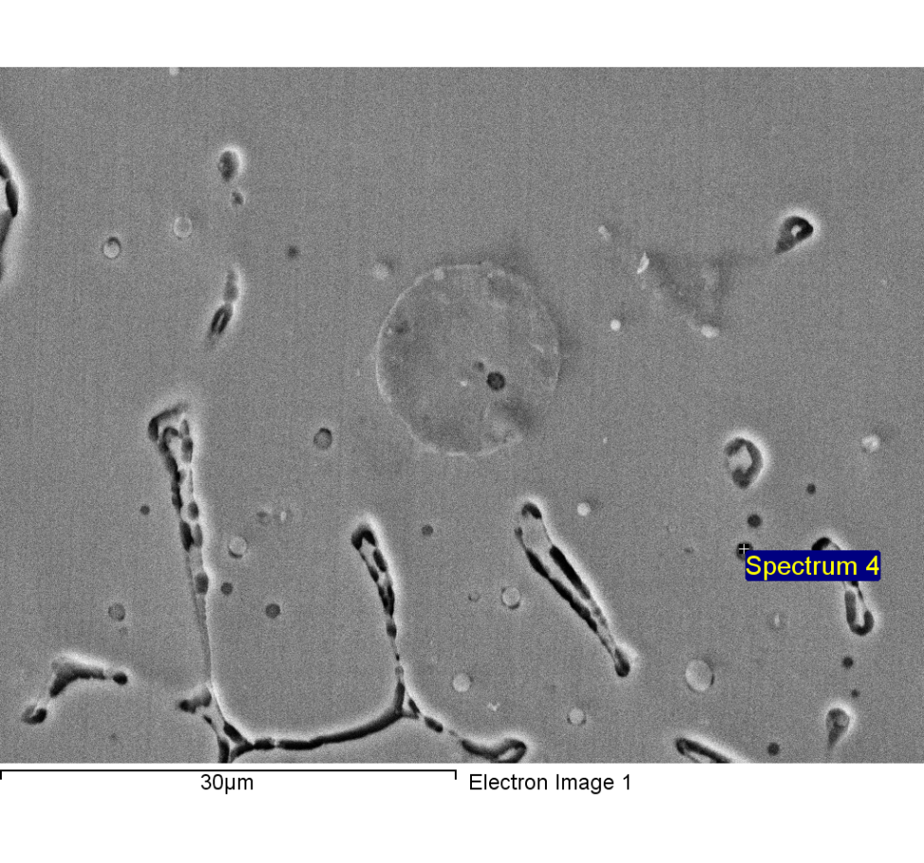

Spectrum processing :

Peak possibly omitted : 4.180 keV

Processing option : All elements analyzed (Normalised)

Number of iterations = 5

Standard :

C CaCO3 1-Jun-1999 12:00 AM

O SiO2 1-Jun-1999 12:00 AM

Al Al2O3 1-Jun-1999 12:00 AM

Si SiO2 1-Jun-1999 12:00 AM

S FeS2 1-Jun-1999 12:00 AM

Cr Cr 1-Jun-1999 12:00 AM

Mn Mn 1-Jun-1999 12:00 AM

Fe Fe 1-Jun-1999 12:00 AM

Ni Ni 1-Jun-1999 12:00 AM

|  |  |  |  |
| --- | --- | --- | --- |
| Element | Weight% | Atomic% |  |
|  |  |  |  |
| C K | 2.83 | 7.38 |  |
| O K | 22.40 | 43.87 |  |
| Al K | 0.72 | 0.83 |  |
| Si K | 9.93 | 11.08 |  |
| S K | 0.69 | 0.67 |  |
| Cr K | 13.07 | 7.88 |  |
| Mn K | 16.31 | 9.30 |  |
| Fe K | 30.19 | 16.93 |  |
| Ni K | 3.86 | 2.06 |  |
|  |  |  |  |
| Totals | 100.00 |  |  |

1/24/2018 6:53:14 PM

Project 8

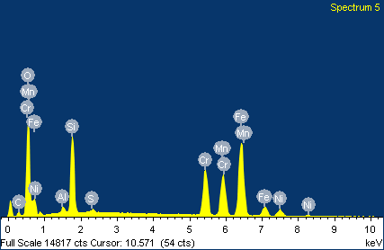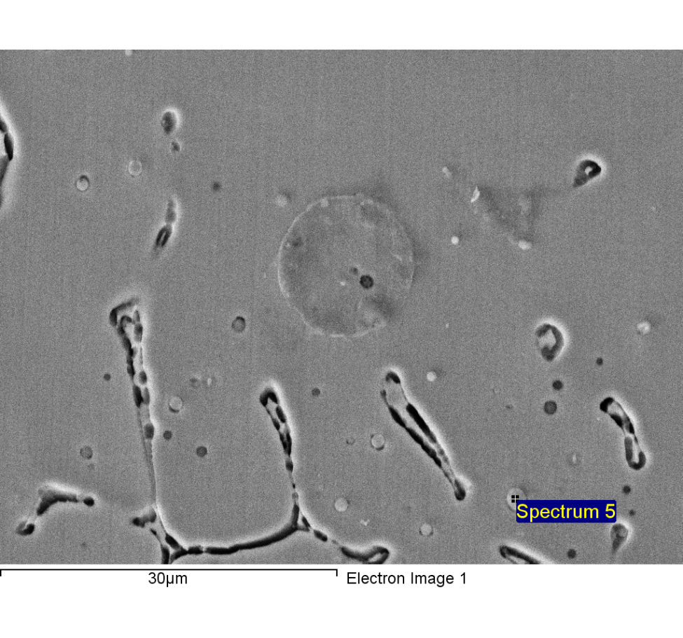

Spectrum processing :

Peak possibly omitted : 11.859 keV

Processing option : All elements analyzed (Normalised)

Number of iterations = 5

Standard :

C CaCO3 1-Jun-1999 12:00 AM

O SiO2 1-Jun-1999 12:00 AM

Al Al2O3 1-Jun-1999 12:00 AM

Si SiO2 1-Jun-1999 12:00 AM

S FeS2 1-Jun-1999 12:00 AM

Cr Cr 1-Jun-1999 12:00 AM

Mn Mn 1-Jun-1999 12:00 AM

Fe Fe 1-Jun-1999 12:00 AM

Ni Ni 1-Jun-1999 12:00 AM

|  |  |  |  |
| --- | --- | --- | --- |
| Element | Weight% | Atomic% |  |
|  |  |  |  |
| **C K** | 4.42 | 11.01 |  |
| O K | 23.68 | 44.28 |  |
| Al K | 0.81 | 0.90 |  |
| Si K | 9.52 | 10.14 |  |
| S K | 0.43 | 0.40 |  |
| Cr K | 12.75 | 7.34 |  |
| Mn K | 13.12 | 7.15 |  |
| Fe K | 30.91 | 16.56 |  |
| Ni K | 4.36 | 2.22 |  |
|  |  |  |  |
| Totals | 100.00 |  |  |

1/24/2018 6:53:46 PM

Project 8

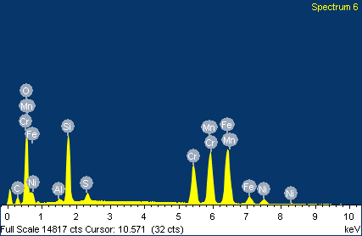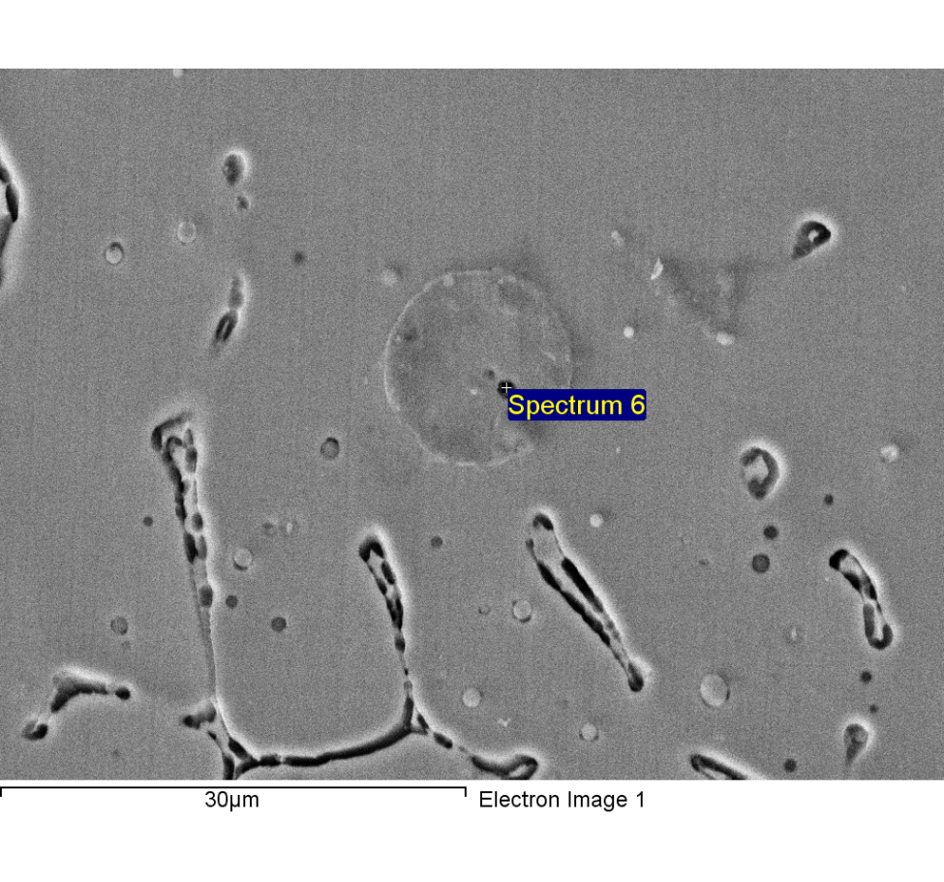

Spectrum processing :

No peaks omitted

Processing option : All elements analyzed (Normalised)

Number of iterations = 5

Standard :

C CaCO3 1-Jun-1999 12:00 AM

O SiO2 1-Jun-1999 12:00 AM

Al Al2O3 1-Jun-1999 12:00 AM

Si SiO2 1-Jun-1999 12:00 AM

S FeS2 1-Jun-1999 12:00 AM

Cr Cr 1-Jun-1999 12:00 AM

Mn Mn 1-Jun-1999 12:00 AM

Fe Fe 1-Jun-1999 12:00 AM

Ni Ni 1-Jun-1999 12:00 AM

|  |  |  |  |
| --- | --- | --- | --- |
| Element | Weight% | Atomic% |  |
|  |  |  |  |
| C K | 7.90 | 18.97 |  |
| O K | 21.47 | 38.71 |  |
| Al K | 0.49 | 0.52 |  |
| Si K | 8.98 | 9.22 |  |
| S K | 1.14 | 1.03 |  |
| Cr K | 12.02 | 6.67 |  |
| Mn K | 19.36 | 10.17 |  |
| Fe K | 25.05 | 12.94 |  |
| Ni K | 3.60 | 1.77 |  |
|  |  |  |  |
| Totals | 100.00 |  |  |

1/24/2018 6:53:56 PM

Project 8

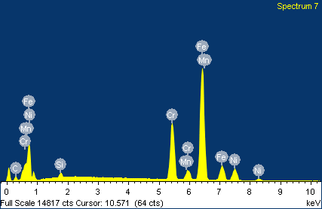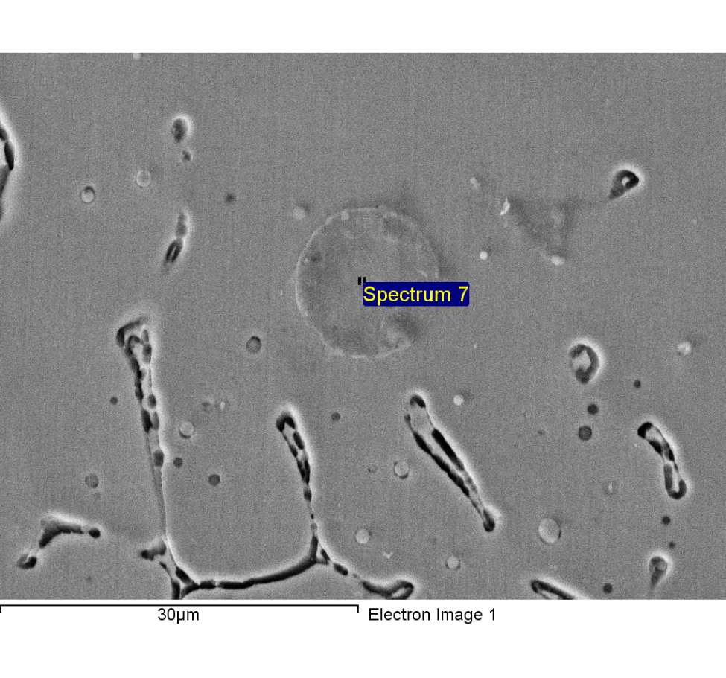

Spectrum processing :

Peaks possibly omitted : 11.801, 12.799 keV

Processing option : All elements analyzed (Normalised)

Number of iterations = 4

Standard :

C CaCO3 1-Jun-1999 12:00 AM

Si SiO2 1-Jun-1999 12:00 AM

Cr Cr 1-Jun-1999 12:00 AM

Mn Mn 1-Jun-1999 12:00 AM

Fe Fe 1-Jun-1999 12:00 AM

Ni Ni 1-Jun-1999 12:00 AM

|  |  |  |  |
| --- | --- | --- | --- |
| Element | Weight% | Atomic% |  |
|  |  |  |  |
| C K | 5.46 | 20.86 |  |
| Si K | 0.87 | 1.42 |  |
| Cr K | 19.84 | 17.50 |  |
| Mn K | 1.47 | 1.23 |  |
| Fe K | 61.96 | 50.87 |  |
| Ni K | 10.39 | 8.12 |  |
|  |  |  |  |
| Totals | 100.00 |  |  |

1/24/2018 6:54:44 PM

Project 8

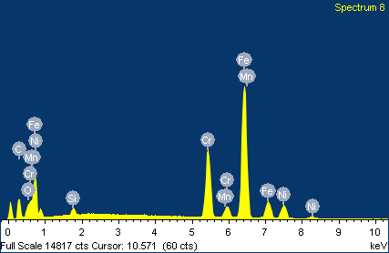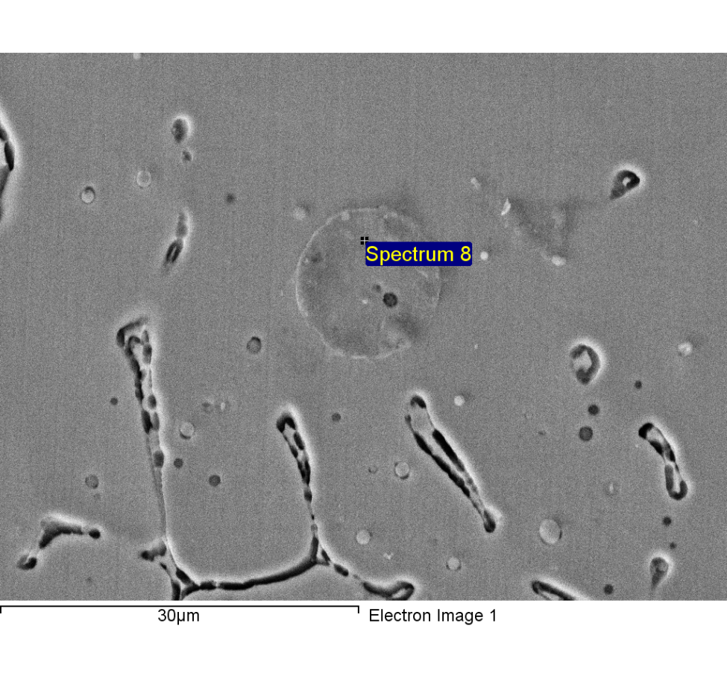

Spectrum processing :

Peak possibly omitted : 3.660 keV

Processing option : All elements analyzed (Normalised)

Number of iterations = 4

Standard :

C CaCO3 1-Jun-1999 12:00 AM

O SiO2 1-Jun-1999 12:00 AM

Si SiO2 1-Jun-1999 12:00 AM

Cr Cr 1-Jun-1999 12:00 AM

Mn Mn 1-Jun-1999 12:00 AM

Fe Fe 1-Jun-1999 12:00 AM

Ni Ni 1-Jun-1999 12:00 AM

|  |  |  |  |
| --- | --- | --- | --- |
| Element | Weight% | Atomic% |  |
|  |  |  |  |
| C K | 17.59 | 47.82 |  |
| O K | 2.10 | 4.29 |  |
| Si K | 0.78 | 0.91 |  |
| Cr K | 16.75 | 10.52 |  |
| Mn K | 1.29 | 0.77 |  |
| Fe K | 52.89 | 30.92 |  |
| Ni K | 8.59 | 4.78 |  |
|  |  |  |  |
| Totals | 100.00 |  |  |

1/24/2018 6:54:58 PM

Project 8

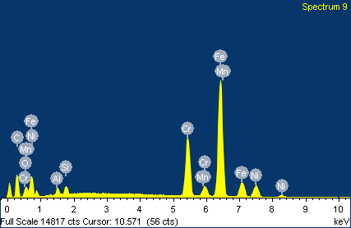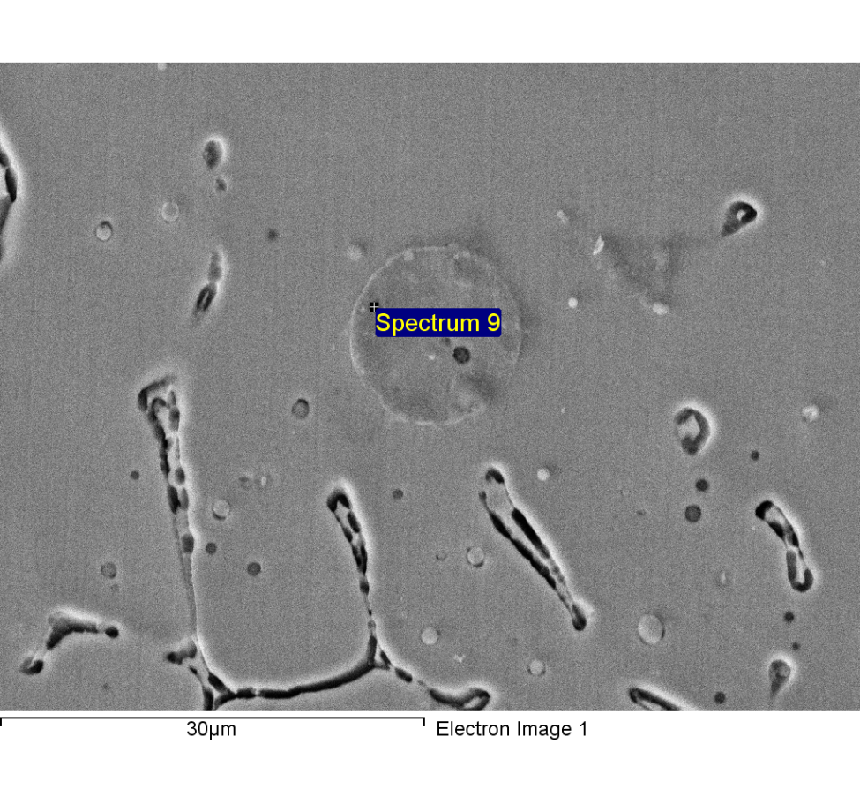

Spectrum processing :

Peak possibly omitted : 11.859 keV

Processing option : All elements analyzed (Normalised)

Number of iterations = 5

Standard :

C CaCO3 1-Jun-1999 12:00 AM

O SiO2 1-Jun-1999 12:00 AM

Al Al2O3 1-Jun-1999 12:00 AM

Si SiO2 1-Jun-1999 12:00 AM

Cr Cr 1-Jun-1999 12:00 AM

Mn Mn 1-Jun-1999 12:00 AM

Fe Fe 1-Jun-1999 12:00 AM

Ni Ni 1-Jun-1999 12:00 AM

|  |  |  |  |
| --- | --- | --- | --- |
| Element | Weight% | Atomic% |  |
|  |  |  |  |
| C K | 20.85 | 52.04 |  |
| O K | 2.93 | 5.48 |  |
| Al K | 0.99 | 1.09 |  |
| Si K | 1.05 | 1.12 |  |
| Cr K | 15.77 | 9.09 |  |
| Mn K | 1.30 | 0.71 |  |
| Fe K | 49.29 | 26.46 |  |
| Ni K | 7.82 | 4.00 |  |
|  |  |  |  |
| Totals | 100.00 |  |  |

1/24/2018 6:55:07 PM

Project 8

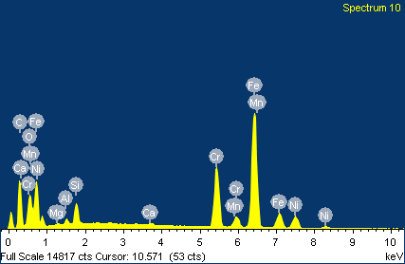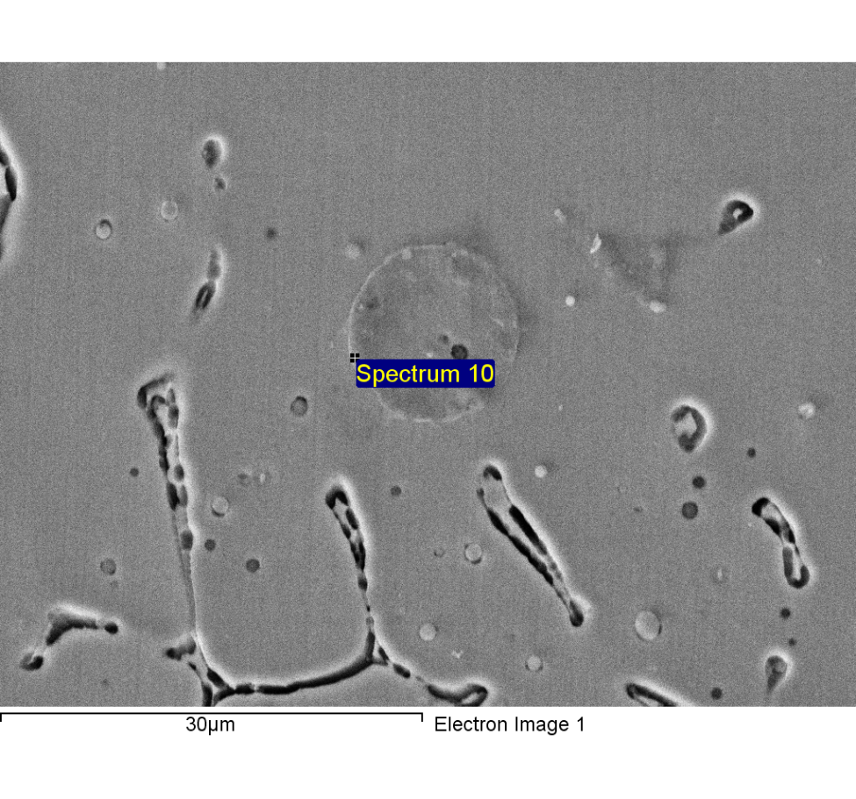

Spectrum processing :

Peaks possibly omitted : 2.320, 2.619, 12.838 keV

Processing option : All elements analyzed (Normalised)

Number of iterations = 6

Standard :

C CaCO3 1-Jun-1999 12:00 AM

O SiO2 1-Jun-1999 12:00 AM

Mg MgO 1-Jun-1999 12:00 AM

Al Al2O3 1-Jun-1999 12:00 AM

Si SiO2 1-Jun-1999 12:00 AM

Ca Wollastonite 1-Jun-1999 12:00 AM

Cr Cr 1-Jun-1999 12:00 AM

Mn Mn 1-Jun-1999 12:00 AM

Fe Fe 1-Jun-1999 12:00 AM

Ni Ni 1-Jun-1999 12:00 AM

|  |  |  |  |
| --- | --- | --- | --- |
| Element | Weight% | Atomic% |  |
|  |  |  |  |
| C K | 29.99 | 59.80 |  |
| O K | 8.11 | 12.15 |  |
| Mg K | 0.24 | 0.24 |  |
| Al K | 0.54 | 0.48 |  |
| Si K | 1.90 | 1.62 |  |
| Ca K | 0.24 | 0.14 |  |
| Cr K | 12.84 | 5.91 |  |
| Mn K | 0.96 | 0.42 |  |
| Fe K | 38.99 | 16.72 |  |
| Ni K | 6.19 | 2.52 |  |
|  |  |  |  |
| Totals | 100.00 |  |  |

1/24/2018 6:55:17 PM

Project 8

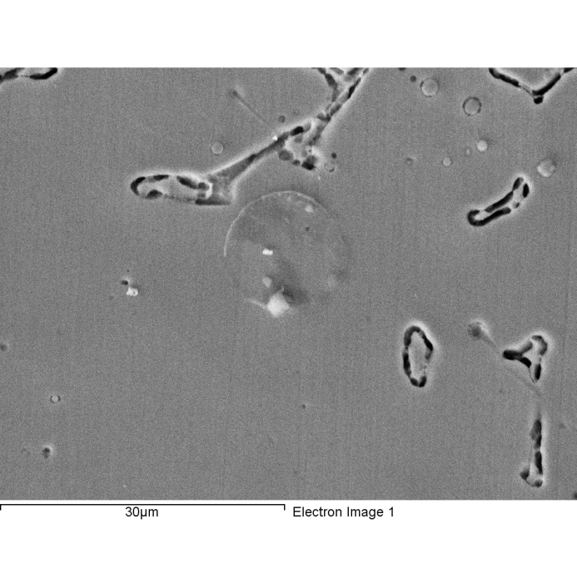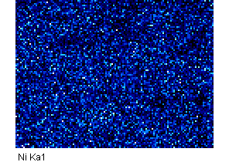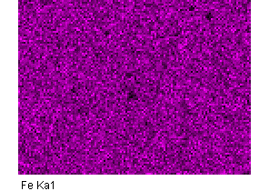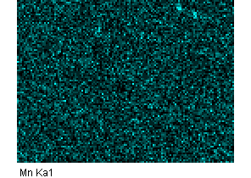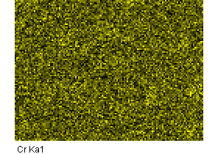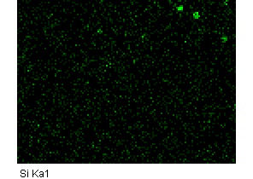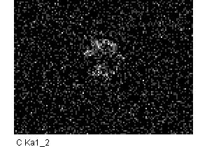––

Comment:2-5

1/24/2018 6:58:19 PM

Project 9

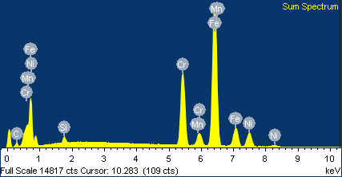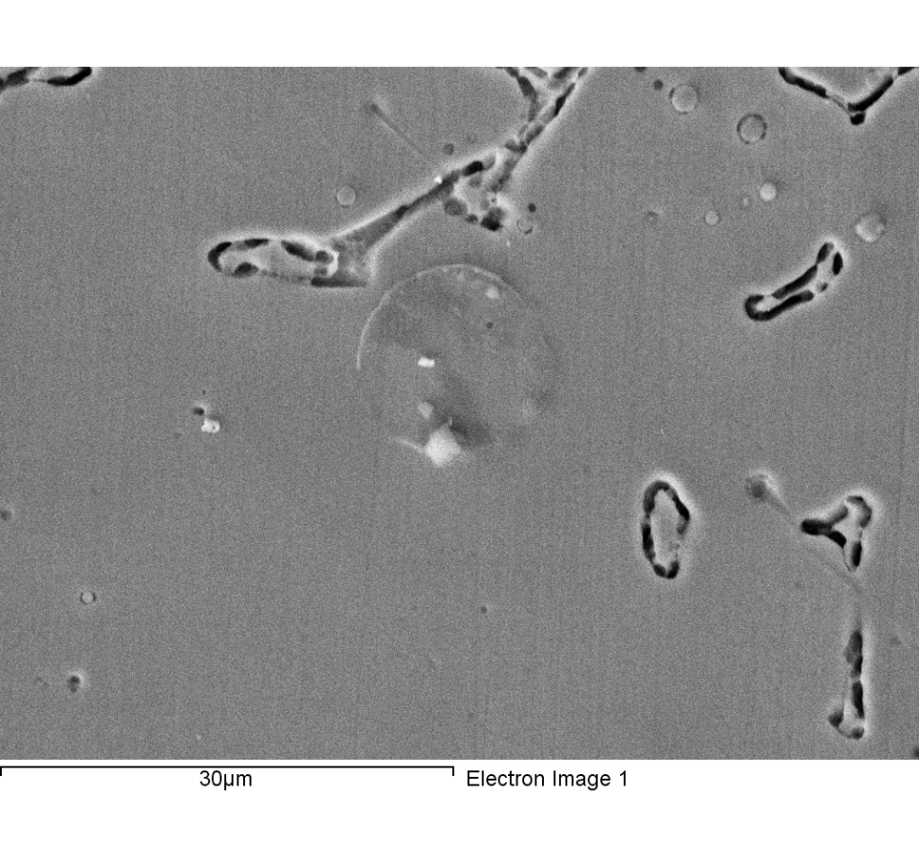

Spectrum processing :

Peaks possibly omitted : 11.827, 12.807, 13.444, 16.395 keV

Processing option : All elements analyzed (Normalised)

Number of iterations = 3

Standard :

C CaCO3 1-Jun-1999 12:00 AM

Si SiO2 1-Jun-1999 12:00 AM

Cr Cr 1-Jun-1999 12:00 AM

Mn Mn 1-Jun-1999 12:00 AM

Fe Fe 1-Jun-1999 12:00 AM

Ni Ni 1-Jun-1999 12:00 AM

|  |  |  |  |
| --- | --- | --- | --- |
| Element | Weight% | Atomic% |  |
|  |  |  |  |
| C K | 4.83 | 18.80 |  |
| Si K | 0.87 | 1.45 |  |
| Cr K | 20.00 | 17.97 |  |
| Mn K | 1.64 | 1.39 |  |
| Fe K | 62.92 | 52.64 |  |
| Ni K | 9.74 | 7.75 |  |
|  |  |  |  |
| Totals | 100.00 |  |  |

Comment:2-5

1/24/2018 6:58:38 PM

Project 9

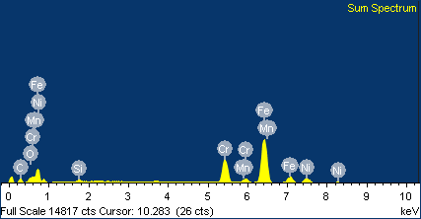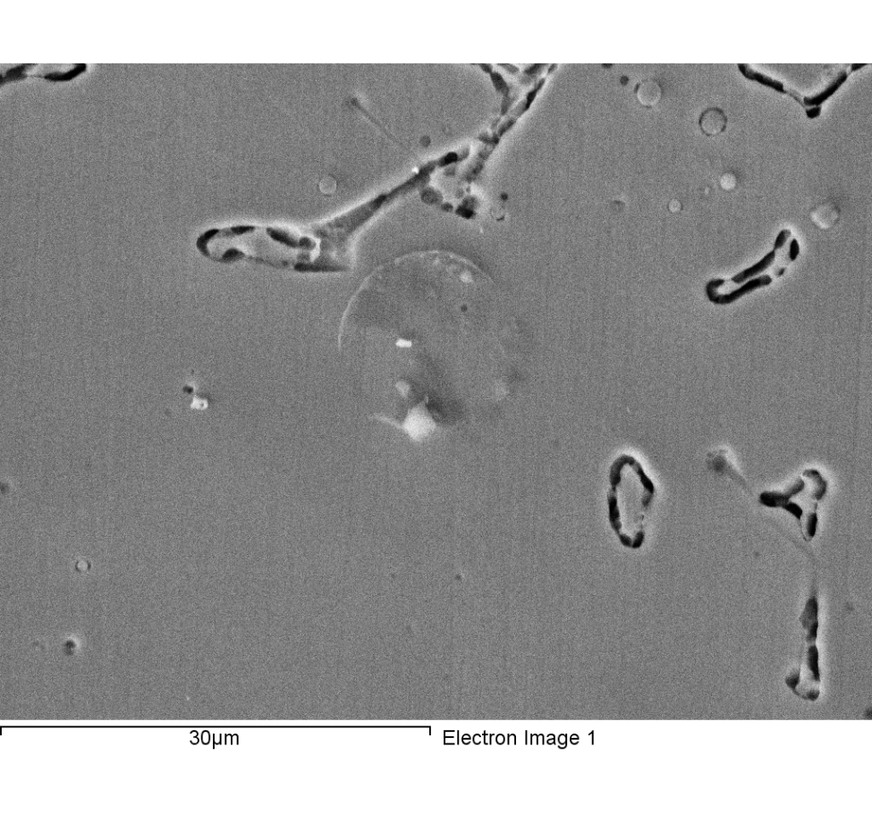

Spectrum processing :

Peaks possibly omitted : 3.691, 11.826, 12.750 keV

Processing option : All elements analyzed (Normalised)

Number of iterations = 3

Standard :

C CaCO3 1-Jun-1999 12:00 AM

O SiO2 1-Jun-1999 12:00 AM

Si SiO2 1-Jun-1999 12:00 AM

Cr Cr 1-Jun-1999 12:00 AM

Mn Mn 1-Jun-1999 12:00 AM

Fe Fe 1-Jun-1999 12:00 AM

Ni Ni 1-Jun-1999 12:00 AM

|  |  |  |  |
| --- | --- | --- | --- |
| Element | Weight% | Atomic% |  |
|  |  |  |  |
| C K | 11.29 | 35.47 |  |
| O K | 1.97 | 4.64 |  |
| Si K | 0.96 | 1.29 |  |
| Cr K | 18.52 | 13.44 |  |
| Mn K | 1.37 | 0.94 |  |
| Fe K | 56.79 | 38.37 |  |
| Ni K | 9.10 | 5.85 |  |
|  |  |  |  |
| Totals | 100.00 |  |  |

Comment:

1/24/2018 7:00:01 PM

Project 9

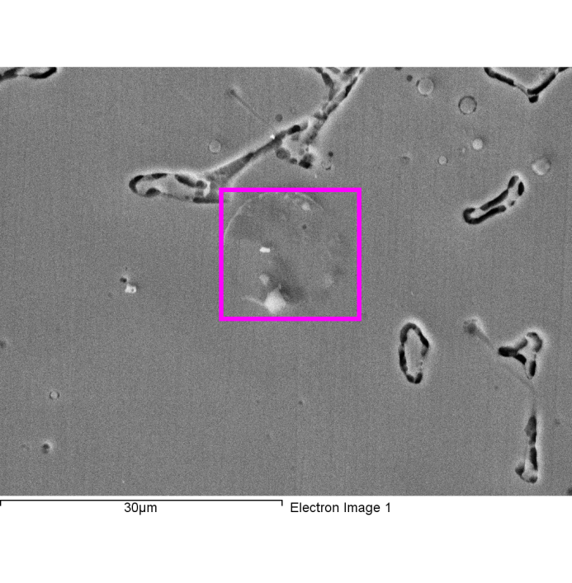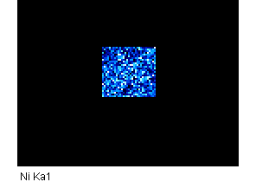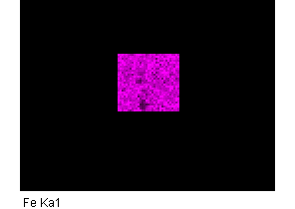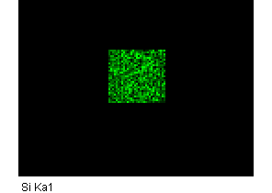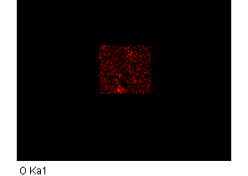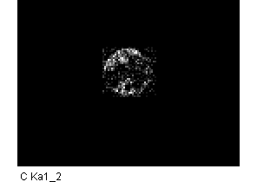

Comment:

1/24/2018 7:00:12 PM

Project 9

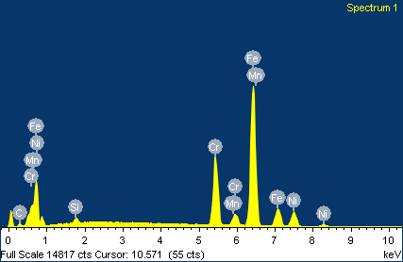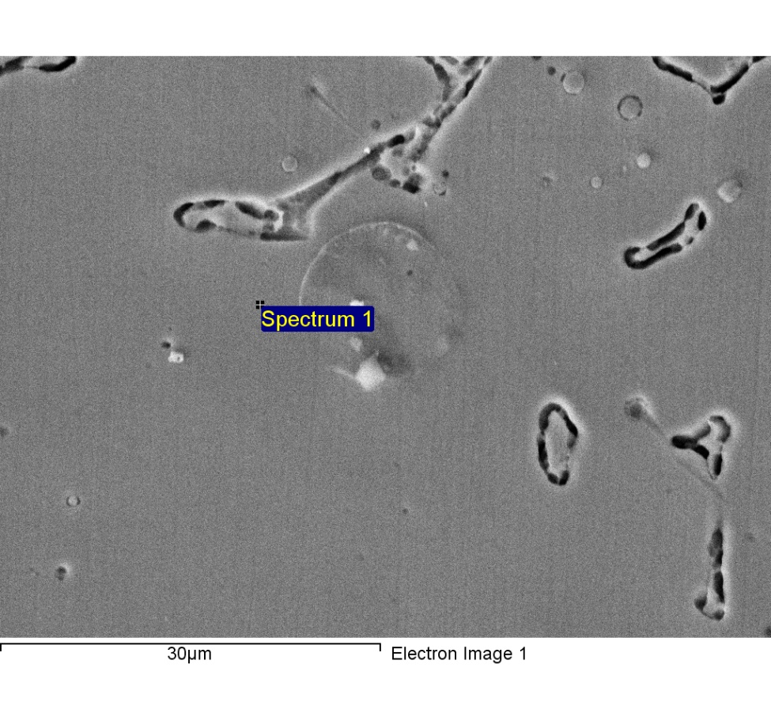

Spectrum processing :

Peaks possibly omitted : **12.831, 13.430 keV**

Processing option : All elements analyzed (Normalised)

**Number of iterations = 4**

Standard :

C CaCO3 1-Jun-1999 12:00 AM

Si SiO2 1-Jun-1999 12:00 AM

Cr Cr 1-Jun-1999 12:00 AM

Mn Mn 1-Jun-1999 12:00 AM

Fe Fe 1-Jun-1999 12:00 AM

Ni Ni 1-Jun-1999 12:00 AM

|  |  |  |  |
| --- | --- | --- | --- |
| Element | Weight% | Atomic% |  |
|  |  |  |  |
| C **K** | 4.07 | 16.22 |  |
| Si **K** | 0.80 | 1.37 |  |
| Cr **K** | 19.34 | 17.82 |  |
| Mn K | 1.53 | 1.33 |  |
| Fe K | 63.88 | 54.79 |  |
| Ni K | 10.38 | 8.47 |  |
|  |  |  |  |
| Totals | 100.00 |  |  |

1/24/2018 7:04:52 PM

Project 9

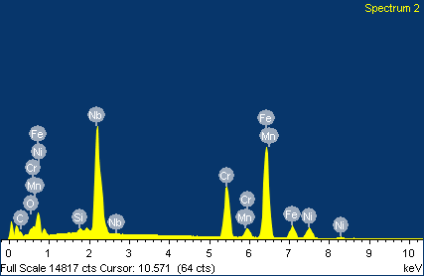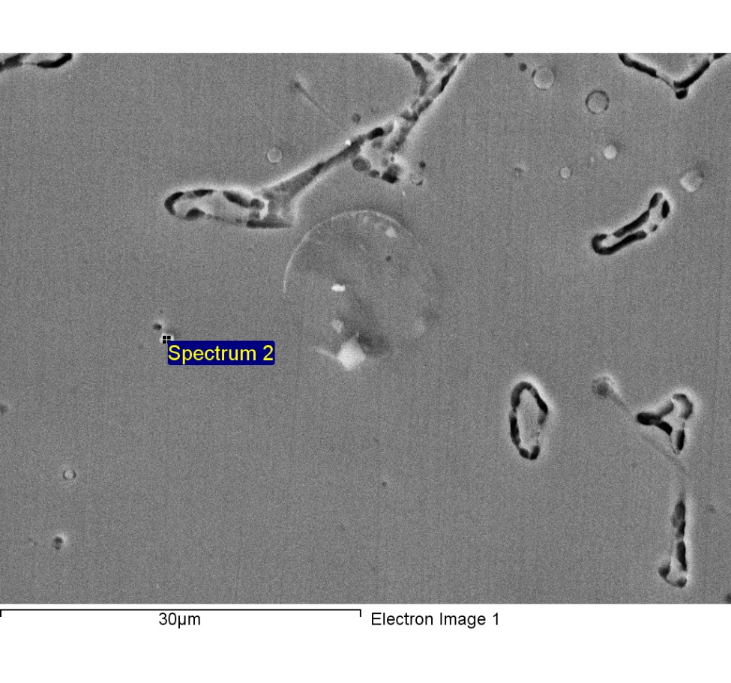

Spectrum processing :

No peaks omitted

Processing option : All elements analyzed (Normalised)

Number of iterations = 4

Standard :

C CaCO3 1-Jun-1999 12:00 AM

O SiO2 1-Jun-1999 12:00 AM

Si SiO2 1-Jun-1999 12:00 AM

Cr Cr 1-Jun-1999 12:00 AM

Mn Mn 1-Jun-1999 12:00 AM

Fe Fe 1-Jun-1999 12:00 AM

Ni Ni 1-Jun-1999 12:00 AM

Nb Nb 1-Jun-1999 12:00 AM

|  |  |  |  |
| --- | --- | --- | --- |
| Element | Weight% | Atomic% |  |
|  |  |  |  |
| C K | 7.41 | 28.31 |  |
| O K | 2.24 | 6.42 |  |
| Si K | 0.49 | 0.80 |  |
| Cr K | 14.32 | 12.64 |  |
| Mn K | 1.07 | 0.89 |  |
| Fe K | 37.66 | 30.95 |  |
| Ni K | 6.30 | 4.93 |  |
| Nb L | 30.51 | 15.07 |  |
|  |  |  |  |
| Totals | 100.00 |  |  |

1/24/2018 7:05:01 PM

Project 9

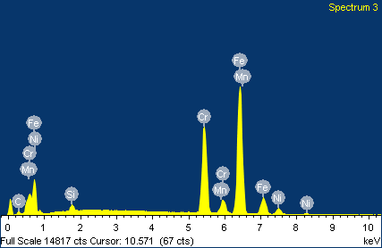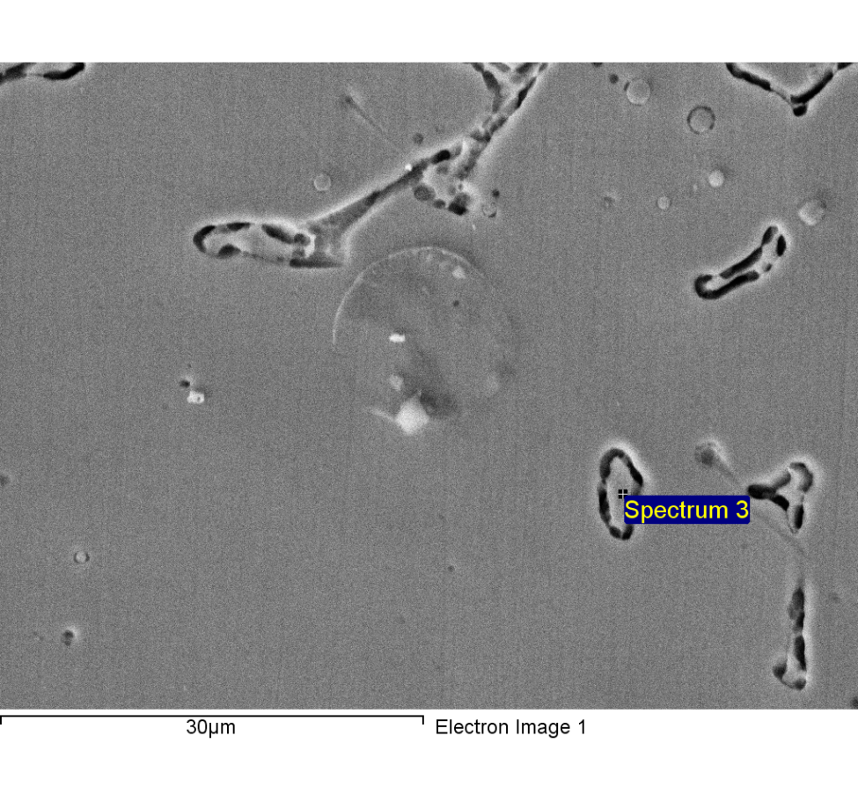

Spectrum processing :

Peaks possibly omitted : 11.820, 12.778 keV

Processing option : All elements analyzed (Normalised)

Number of iterations = 4

Standard :

C CaCO3 1-Jun-1999 12:00 AM

Si SiO2 1-Jun-1999 12:00 AM

Cr Cr 1-Jun-1999 12:00 AM

Mn Mn 1-Jun-1999 12:00 AM

Fe Fe 1-Jun-1999 12:00 AM

Ni Ni 1-Jun-1999 12:00 AM

|  |  |  |  |
| --- | --- | --- | --- |
| Element | Weight% | Atomic% |  |
|  |  |  |  |
| C K | 3.53 | 14.20 |  |
| Si K | 0.98 | 1.68 |  |
| Cr K | 26.73 | 24.83 |  |
| Mn K | 1.24 | 1.09 |  |
| Fe K | 62.85 | 54.35 |  |
| Ni K | 4.68 | 3.85 |  |
|  |  |  |  |
| Totals | 100.00 |  |  |

1/24/2018 7:05:11 PM

Project 9

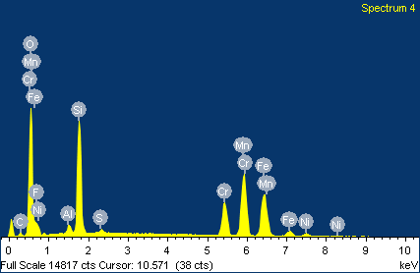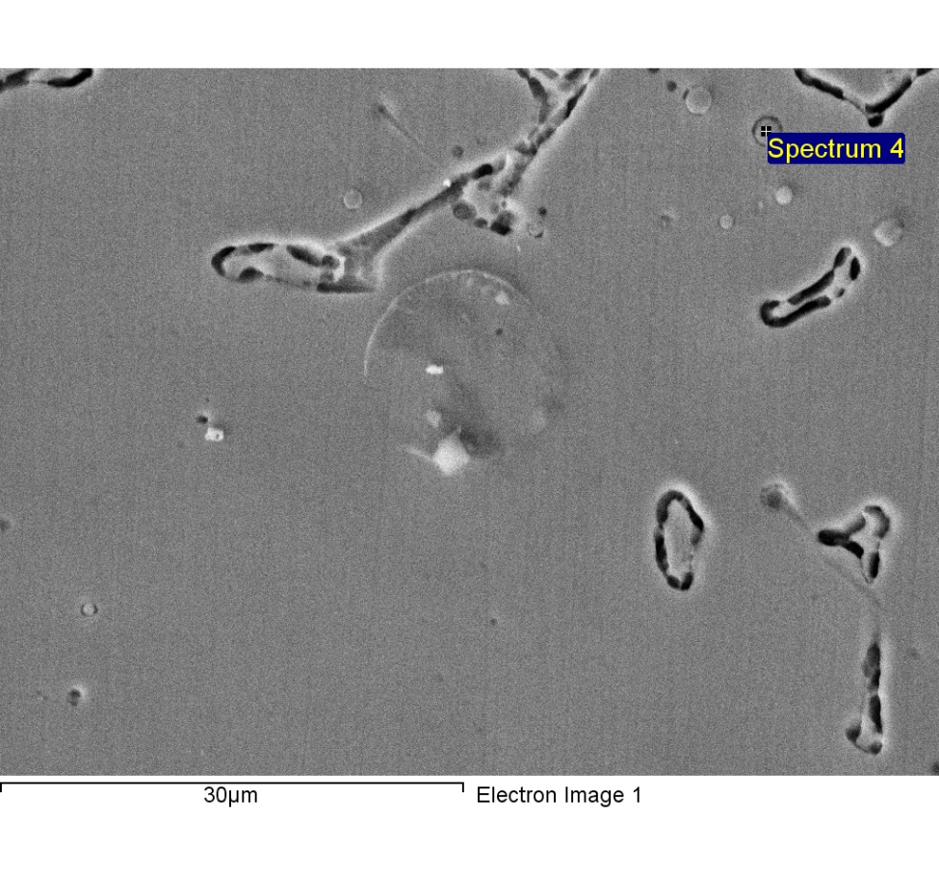

Spectrum processing :

No peaks omitted

Processing option : All elements analyzed (Normalised)

Number of iterations = 5

Standard :

C CaCO3 1-Jun-1999 12:00 AM

O SiO2 1-Jun-1999 12:00 AM

F MgF2 1-Jun-1999 12:00 AM

Al Al2O3 1-Jun-1999 12:00 AM

Si SiO2 1-Jun-1999 12:00 AM

S FeS2 1-Jun-1999 12:00 AM

Cr Cr 1-Jun-1999 12:00 AM

Mn Mn 1-Jun-1999 12:00 AM

Fe Fe 1-Jun-1999 12:00 AM

Ni Ni 1-Jun-1999 12:00 AM

|  |  |  |  |
| --- | --- | --- | --- |
| Element | Weight% | Atomic% |  |
|  |  |  |  |
| C K | 3.89 | 8.64 |  |
| O K | 29.68 | 49.52 |  |
| F K | 3.08 | 4.33 |  |
| Al K | 0.97 | 0.96 |  |
| Si K | 12.90 | 12.26 |  |
| S K | 0.49 | 0.41 |  |
| Cr K | 9.32 | 4.78 |  |
| Mn K | 21.17 | 10.29 |  |
| Fe K | 16.71 | 7.99 |  |
| Ni K | 1.80 | 0.82 |  |
|  |  |  |  |
| Totals | 100.00 |  |  |

1/24/2018 7:05:21 PM

Project 9

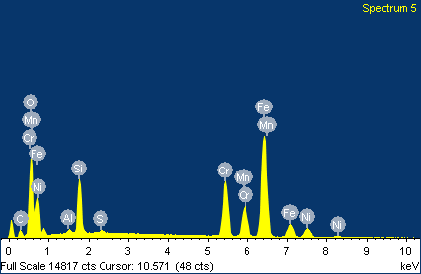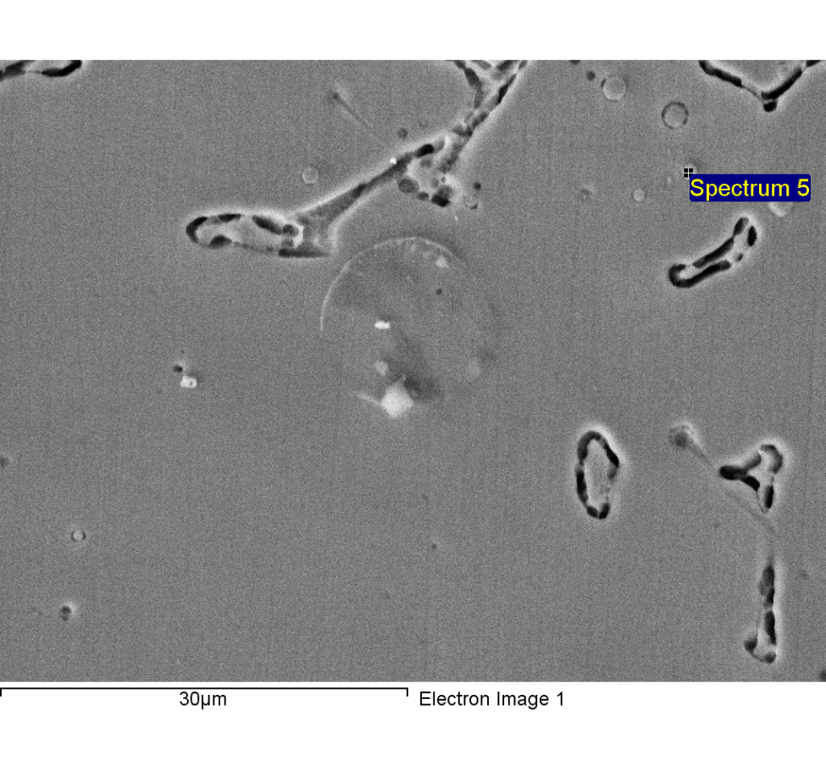

Spectrum processing :

Peak possibly omitted : 12.830 keV

Processing option : All elements analyzed (Normalised)

Number of iterations = 5

Standard :

C CaCO3 1-Jun-1999 12:00 AM

O SiO2 1-Jun-1999 12:00 AM

Al Al2O3 1-Jun-1999 12:00 AM

Si SiO2 1-Jun-1999 12:00 AM

S FeS2 1-Jun-1999 12:00 AM

Cr Cr 1-Jun-1999 12:00 AM

Mn Mn 1-Jun-1999 12:00 AM

Fe Fe 1-Jun-1999 12:00 AM

Ni Ni 1-Jun-1999 12:00 AM

|  |  |  |  |
| --- | --- | --- | --- |
| Element | Weight% | Atomic% |  |
|  |  |  |  |
| C K | 6.56 | 17.30 |  |
| O K | 17.85 | 35.34 |  |
| Al K | 0.43 | 0.50 |  |
| Si K | 6.39 | 7.20 |  |
| S K | 0.31 | 0.30 |  |
| Cr K | 13.92 | 8.48 |  |
| Mn K | 8.70 | 5.02 |  |
| Fe K | 40.13 | 22.76 |  |
| Ni K | 5.72 | 3.09 |  |
|  |  |  |  |
| Totals | 100.00 |  |  |

1/24/2018 7:05:30 PM

Project 9

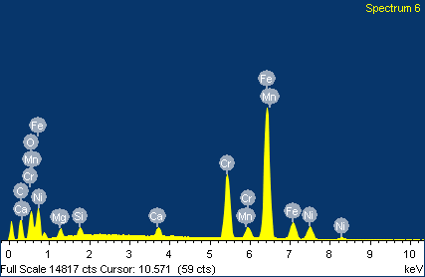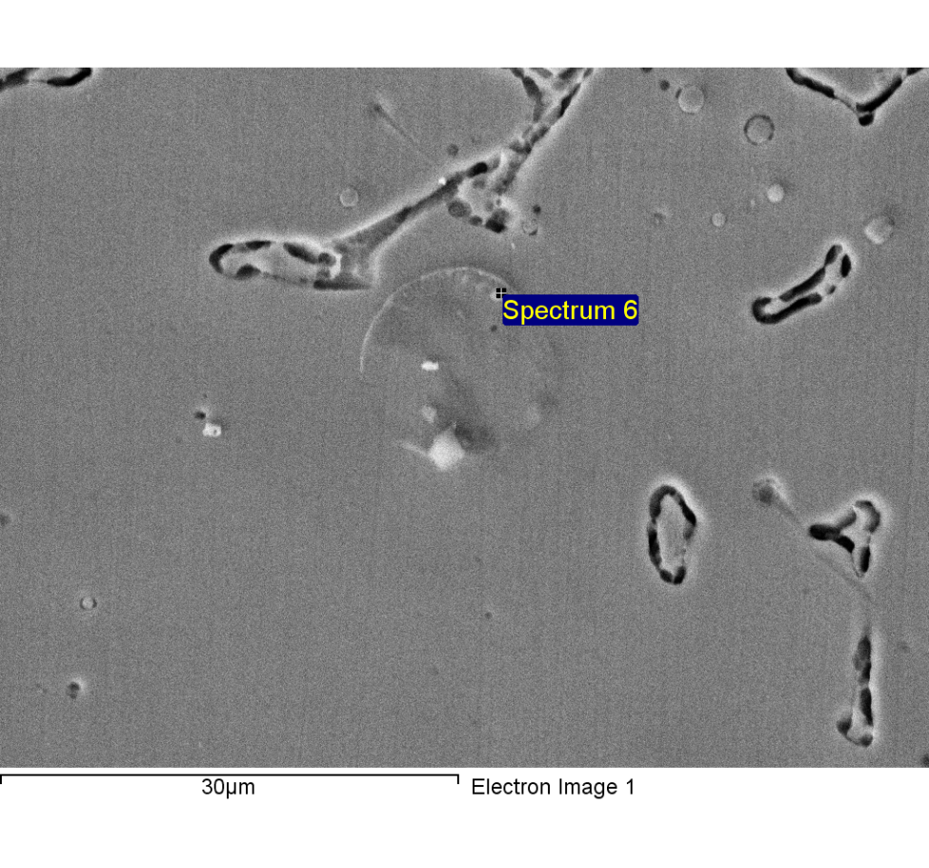

Spectrum processing :

Peak possibly omitted : 12.821 keV

Processing option : All elements analyzed (Normalised)

Number of iterations = 5

Standard :

C CaCO3 1-Jun-1999 12:00 AM

O SiO2 1-Jun-1999 12:00 AM

Mg MgO 1-Jun-1999 12:00 AM

Si SiO2 1-Jun-1999 12:00 AM

Ca Wollastonite 1-Jun-1999 12:00 AM

Cr Cr 1-Jun-1999 12:00 AM

Mn Mn 1-Jun-1999 12:00 AM

Fe Fe 1-Jun-1999 12:00 AM

Ni Ni 1-Jun-1999 12:00 AM

|  |  |  |  |
| --- | --- | --- | --- |
| Element | Weight% | Atomic% |  |
|  |  |  |  |
| C K | 16.35 | 42.00 |  |
| O K | 6.89 | 13.28 |  |
| Mg K | 1.60 | 2.04 |  |
| Si K | 0.91 | 1.00 |  |
| Ca K | 1.04 | 0.80 |  |
| Cr K | 15.19 | 9.01 |  |
| Mn K | 1.12 | 0.63 |  |
| Fe K | 49.45 | 27.32 |  |
| Ni K | 7.46 | 3.92 |  |
|  |  |  |  |
| Totals | 100.00 |  |  |

1/24/2018 7:05:56 PM

Project 9

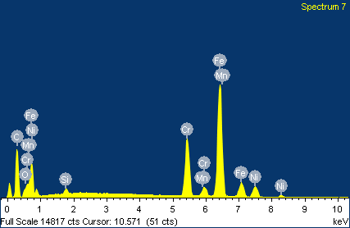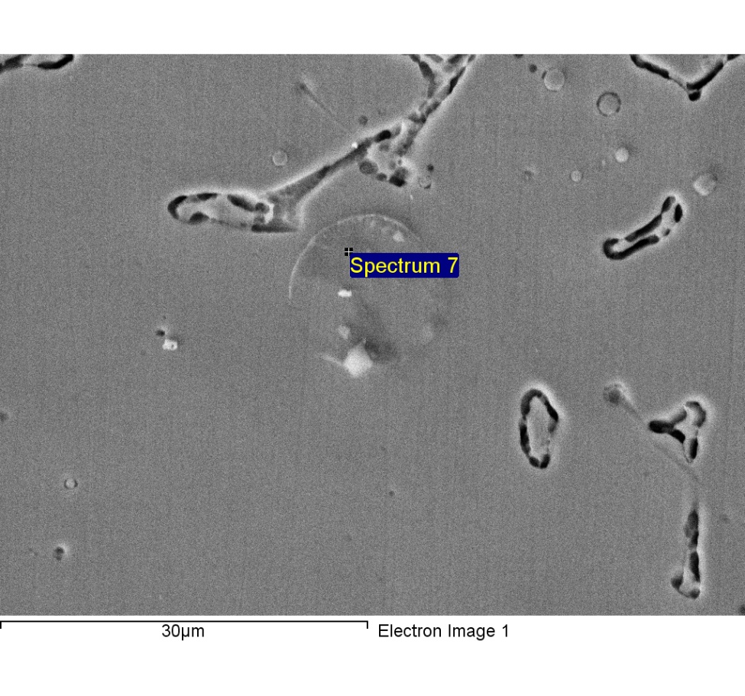

Spectrum processing :

Peak possibly omitted : 12.790 keV

Processing option : All elements analyzed (Normalised)

Number of iterations = 4

Standard :

C CaCO3 1-Jun-1999 12:00 AM

O SiO2 1-Jun-1999 12:00 AM

Si SiO2 1-Jun-1999 12:00 AM

Cr Cr 1-Jun-1999 12:00 AM

Mn Mn 1-Jun-1999 12:00 AM

Fe Fe 1-Jun-1999 12:00 AM

Ni Ni 1-Jun-1999 12:00 AM

|  |  |  |  |
| --- | --- | --- | --- |
| Element | Weight% | Atomic% |  |
|  |  |  |  |
| C K | 33.63 | 68.74 |  |
| O K | 1.40 | 2.15 |  |
| Si K | 0.53 | 0.46 |  |
| Cr K | 13.86 | 6.55 |  |
| Mn K | 0.93 | 0.42 |  |
| Fe K | 43.18 | 18.98 |  |
| Ni K | 6.47 | 2.71 |  |
|  |  |  |  |
| Totals | 100.00 |  |  |

1/24/2018 7:06:05 PM

Project 9

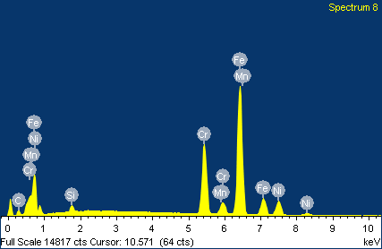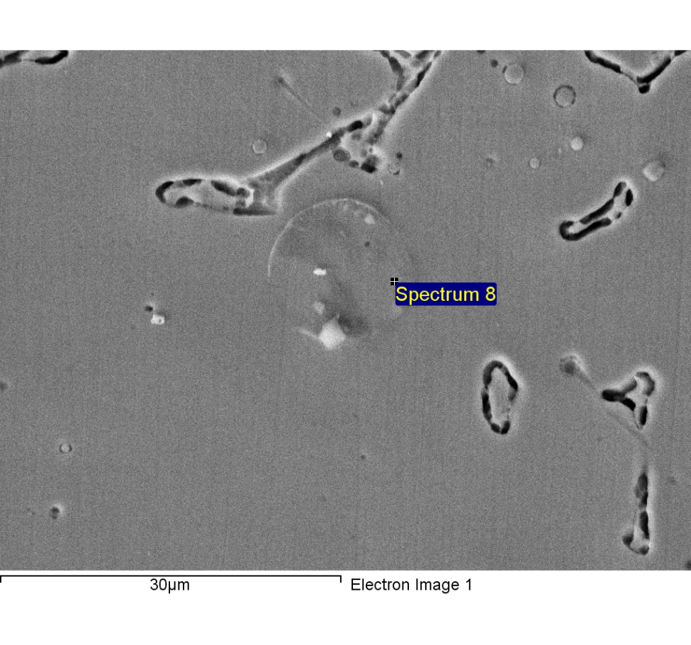

Spectrum processing :

Peak possibly omitted : 11.810 keV

Processing option : All elements analyzed (Normalised)

Number of iterations = 4

Standard :

C CaCO3 1-Jun-1999 12:00 AM

Si SiO2 1-Jun-1999 12:00 AM

Cr Cr 1-Jun-1999 12:00 AM

Mn Mn 1-Jun-1999 12:00 AM

Fe Fe 1-Jun-1999 12:00 AM

Ni Ni 1-Jun-1999 12:00 AM

|  |  |  |  |
| --- | --- | --- | --- |
| Element | Weight% | Atomic% |  |
|  |  |  |  |
| C K | 6.23 | 23.23 |  |
| Si K | 0.94 | 1.49 |  |
| Cr K | 20.36 | 17.54 |  |
| Mn K | 1.72 | 1.40 |  |
| Fe K | 60.24 | 48.31 |  |
| Ni K | 10.52 | 8.03 |  |
|  |  |  |  |
| Totals | 100.00 |  |  |

1/24/2018 7:06:15 PM

Project 9

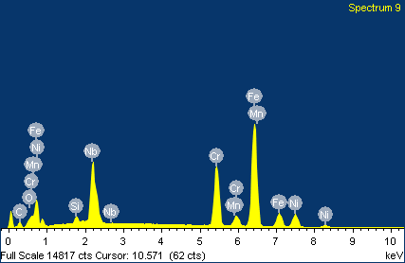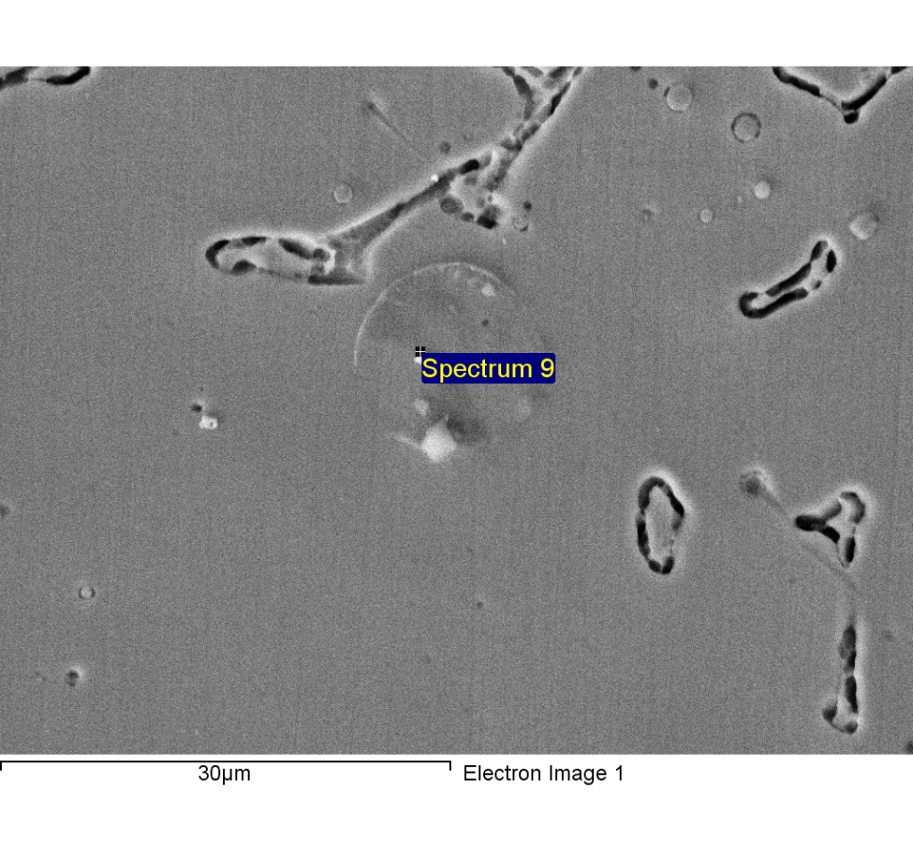

Spectrum processing :

No peaks omitted

Processing option : All elements analyzed (Normalised)

Number of iterations = 4

Standard :

C CaCO3 1-Jun-1999 12:00 AM

O SiO2 1-Jun-1999 12:00 AM

Si SiO2 1-Jun-1999 12:00 AM

Cr Cr 1-Jun-1999 12:00 AM

Mn Mn 1-Jun-1999 12:00 AM

Fe Fe 1-Jun-1999 12:00 AM

Ni Ni 1-Jun-1999 12:00 AM

Nb Nb 1-Jun-1999 12:00 AM

|  |  |  |  |
| --- | --- | --- | --- |
| Element | Weight% | Atomic% |  |
|  |  |  |  |
| C K | 6.88 | 26.00 |  |
| O K | 1.46 | 4.14 |  |
| Si K | 0.83 | 1.35 |  |
| Cr K | 17.59 | 15.35 |  |
| Mn K | 1.27 | 1.05 |  |
| Fe K | 44.84 | 36.43 |  |
| Ni K | 8.58 | 6.63 |  |
| Nb L | 18.54 | 9.05 |  |
|  |  |  |  |
| Totals | 100.00 |  |  |

1/24/2018 7:06:25 PM

Project 9

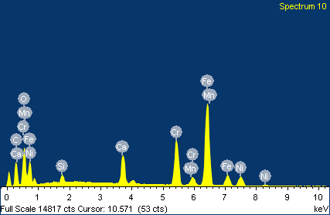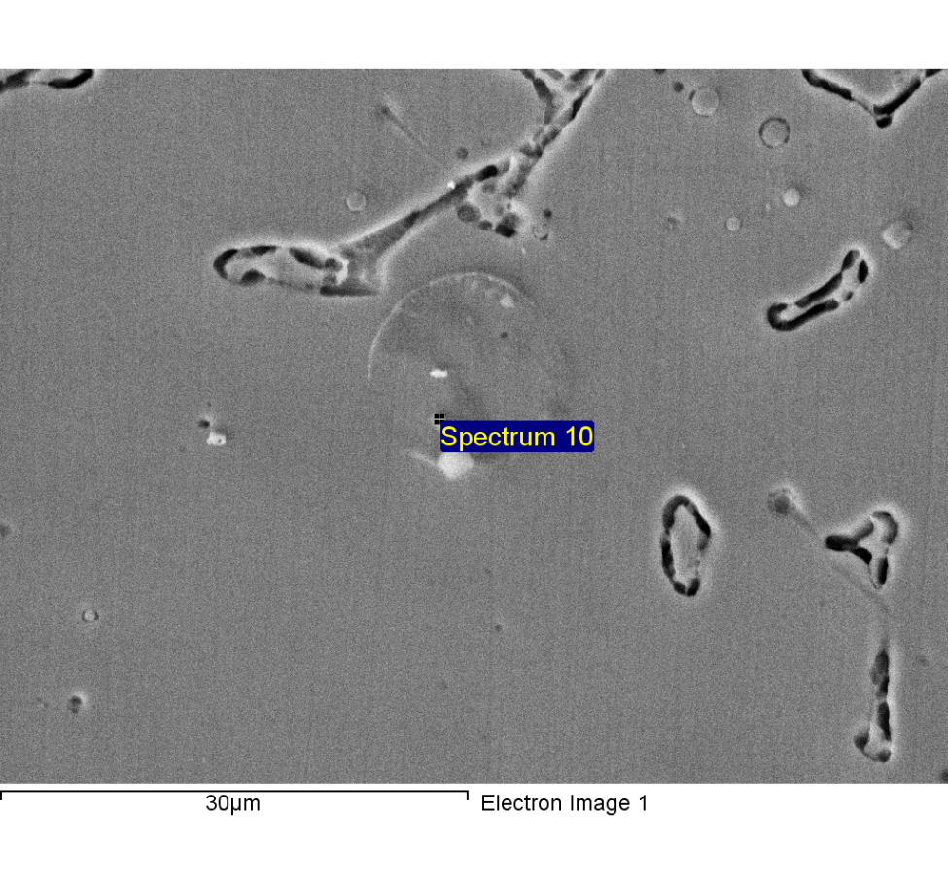

Spectrum processing :

Peak possibly omitted : 12.820 keV

Processing option : All elements analyzed (Normalised)

Number of iterations = 5

Standard :

C CaCO3 1-Jun-1999 12:00 AM

O SiO2 1-Jun-1999 12:00 AM

Si SiO2 1-Jun-1999 12:00 AM

Ca Wollastonite 1-Jun-1999 12:00 AM

Cr Cr 1-Jun-1999 12:00 AM

Mn Mn 1-Jun-1999 12:00 AM

Fe Fe 1-Jun-1999 12:00 AM

Ni Ni 1-Jun-1999 12:00 AM

|  |  |  |  |
| --- | --- | --- | --- |
| Element | Weight% | Atomic% |  |
|  |  |  |  |
| C K | 20.07 | 44.10 |  |
| O K | 14.00 | 23.09 |  |
| Si K | 0.95 | 0.89 |  |
| Ca K | 4.74 | 3.12 |  |
| Cr K | 13.86 | 7.03 |  |
| Mn K | 1.00 | 0.48 |  |
| Fe K | 38.48 | 18.18 |  |
| Ni K | 6.90 | 3.10 |  |
|  |  |  |  |
| Totals | 100.00 |  |  |

1/24/2018 7:06:35 PM

Project 9

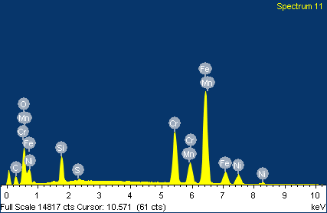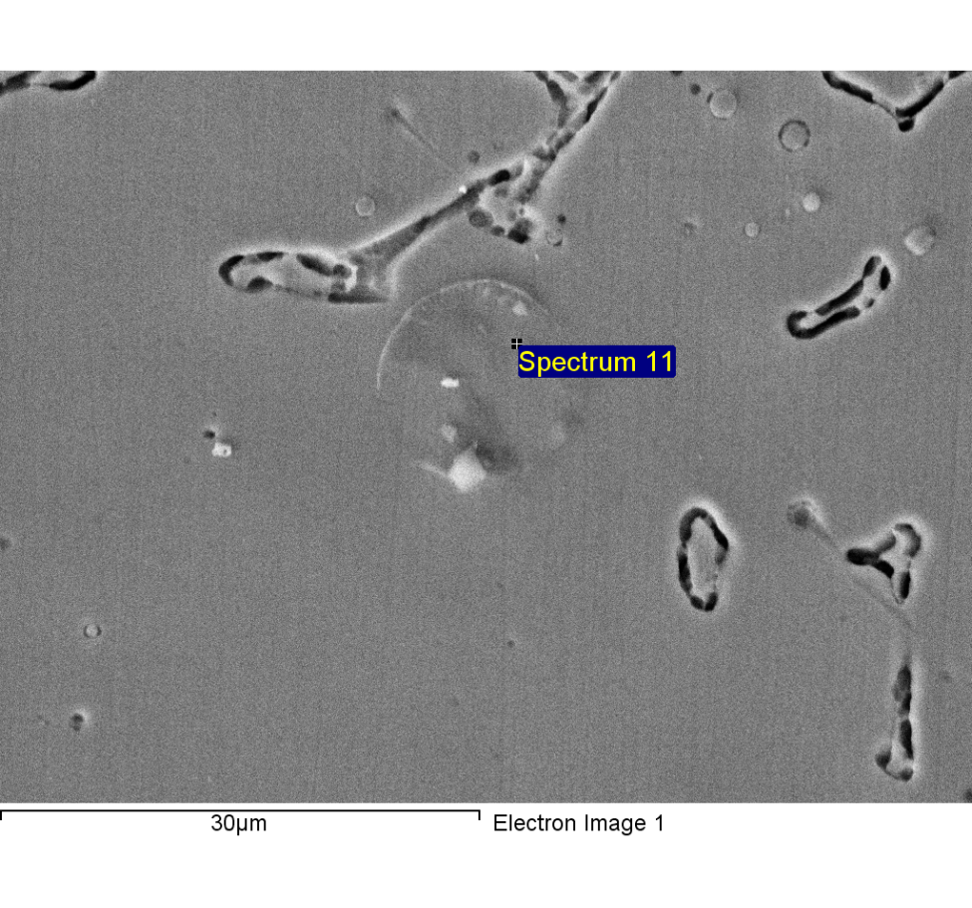

Spectrum processing :

Peak possibly omitted : 12.280 keV

Processing option : All elements analyzed (Normalised)

Number of iterations = 5

Standard :

C CaCO3 1-Jun-1999 12:00 AM

O SiO2 1-Jun-1999 12:00 AM

Si SiO2 1-Jun-1999 12:00 AM

S FeS2 1-Jun-1999 12:00 AM

Cr Cr 1-Jun-1999 12:00 AM

Mn Mn 1-Jun-1999 12:00 AM

Fe Fe 1-Jun-1999 12:00 AM

Ni Ni 1-Jun-1999 12:00 AM

|  |  |  |  |
| --- | --- | --- | --- |
| Element | Weight% | Atomic% |  |
|  |  |  |  |
| C K | 9.74 | 27.14 |  |
| O K | 10.58 | 22.12 |  |
| Si K | 3.91 | 4.66 |  |
| S K | 0.30 | 0.31 |  |
| Cr K | 16.12 | 10.37 |  |
| Mn K | 6.60 | 4.02 |  |
| Fe K | 45.44 | 27.22 |  |
| Ni K | 7.31 | 4.16 |  |
|  |  |  |  |
| Totals | 100.00 |  |  |

1/24/2018 7:06:51 PM

Project 9

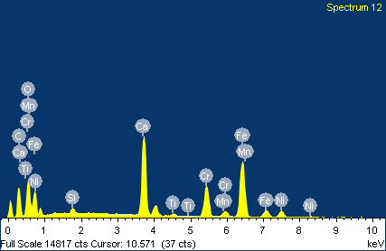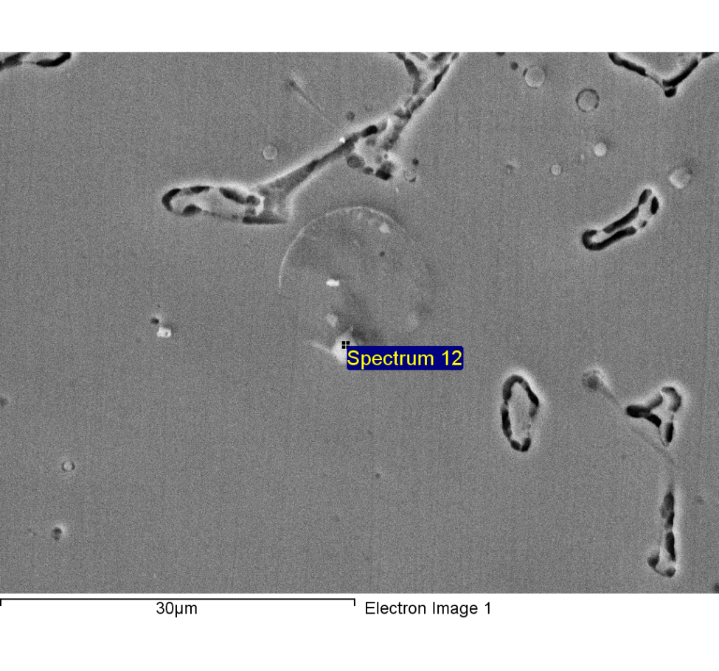

Spectrum processing :

Peak possibly omitted : 1.250 keV

Processing option : All elements analyzed (Normalised)

Number of iterations = 5

Standard :

C CaCO3 1-Jun-1999 12:00 AM

O SiO2 1-Jun-1999 12:00 AM

Si SiO2 1-Jun-1999 12:00 AM

Ca Wollastonite 1-Jun-1999 12:00 AM

Ti Ti 1-Jun-1999 12:00 AM

Cr Cr 1-Jun-1999 12:00 AM

Mn Mn 1-Jun-1999 12:00 AM

Fe Fe 1-Jun-1999 12:00 AM

Ni Ni 1-Jun-1999 12:00 AM

|  |  |  |  |
| --- | --- | --- | --- |
| Element | Weight% | Atomic% |  |
|  |  |  |  |
| C K | 22.10 | 42.99 |  |
| O K | 20.79 | 30.37 |  |
| Si K | 0.64 | 0.53 |  |
| Ca K | 13.49 | 7.87 |  |
| Ti K | 0.53 | 0.26 |  |
| Cr K | 10.05 | 4.52 |  |
| Mn K | 0.76 | 0.32 |  |
| Fe K | 27.20 | 11.38 |  |
| Ni K | 4.45 | 1.77 |  |
|  |  |  |  |
| Totals | 100.00 |  |  |

1/24/2018 7:07:07 PM

Project 9

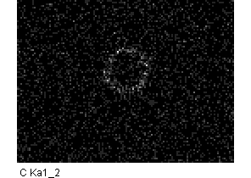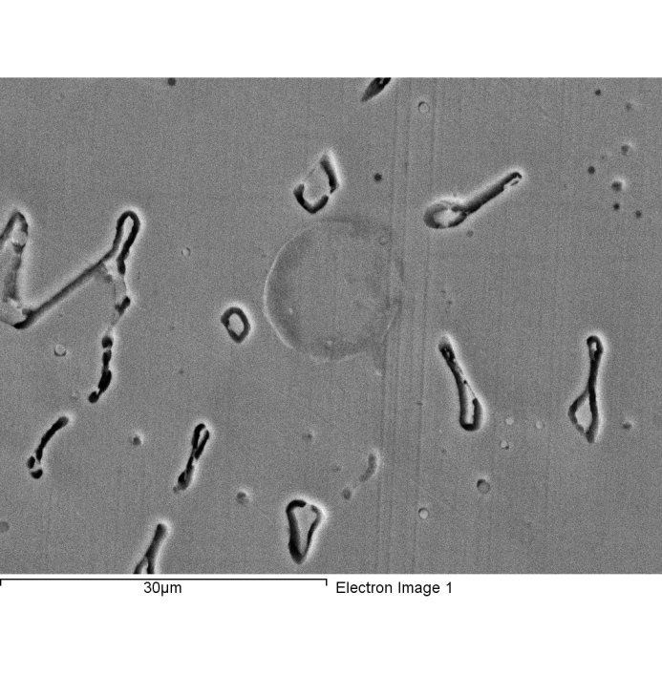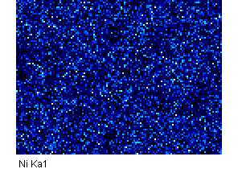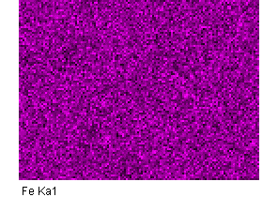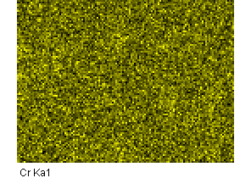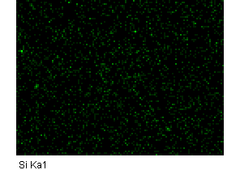

Comment:2-6

1/24/2018 7:09:15 PM

Project 9

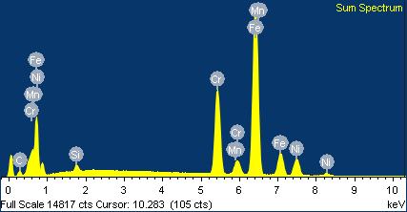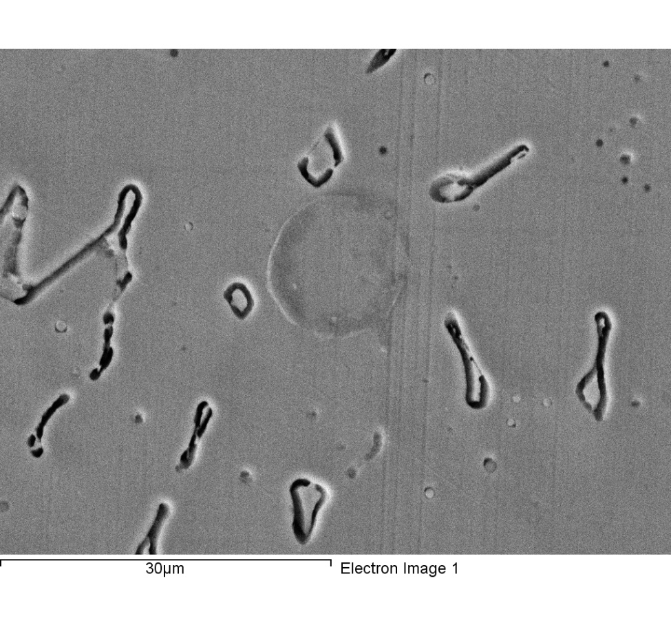

Spectrum processing :

Peaks possibly omitted : 11.831, 12.812 keV

Processing option : All elements analyzed (Normalised)

Number of iterations = 3

Standard :

C CaCO3 1-Jun-1999 12:00 AM

Si SiO2 1-Jun-1999 12:00 AM

Cr Cr 1-Jun-1999 12:00 AM

Mn Mn 1-Jun-1999 12:00 AM

Fe Fe 1-Jun-1999 12:00 AM

Ni Ni 1-Jun-1999 12:00 AM

|  |  |  |  |
| --- | --- | --- | --- |
| Element | Weight% | Atomic% |  |
|  |  |  |  |
| C K | 4.63 | 18.13 |  |
| Si K | 0.80 | 1.35 |  |
| Cr K | 19.91 | 18.02 |  |
| Mn K | 1.52 | 1.30 |  |
| Fe K | 63.23 | 53.27 |  |
| Ni K | 9.90 | 7.94 |  |
|  |  |  |  |
| Totals | 100.00 |  |  |

Comment:2-6

1/24/2018 7:09:29 PM

Project 9

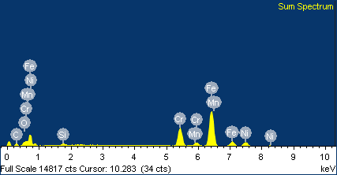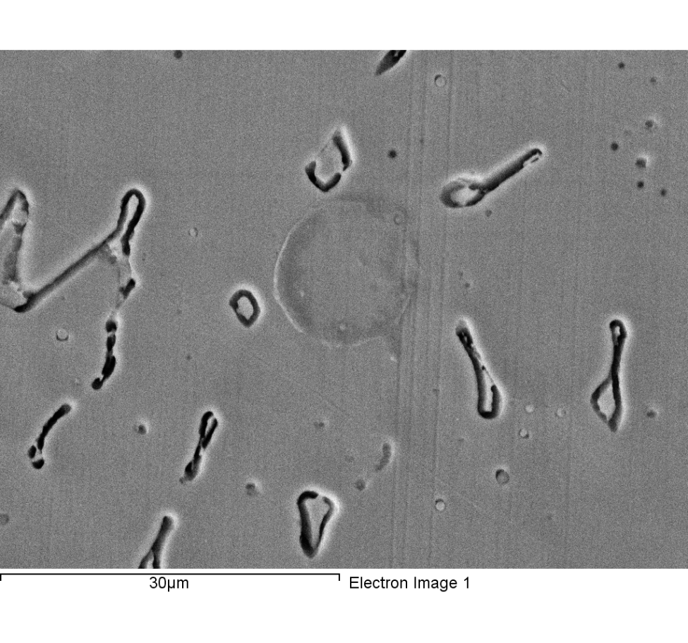

Spectrum processing :

Peaks possibly omitted : 11.845, 12.800 keV

Processing option : All elements analyzed (Normalised)

Number of iterations = 3

Standard :

C CaCO3 1-Jun-1999 12:00 AM

O SiO2 1-Jun-1999 12:00 AM

Si SiO2 1-Jun-1999 12:00 AM

Cr Cr 1-Jun-1999 12:00 AM

Mn Mn 1-Jun-1999 12:00 AM

Fe Fe 1-Jun-1999 12:00 AM

Ni Ni 1-Jun-1999 12:00 AM

|  |  |  |  |
| --- | --- | --- | --- |
| Element | Weight% | Atomic% |  |
|  |  |  |  |
| C K | 10.22 | 33.08 |  |
| O K | 1.82 | 4.43 |  |
| Si K | 0.91 | 1.26 |  |
| Cr K | 18.03 | 13.48 |  |
| Mn K | 1.49 | 1.06 |  |
| Fe K | 57.96 | 40.35 |  |
| Ni K | 9.56 | 6.33 |  |
|  |  |  |  |
| Totals | 100.00 |  |  |

Comment:

1/24/2018 7:11:01 PM

Project 9

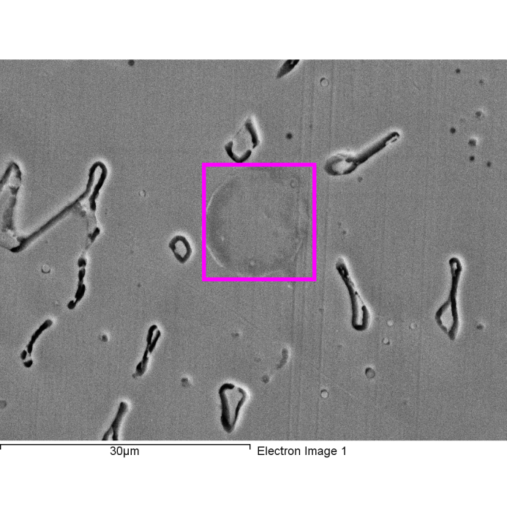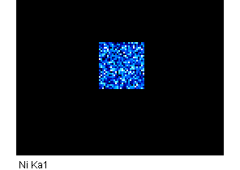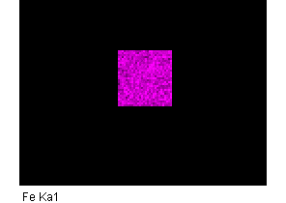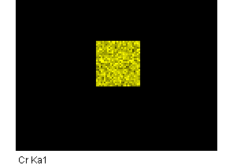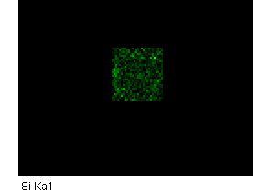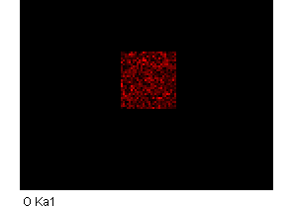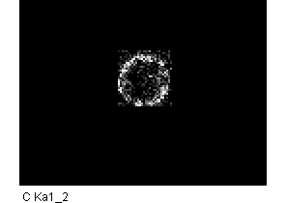

Comment:

1/24/2018 7:11:13 PM

Project 9

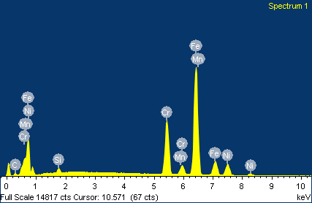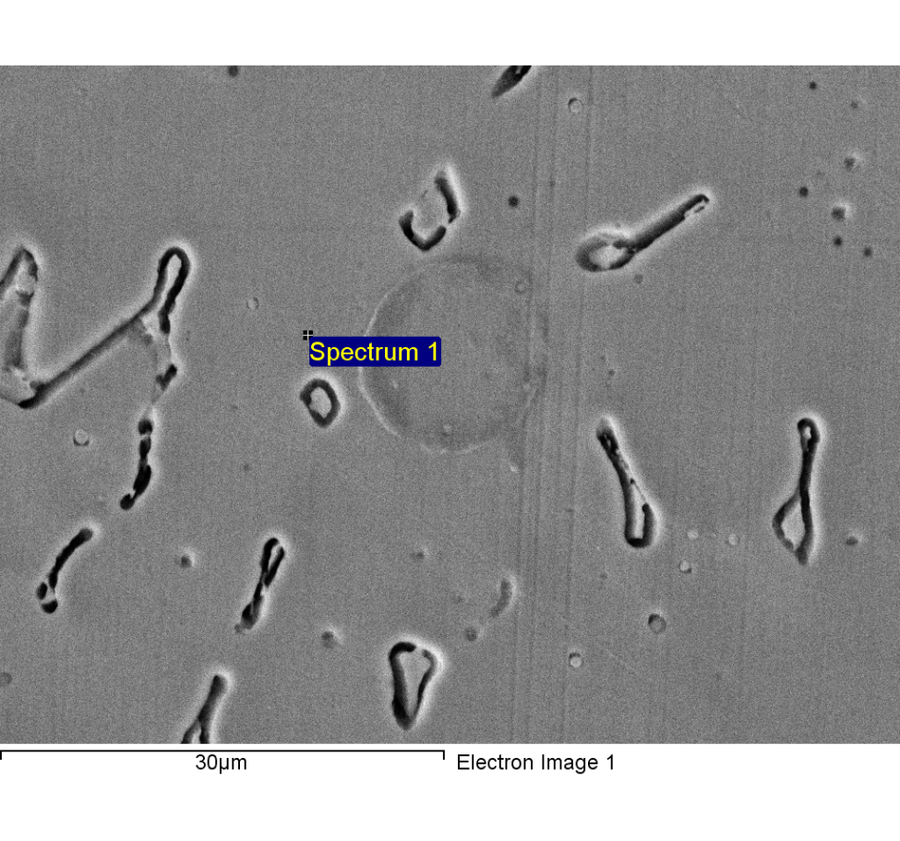

Spectrum processing :

Peaks possibly omitted : 11.831, 12.801 keV

Processing option : All elements analyzed (Normalised)

Number of iterations = 4

Standard :

C CaCO3 1-Jun-1999 12:00 AM

Si SiO2 1-Jun-1999 12:00 AM

Cr Cr 1-Jun-1999 12:00 AM

Mn Mn 1-Jun-1999 12:00 AM

Fe Fe 1-Jun-1999 12:00 AM

Ni Ni 1-Jun-1999 12:00 AM

|  |  |  |  |
| --- | --- | --- | --- |
| Element | Weight% | Atomic% |  |
|  |  |  |  |
| C K | 4.08 | 16.26 |  |
| Si K | 0.84 | 1.44 |  |
| Cr K | 19.70 | 18.13 |  |
| Mn K | 1.53 | 1.34 |  |
| Fe K | 63.37 | 54.30 |  |
| Ni K | 10.47 | 8.54 |  |
|  |  |  |  |
| Totals | 100.00 |  |  |

1/24/2018 7:15:03 PM

Project 9

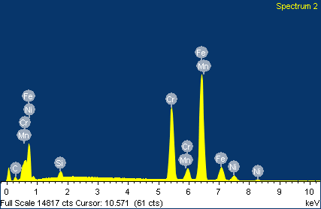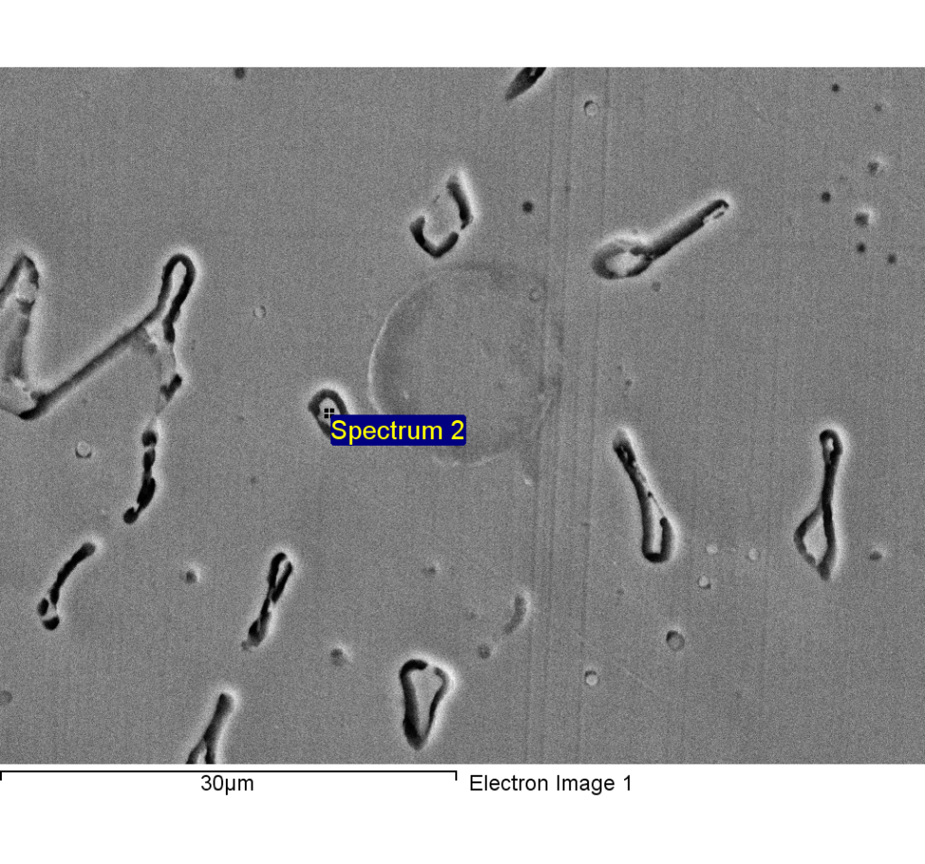

Spectrum processing :

Peaks possibly omitted : 11.807, 12.780 keV

Processing option : All elements analyzed (Normalised)

Number of iterations = 4

Standard :

C CaCO3 1-Jun-1999 12:00 AM

Si SiO2 1-Jun-1999 12:00 AM

Cr Cr 1-Jun-1999 12:00 AM

Mn Mn 1-Jun-1999 12:00 AM

Fe Fe 1-Jun-1999 12:00 AM

Ni Ni 1-Jun-1999 12:00 AM

|  |  |  |  |
| --- | --- | --- | --- |
| Element | Weight% | Atomic% |  |
|  |  |  |  |
| C K | 4.83 | 18.64 |  |
| Si K | 1.13 | 1.86 |  |
| Cr K | 26.39 | 23.52 |  |
| Mn K | 1.11 | 0.93 |  |
| Fe K | 62.05 | 51.49 |  |
| Ni K | 4.50 | 3.55 |  |
|  |  |  |  |
| Totals | 100.00 |  |  |

1/24/2018 7:15:15 PM

Project 9

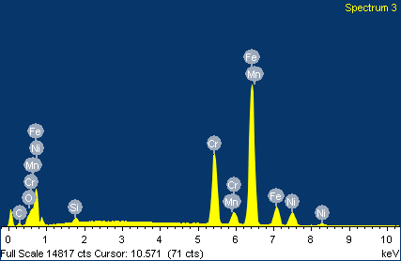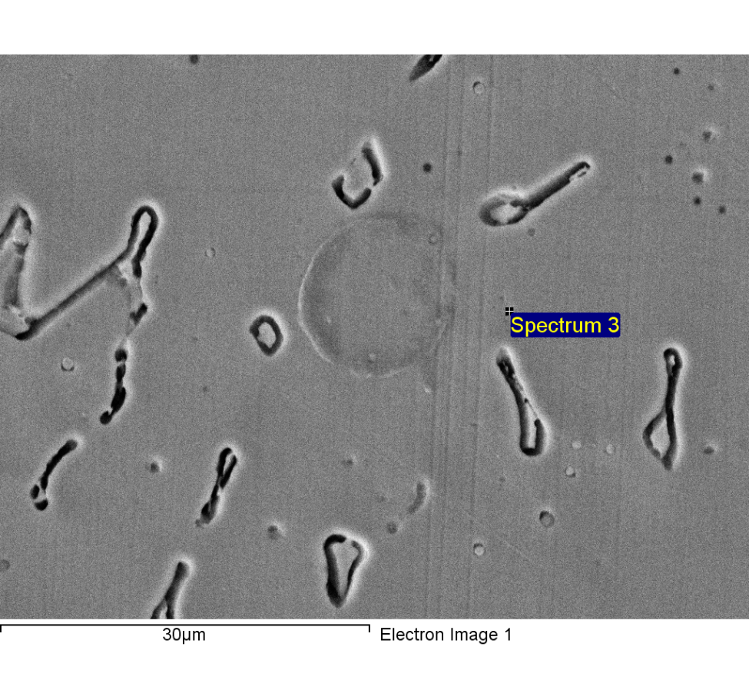

Spectrum processing :

Peaks possibly omitted : 11.819, 12.816 keV

Processing option : All elements analyzed (Normalised)

Number of iterations = 4

Standard :

C CaCO3 1-Jun-1999 12:00 AM

O SiO2 1-Jun-1999 12:00 AM

Si SiO2 1-Jun-1999 12:00 AM

Cr Cr 1-Jun-1999 12:00 AM

Mn Mn 1-Jun-1999 12:00 AM

Fe Fe 1-Jun-1999 12:00 AM

Ni Ni 1-Jun-1999 12:00 AM

|  |  |  |  |
| --- | --- | --- | --- |
| Element | Weight% | Atomic% |  |
|  |  |  |  |
| C K | 2.86 | 11.63 |  |
| O K | 0.90 | 2.76 |  |
| Si K | 0.65 | 1.13 |  |
| Cr K | 20.11 | 18.88 |  |
| Mn K | 1.78 | 1.58 |  |
| Fe K | 64.09 | 56.02 |  |
| Ni K | 9.61 | 7.99 |  |
|  |  |  |  |
| Totals | 100.00 |  |  |

1/24/2018 7:15:24 PM

Project 9

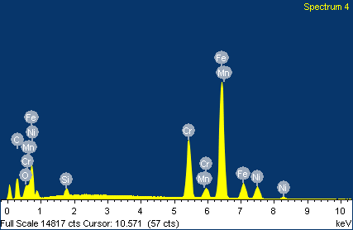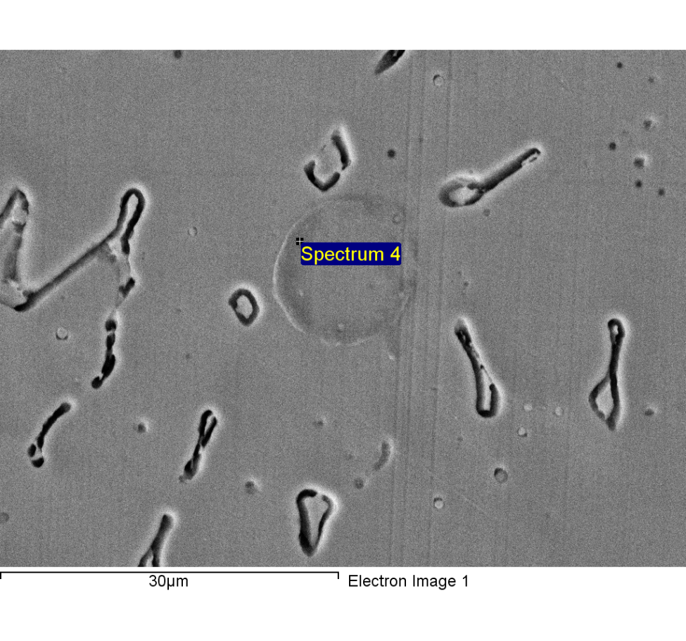

Spectrum processing :

Peak possibly omitted : 11.820 keV

Processing option : All elements analyzed (Normalised)

Number of iterations = 4

Standard :

C CaCO3 1-Jun-1999 12:00 AM

O SiO2 1-Jun-1999 12:00 AM

Si SiO2 1-Jun-1999 12:00 AM

Cr Cr 1-Jun-1999 12:00 AM

Mn Mn 1-Jun-1999 12:00 AM

Fe Fe 1-Jun-1999 12:00 AM

Ni Ni 1-Jun-1999 12:00 AM

|  |  |  |  |
| --- | --- | --- | --- |
| Element | Weight% | Atomic% |  |
|  |  |  |  |
| C K | 19.67 | 50.69 |  |
| O K | 2.78 | 5.38 |  |
| Si K | 0.94 | 1.03 |  |
| Cr K | 15.91 | 9.47 |  |
| Mn K | 1.25 | 0.71 |  |
| Fe K | 51.08 | 28.31 |  |
| Ni K | 8.37 | 4.41 |  |
|  |  |  |  |
| Totals | 100.00 |  |  |

1/24/2018 7:15:34 PM

Project 9

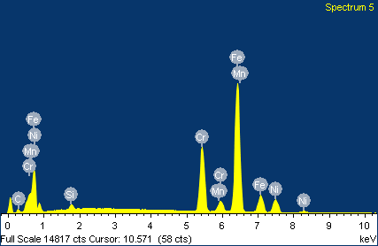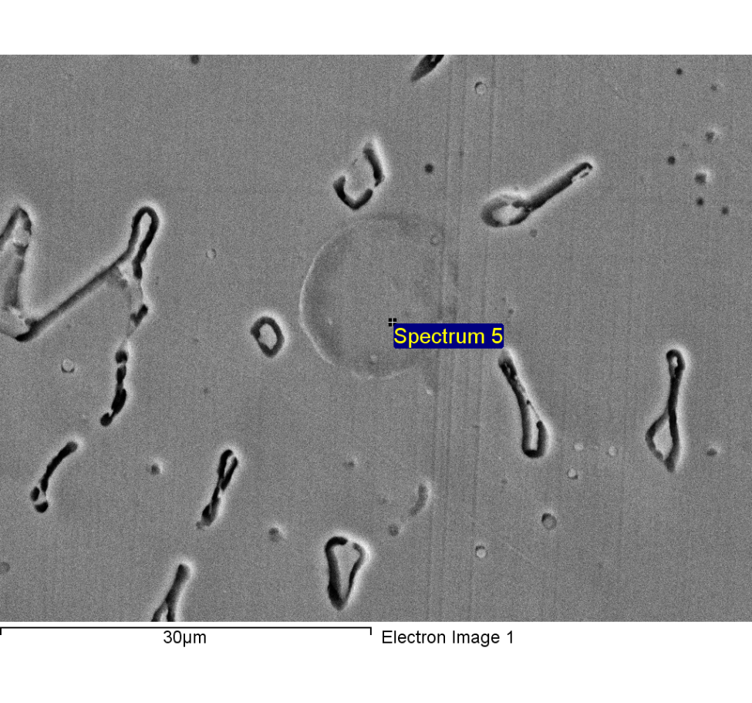

Spectrum processing :

Peaks possibly omitted : 11.820, 12.826 keV

Processing option : All elements analyzed (Normalised)

Number of iterations = 4

Standard :

C CaCO3 1-Jun-1999 12:00 AM

Si SiO2 1-Jun-1999 12:00 AM

Cr Cr 1-Jun-1999 12:00 AM

Mn Mn 1-Jun-1999 12:00 AM

Fe Fe 1-Jun-1999 12:00 AM

Ni Ni 1-Jun-1999 12:00 AM

|  |  |  |  |
| --- | --- | --- | --- |
| Element | Weight% | Atomic% |  |
|  |  |  |  |
| C K | 4.49 | 17.67 |  |
| Si K | 0.79 | 1.33 |  |
| Cr K | 19.55 | 17.77 |  |
| Mn K | 1.26 | 1.08 |  |
| Fe K | 63.41 | 53.69 |  |
| Ni K | 10.51 | 8.46 |  |
|  |  |  |  |
| Totals | 100.00 |  |  |

1/24/2018 7:15:44 PM

Project 9

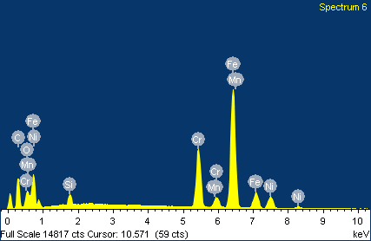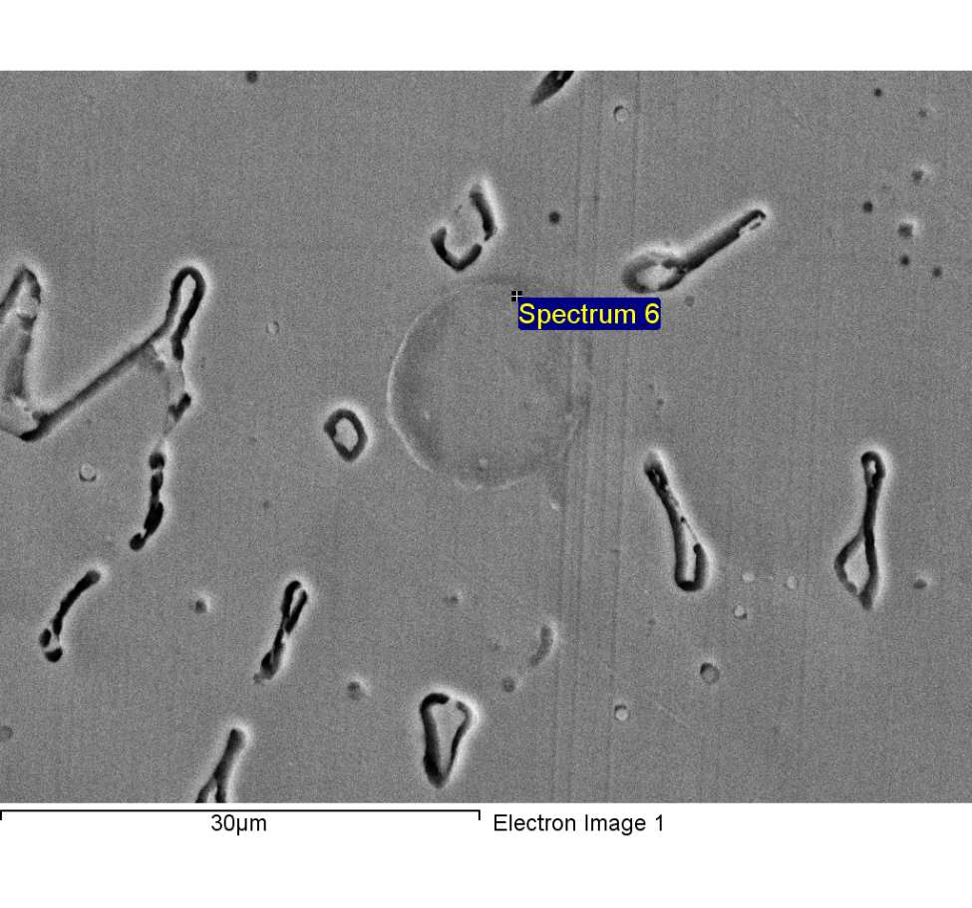

Spectrum processing :

Peaks possibly omitted : 2.340, 11.800, 12.799 keV

Processing option : All elements analyzed (Normalised)

Number of iterations = 5

Standard :

C CaCO3 1-Jun-1999 12:00 AM

O SiO2 1-Jun-1999 12:00 AM

Si SiO2 1-Jun-1999 12:00 AM

Cr Cr 1-Jun-1999 12:00 AM

Mn Mn 1-Jun-1999 12:00 AM

Fe Fe 1-Jun-1999 12:00 AM

Ni Ni 1-Jun-1999 12:00 AM

|  |  |  |  |
| --- | --- | --- | --- |
| Element | Weight% | Atomic% |  |
|  |  |  |  |
| C K | 24.44 | 56.25 |  |
| O K | 4.37 | 7.54 |  |
| Si K | 1.23 | 1.21 |  |
| Cr K | 14.56 | 7.74 |  |
| Mn K | 1.24 | 0.63 |  |
| Fe K | 46.66 | 23.10 |  |
| Ni K | 7.50 | 3.53 |  |
|  |  |  |  |
| Totals | 100.00 |  |  |

1/24/2018 7:16:14 PM

Project 9

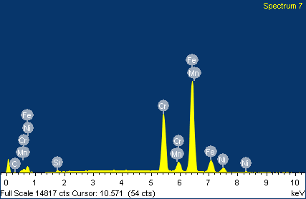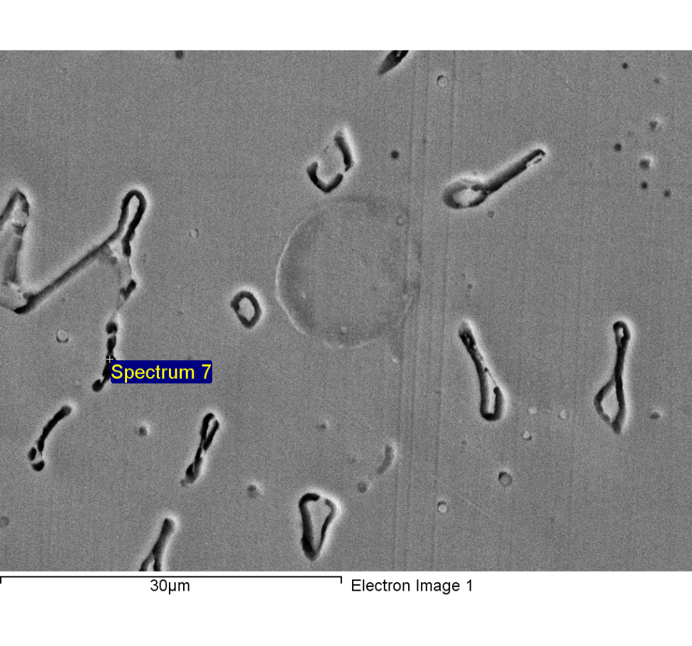

Spectrum processing :

Peak possibly omitted : 11.819 keV

Processing option : All elements analyzed (Normalised)

Number of iterations = 3

Standard :

C CaCO3 1-Jun-1999 12:00 AM

Si SiO2 1-Jun-1999 12:00 AM

Cr Cr 1-Jun-1999 12:00 AM

Mn Mn 1-Jun-1999 12:00 AM

Fe Fe 1-Jun-1999 12:00 AM

Ni Ni 1-Jun-1999 12:00 AM

|  |  |  |  |
| --- | --- | --- | --- |
| Element | Weight% | Atomic% |  |
|  |  |  |  |
| C K | 1.31 | 5.71 |  |
| Si K | 0.34 | 0.63 |  |
| Cr K | 25.87 | 26.02 |  |
| Mn K | 1.65 | 1.57 |  |
| Fe K | 65.55 | 61.37 |  |
| Ni K | 5.28 | 4.71 |  |
|  |  |  |  |
| Totals | 100.00 |  |  |

1/24/2018 7:16:24 PM

Project 9

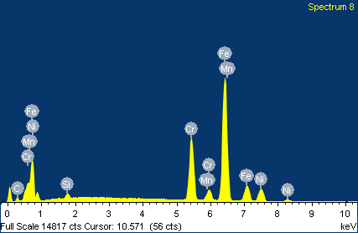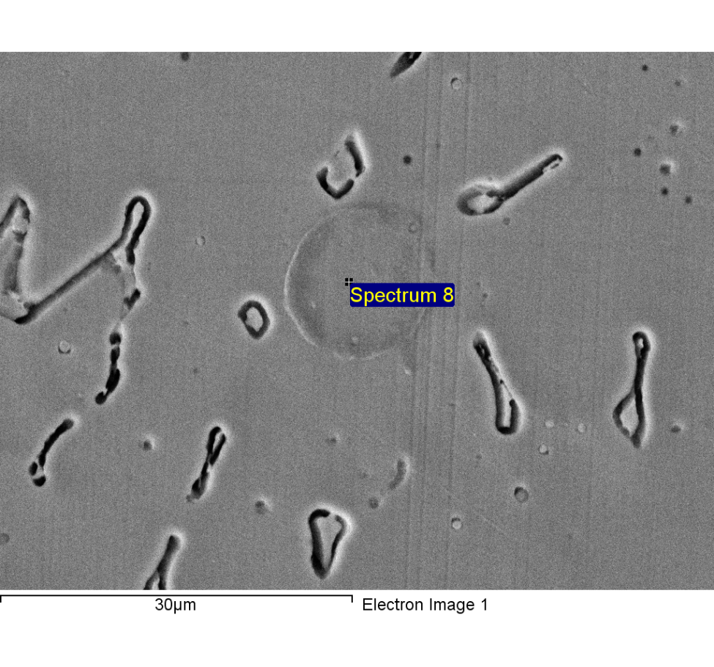

Spectrum processing :

Peaks possibly omitted : 11.803, 12.780 keV

Processing option : All elements analyzed (Normalised)

Number of iterations = 4

Standard :

C CaCO3 1-Jun-1999 12:00 AM

Si SiO2 1-Jun-1999 12:00 AM

Cr Cr 1-Jun-1999 12:00 AM

Mn Mn 1-Jun-1999 12:00 AM

Fe Fe 1-Jun-1999 12:00 AM

Ni Ni 1-Jun-1999 12:00 AM

|  |  |  |  |
| --- | --- | --- | --- |
| Element | Weight% | Atomic% |  |
|  |  |  |  |
| C K | 4.31 | 17.05 |  |
| Si K | 0.85 | 1.43 |  |
| Cr K | 19.57 | 17.89 |  |
| Mn K | 1.59 | 1.37 |  |
| Fe K | 63.15 | 53.73 |  |
| Ni K | 10.53 | 8.53 |  |
|  |  |  |  |
| Totals | 100.00 |  |  |

1/24/2018 7:16:36 PM

Project 9

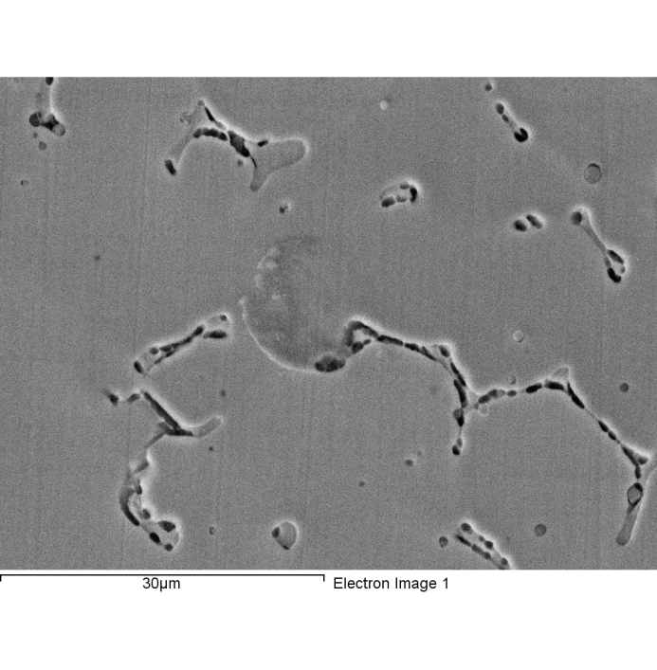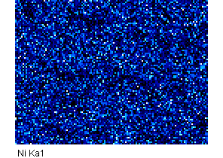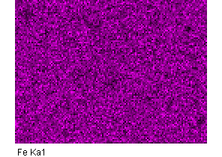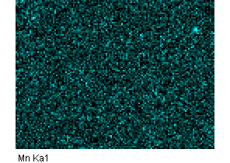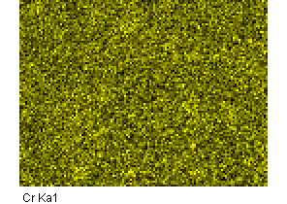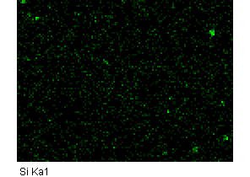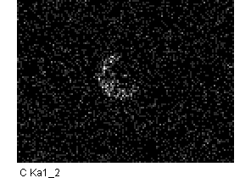

Comment:2-7

1/24/2018 7:18:43 PM

Project 9

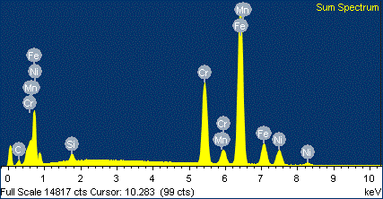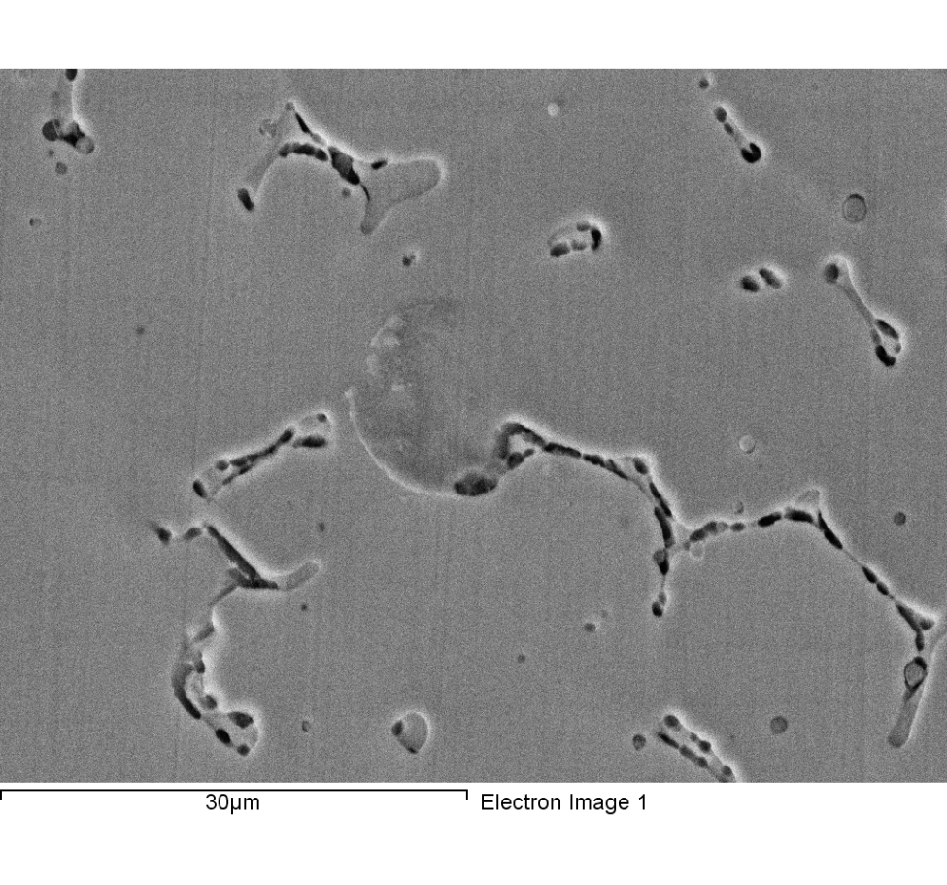

Spectrum processing :

Peaks possibly omitted : 11.824, 12.799, 13.459 keV

Processing option : All elements analyzed (Normalised)

Number of iterations = 3

Standard :

C CaCO3 1-Jun-1999 12:00 AM

Si SiO2 1-Jun-1999 12:00 AM

Cr Cr 1-Jun-1999 12:00 AM

Mn Mn 1-Jun-1999 12:00 AM

Fe Fe 1-Jun-1999 12:00 AM

Ni Ni 1-Jun-1999 12:00 AM

|  |  |  |  |
| --- | --- | --- | --- |
| Element | Weight% | Atomic% |  |
|  |  |  |  |
| C K | 4.52 | 17.73 |  |
| Si K | 0.89 | 1.49 |  |
| Cr K | 20.30 | 18.41 |  |
| Mn K | 1.59 | 1.37 |  |
| Fe K | 63.32 | 53.47 |  |
| Ni K | 9.38 | 7.54 |  |
|  |  |  |  |
| Totals | 100.00 |  |  |

Comment:2-7

1/24/2018 7:18:56 PM

Project 9

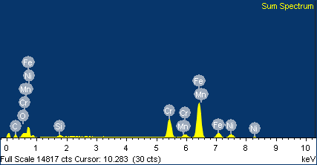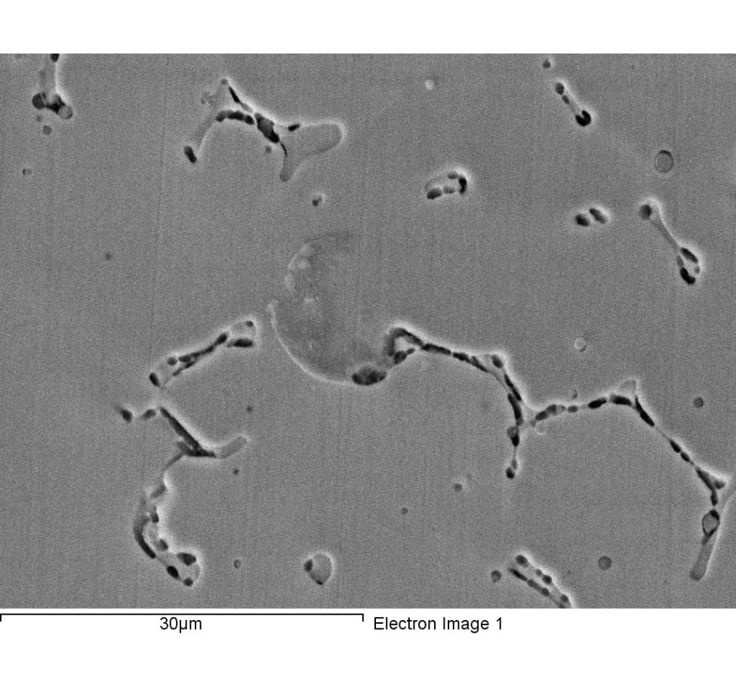

Spectrum processing :

Peak possibly omitted : 12.815 keV

Processing option : All elements analyzed (Normalised)

Number of iterations = 3

Standard :

C CaCO3 1-Jun-1999 12:00 AM

O SiO2 1-Jun-1999 12:00 AM

Si SiO2 1-Jun-1999 12:00 AM

Cr Cr 1-Jun-1999 12:00 AM

Mn Mn 1-Jun-1999 12:00 AM

Fe Fe 1-Jun-1999 12:00 AM

Ni Ni 1-Jun-1999 12:00 AM

|  |  |  |  |
| --- | --- | --- | --- |
| Element | Weight% | Atomic% |  |
|  |  |  |  |
| C K | 11.20 | 35.31 |  |
| O K | 1.88 | 4.46 |  |
| Si K | 0.95 | 1.29 |  |
| Cr K | 18.62 | 13.56 |  |
| Mn K | 1.28 | 0.88 |  |
| Fe K | 57.52 | 38.99 |  |
| Ni K | 8.55 | 5.51 |  |
|  |  |  |  |
| Totals | 100.00 |  |  |

Comment:

1/24/2018 7:20:25 PM

Project 9

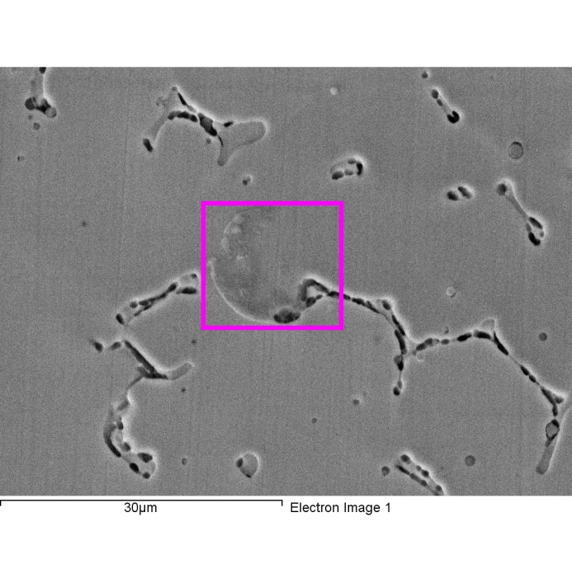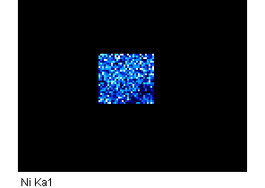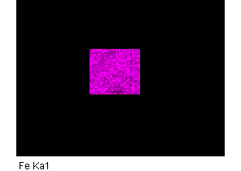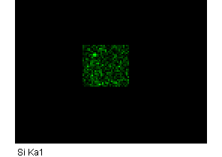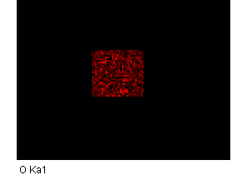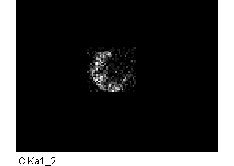

Comment:

1/24/2018 7:20:38 PM

Project 9

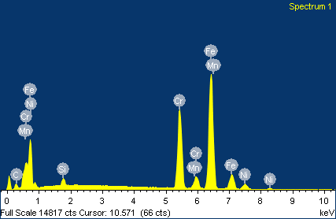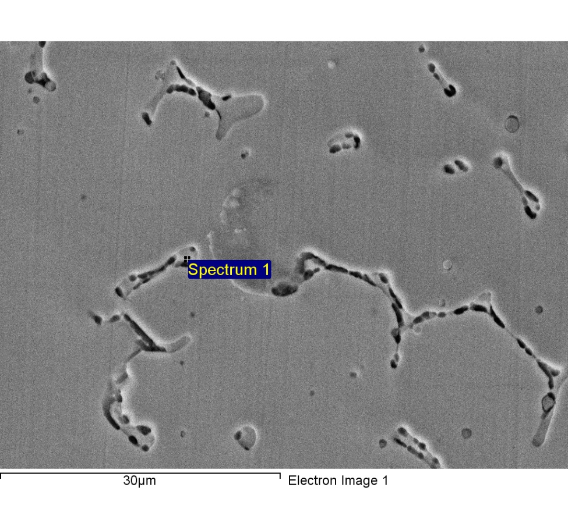

Spectrum processing :

Peaks possibly omitted : 11.825, 12.828, 14.890 keV

Processing option : All elements analyzed (Normalised)

Number of iterations = 4

Standard :

C CaCO3 1-Jun-1999 12:00 AM

Si SiO2 1-Jun-1999 12:00 AM

Cr Cr 1-Jun-1999 12:00 AM

Mn Mn 1-Jun-1999 12:00 AM

Fe Fe 1-Jun-1999 12:00 AM

Ni Ni 1-Jun-1999 12:00 AM

|  |  |  |  |
| --- | --- | --- | --- |
| Element | Weight% | Atomic% |  |
|  |  |  |  |
| C K | 6.39 | 23.55 |  |
| Si K | 1.20 | 1.89 |  |
| Cr K | 26.17 | 22.26 |  |
| Mn K | 1.24 | 1.00 |  |
| Fe K | 60.64 | 48.03 |  |
| Ni K | 4.35 | 3.28 |  |
|  |  |  |  |
| Totals | 100.00 |  |  |

1/24/2018 7:23:26 PM

Project 9

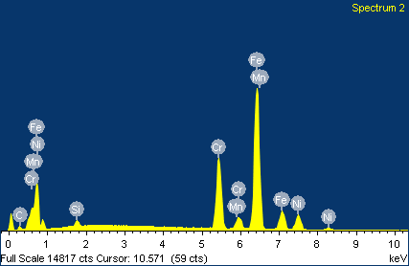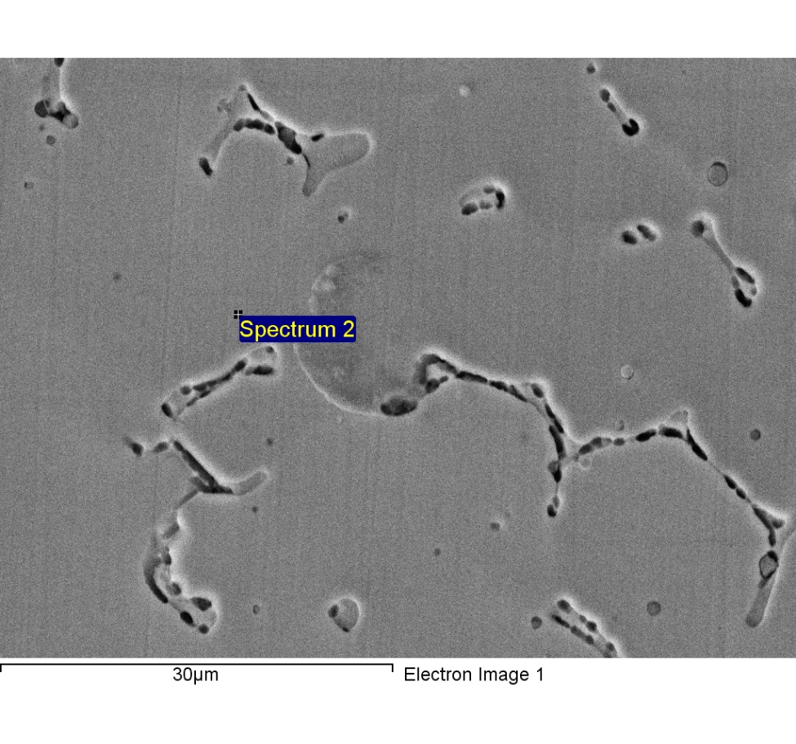

Spectrum processing :

Peaks possibly omitted : 11.340, 11.792, 12.832 keV

Processing option : All elements analyzed (Normalised)

Number of iterations = 4

Standard :

C CaCO3 1-Jun-1999 12:00 AM

Si SiO2 1-Jun-1999 12:00 AM

Cr Cr 1-Jun-1999 12:00 AM

Mn Mn 1-Jun-1999 12:00 AM

Fe Fe 1-Jun-1999 12:00 AM

Ni Ni 1-Jun-1999 12:00 AM

|  |  |  |  |
| --- | --- | --- | --- |
| Element | Weight% | Atomic% |  |
|  |  |  |  |
| C K | 4.39 | 17.33 |  |
| Si K | 0.82 | 1.39 |  |
| Cr K | 19.58 | 17.85 |  |
| Mn K | 1.37 | 1.18 |  |
| Fe K | 63.55 | 53.94 |  |
| Ni K | 10.29 | 8.31 |  |
|  |  |  |  |
| Totals | 100.00 |  |  |

1/24/2018 7:24:44 PM

Project 9

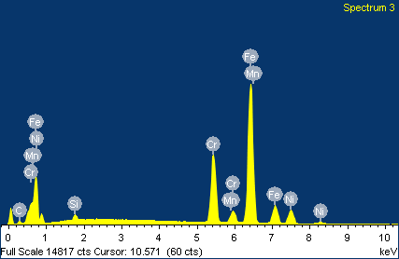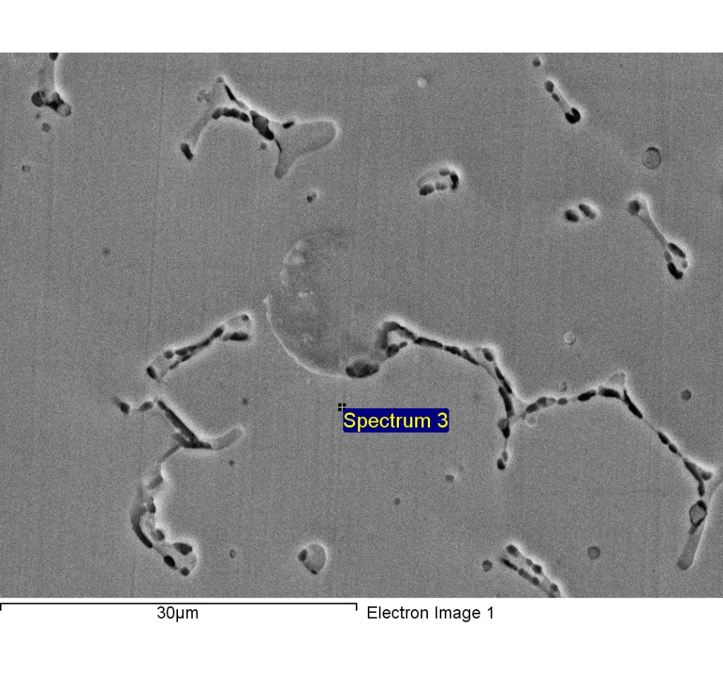

Spectrum processing :

Peaks possibly omitted : 11.842, 12.823, 14.600 keV

Processing option : All elements analyzed (Normalised)

Number of iterations = 4

Standard :

C CaCO3 1-Jun-1999 12:00 AM

Si SiO2 1-Jun-1999 12:00 AM

Cr Cr 1-Jun-1999 12:00 AM

Mn Mn 1-Jun-1999 12:00 AM

Fe Fe 1-Jun-1999 12:00 AM

Ni Ni 1-Jun-1999 12:00 AM

|  |  |  |  |
| --- | --- | --- | --- |
| Element | Weight% | Atomic% |  |
|  |  |  |  |
| C K | 3.85 | 15.45 |  |
| Si K | 0.88 | 1.51 |  |
| Cr K | 19.63 | 18.19 |  |
| Mn K | 1.47 | 1.29 |  |
| Fe K | 63.94 | 55.16 |  |
| Ni K | 10.23 | 8.39 |  |
|  |  |  |  |
| Totals | 100.00 |  |  |

1/24/2018 7:24:55 PM

Project 9

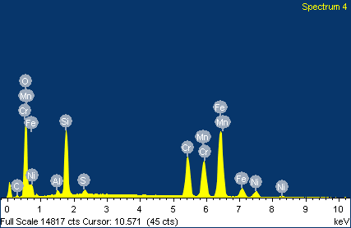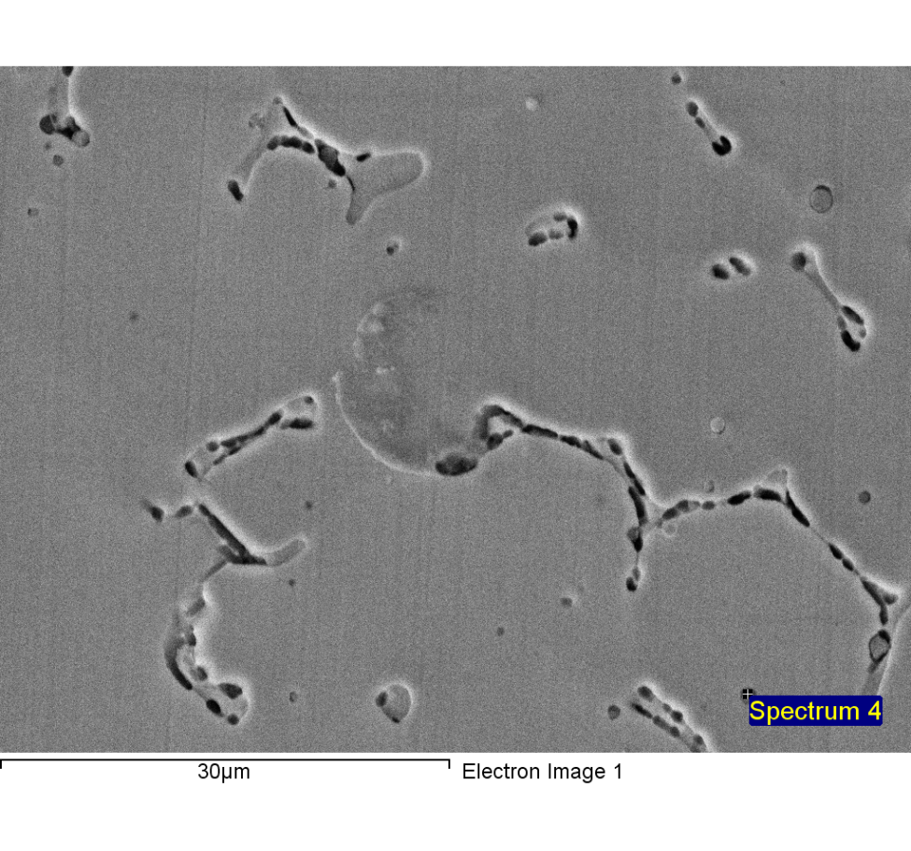

Spectrum processing :

No peaks omitted

Processing option : All elements analyzed (Normalised)

Number of iterations = 5

Standard :

C CaCO3 1-Jun-1999 12:00 AM

O SiO2 1-Jun-1999 12:00 AM

Al Al2O3 1-Jun-1999 12:00 AM

Si SiO2 1-Jun-1999 12:00 AM

S FeS2 1-Jun-1999 12:00 AM

Cr Cr 1-Jun-1999 12:00 AM

Mn Mn 1-Jun-1999 12:00 AM

Fe Fe 1-Jun-1999 12:00 AM

Ni Ni 1-Jun-1999 12:00 AM

|  |  |  |  |
| --- | --- | --- | --- |
| Element | Weight% | Atomic% |  |
|  |  |  |  |
| C K | 2.96 | 7.81 |  |
| O K | 21.68 | 42.91 |  |
| Al K | 0.74 | 0.86 |  |
| Si K | 9.44 | 10.65 |  |
| S K | 0.62 | 0.61 |  |
| Cr K | 13.11 | 7.99 |  |
| Mn K | 13.79 | 7.95 |  |
| Fe K | 32.97 | 18.69 |  |
| Ni K | 4.68 | 2.53 |  |
|  |  |  |  |
| Totals | 100.00 |  |  |

1/24/2018 7:25:06 PM

Project 9

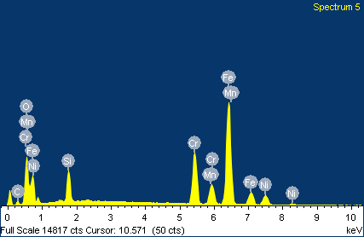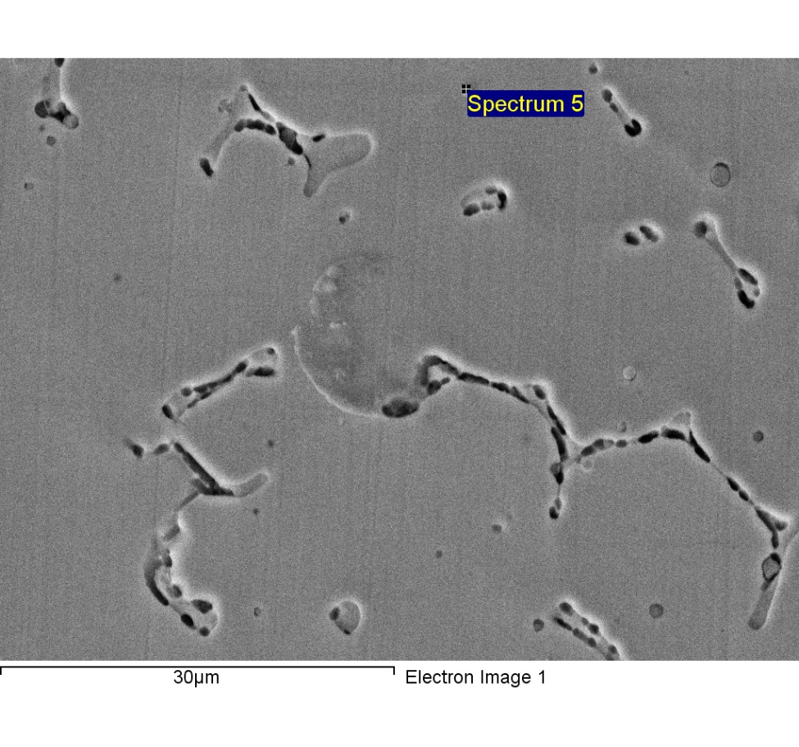

Spectrum processing :

Peaks possibly omitted : 2.320, 4.660, 12.819 keV

Processing option : All elements analyzed (Normalised)

Number of iterations = 5

Standard :

C CaCO3 1-Jun-1999 12:00 AM

O SiO2 1-Jun-1999 12:00 AM

Si SiO2 1-Jun-1999 12:00 AM

Cr Cr 1-Jun-1999 12:00 AM

Mn Mn 1-Jun-1999 12:00 AM

Fe Fe 1-Jun-1999 12:00 AM

Ni Ni 1-Jun-1999 12:00 AM

|  |  |  |  |
| --- | --- | --- | --- |
| Element | Weight% | Atomic% |  |
|  |  |  |  |
| C K | 4.84 | 14.73 |  |
| O K | 11.89 | 27.14 |  |
| Si K | 4.75 | 6.17 |  |
| Cr K | 15.85 | 11.14 |  |
| Mn K | 6.26 | 4.16 |  |
| Fe K | 48.96 | 32.02 |  |
| Ni K | 7.46 | 4.64 |  |
|  |  |  |  |
| Totals | 100.00 |  |  |

1/24/2018 7:25:16 PM

Project 9

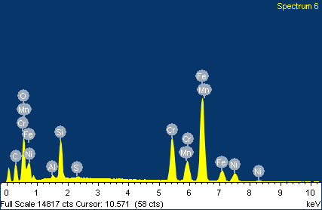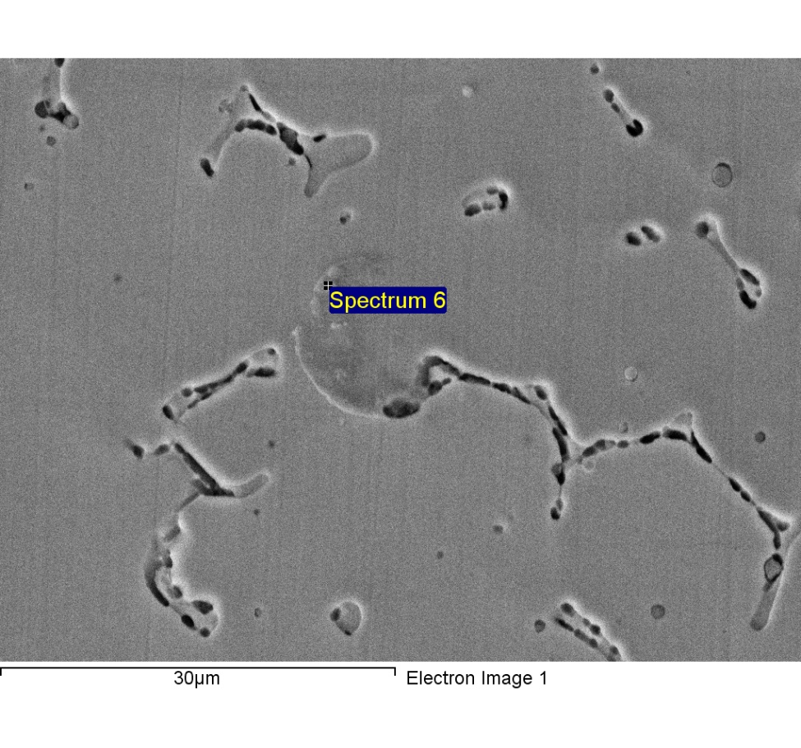

Spectrum processing :

Peak possibly omitted : 11.830 keV

Processing option : All elements analyzed (Normalised)

Number of iterations = 6

Standard :

C CaCO3 1-Jun-1999 12:00 AM

O SiO2 1-Jun-1999 12:00 AM

Al Al2O3 1-Jun-1999 12:00 AM

Si SiO2 1-Jun-1999 12:00 AM

S FeS2 1-Jun-1999 12:00 AM

Cr Cr 1-Jun-1999 12:00 AM

Mn Mn 1-Jun-1999 12:00 AM

Fe Fe 1-Jun-1999 12:00 AM

Ni Ni 1-Jun-1999 12:00 AM

|  |  |  |  |
| --- | --- | --- | --- |
| Element | Weight% | Atomic% |  |
|  |  |  |  |
| C K | 17.62 | 39.82 |  |
| O K | 14.13 | 23.97 |  |
| Al K | 0.47 | 0.47 |  |
| Si K | 4.87 | 4.71 |  |
| S K | 0.24 | 0.20 |  |
| Cr K | 12.62 | 6.59 |  |
| Mn K | 6.16 | 3.04 |  |
| Fe K | 37.83 | 18.39 |  |
| Ni K | 6.07 | 2.81 |  |
|  |  |  |  |
| Totals | 100.00 |  |  |

1/24/2018 7:25:27 PM

Project 9

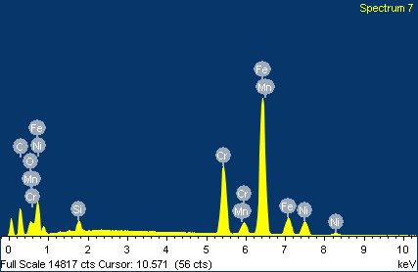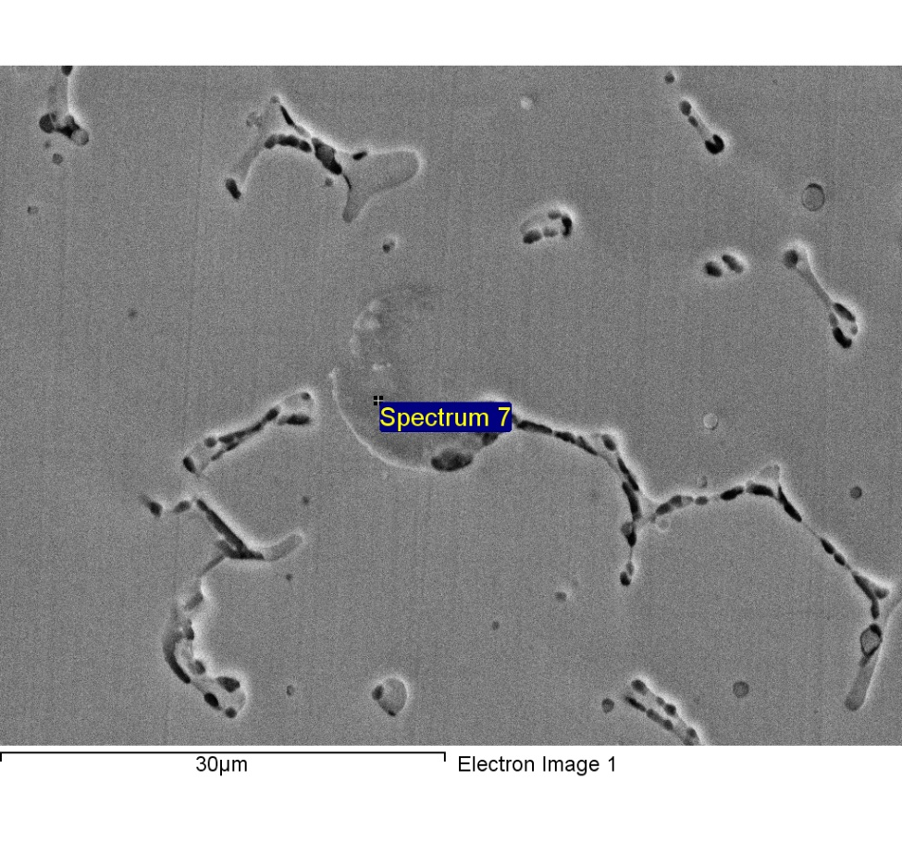

Spectrum processing :

Peaks possibly omitted : 1.260, 11.811, 12.830 keV

Processing option : All elements analyzed (Normalised)

Number of iterations = 5

Standard :

C CaCO3 1-Jun-1999 12:00 AM

O SiO2 1-Jun-1999 12:00 AM

Si SiO2 1-Jun-1999 12:00 AM

Cr Cr 1-Jun-1999 12:00 AM

Mn Mn 1-Jun-1999 12:00 AM

Fe Fe 1-Jun-1999 12:00 AM

Ni Ni 1-Jun-1999 12:00 AM

|  |  |  |  |
| --- | --- | --- | --- |
| Element | Weight% | Atomic% |  |
|  |  |  |  |
| C K | 20.65 | 51.94 |  |
| O K | 3.04 | 5.74 |  |
| Si K | 1.17 | 1.25 |  |
| Cr K | 15.57 | 9.05 |  |
| Mn K | 1.29 | 0.71 |  |
| Fe K | 50.26 | 27.19 |  |
| Ni K | 8.03 | 4.13 |  |
|  |  |  |  |
| Totals | 100.00 |  |  |

1/24/2018 7:26:07 PM

Project 9

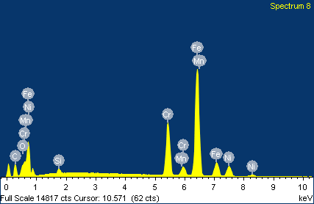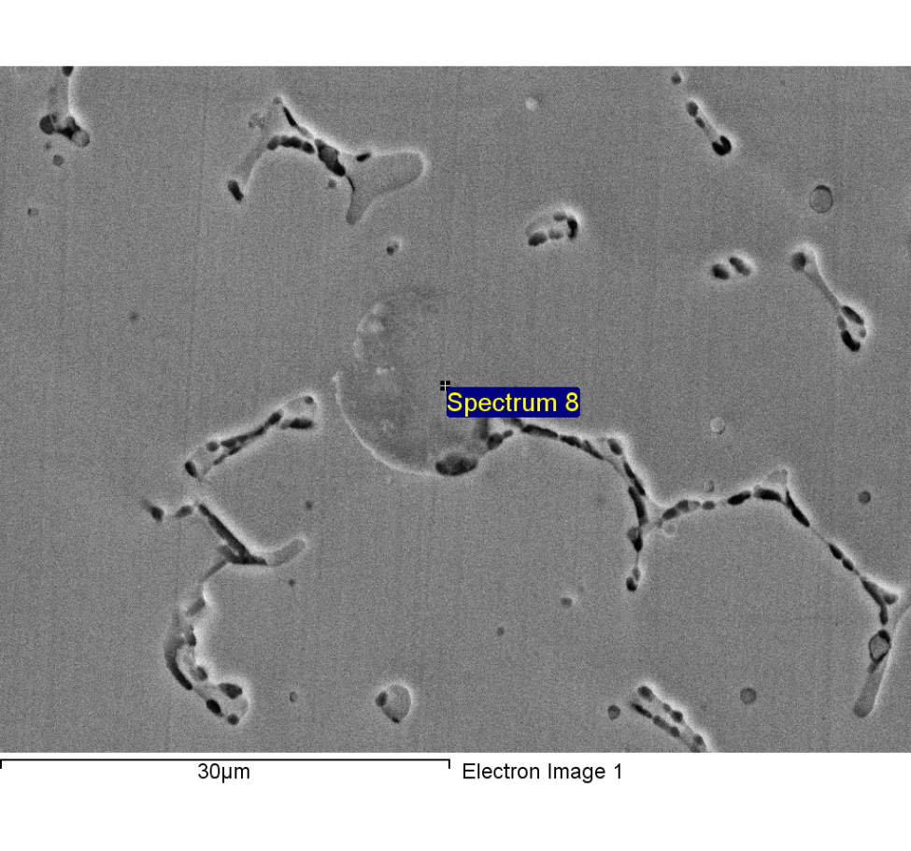

Spectrum processing :

Peak possibly omitted : 12.811 keV

Processing option : All elements analyzed (Normalised)

Number of iterations = 4

Standard :

C CaCO3 1-Jun-1999 12:00 AM

O SiO2 1-Jun-1999 12:00 AM

Si SiO2 1-Jun-1999 12:00 AM

Cr Cr 1-Jun-1999 12:00 AM

Mn Mn 1-Jun-1999 12:00 AM

Fe Fe 1-Jun-1999 12:00 AM

Ni Ni 1-Jun-1999 12:00 AM

|  |  |  |  |
| --- | --- | --- | --- |
| Element | Weight% | Atomic% |  |
|  |  |  |  |
| C K | 14.09 | 41.37 |  |
| O K | 2.14 | 4.71 |  |
| Si K | 0.78 | 0.97 |  |
| Cr K | 17.04 | 11.56 |  |
| Mn K | 1.41 | 0.90 |  |
| Fe K | 55.82 | 35.25 |  |
| Ni K | 8.73 | 5.24 |  |
|  |  |  |  |
| Totals | 100.00 |  |  |

1/24/2018 7:26:23 PM

Project 9

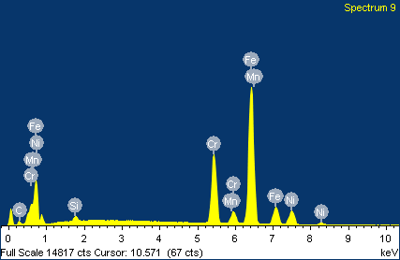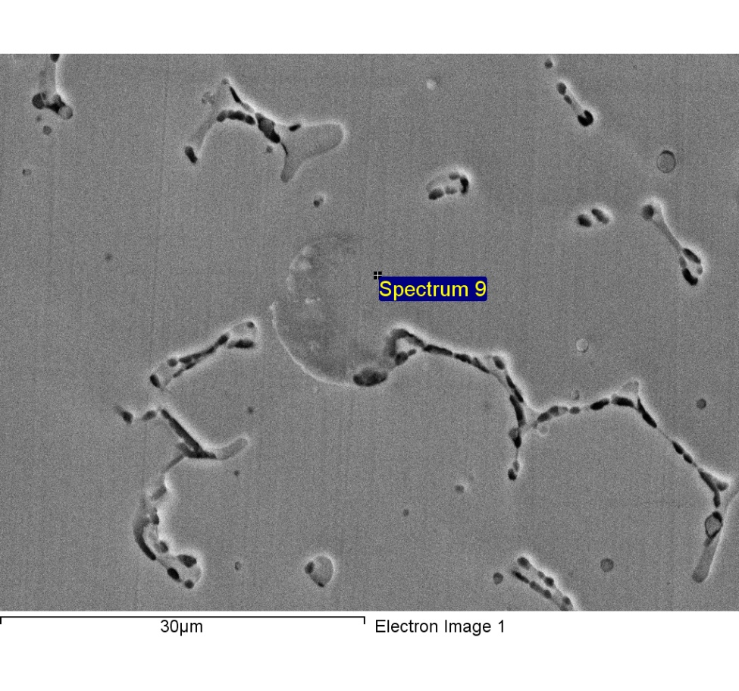

Spectrum processing :

Peak possibly omitted : 12.801 keV

Processing option : All elements analyzed (Normalised)

Number of iterations = 4

Standard :

C CaCO3 1-Jun-1999 12:00 AM

Si SiO2 1-Jun-1999 12:00 AM

Cr Cr 1-Jun-1999 12:00 AM

Mn Mn 1-Jun-1999 12:00 AM

Fe Fe 1-Jun-1999 12:00 AM

Ni Ni 1-Jun-1999 12:00 AM

|  |  |  |  |
| --- | --- | --- | --- |
| Element | Weight% | Atomic% |  |
|  |  |  |  |
| C K | 4.61 | 18.07 |  |
| Si K | 0.75 | 1.26 |  |
| Cr K | 19.76 | 17.90 |  |
| Mn K | 1.59 | 1.36 |  |
| Fe K | 62.90 | 53.06 |  |
| Ni K | 10.40 | 8.35 |  |
|  |  |  |  |
| Totals | 100.00 |  |  |

1/24/2018 7:26:34 PM

Project 9

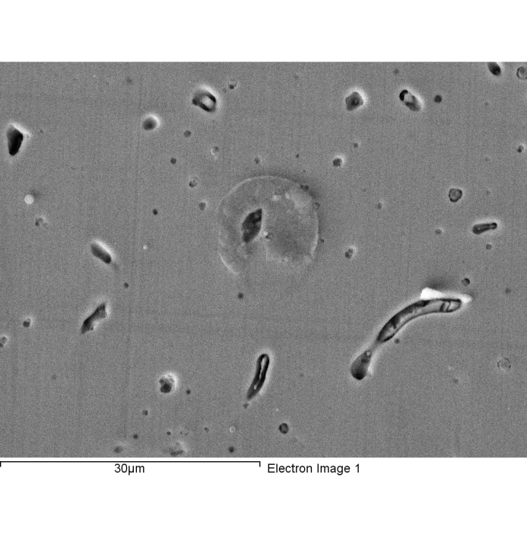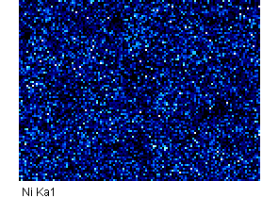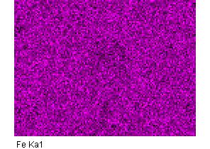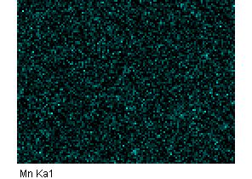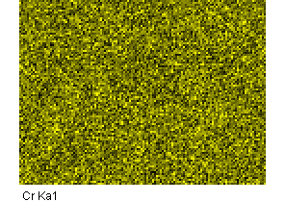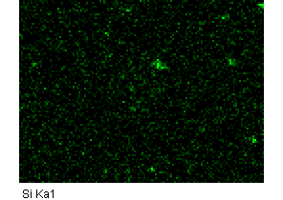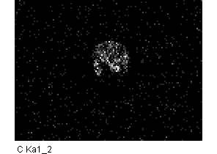

Comment:2-9

1/24/2018 7:29:16 PM

Project 9

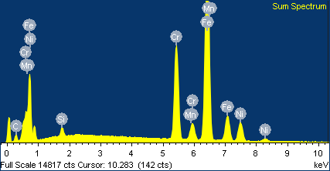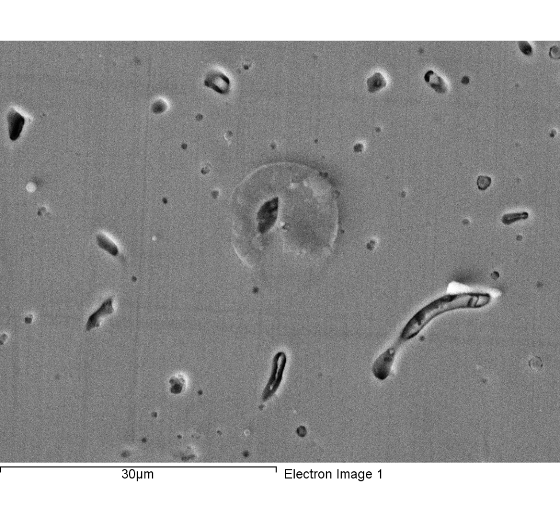

Spectrum processing :

Peaks possibly omitted : 3.655, 11.820, 12.794 keV

Processing option : All elements analyzed (Normalised)

Number of iterations = 3

Standard :

C CaCO3 1-Jun-1999 12:00 AM

Si SiO2 1-Jun-1999 12:00 AM

Cr Cr 1-Jun-1999 12:00 AM

Mn Mn 1-Jun-1999 12:00 AM

Fe Fe 1-Jun-1999 12:00 AM

Ni Ni 1-Jun-1999 12:00 AM

|  |  |  |  |
| --- | --- | --- | --- |
| Element | Weight% | Atomic% |  |
|  |  |  |  |
| C K | 5.44 | 20.76 |  |
| Si K | 0.92 | 1.50 |  |
| Cr K | 19.30 | 17.03 |  |
| Mn K | 1.55 | 1.29 |  |
| Fe K | 63.14 | 51.87 |  |
| Ni K | 9.66 | 7.55 |  |
|  |  |  |  |
| Totals | 100.00 |  |  |

Comment:2-9

1/24/2018 7:29:31 PM

Project 9

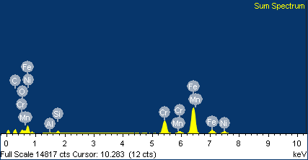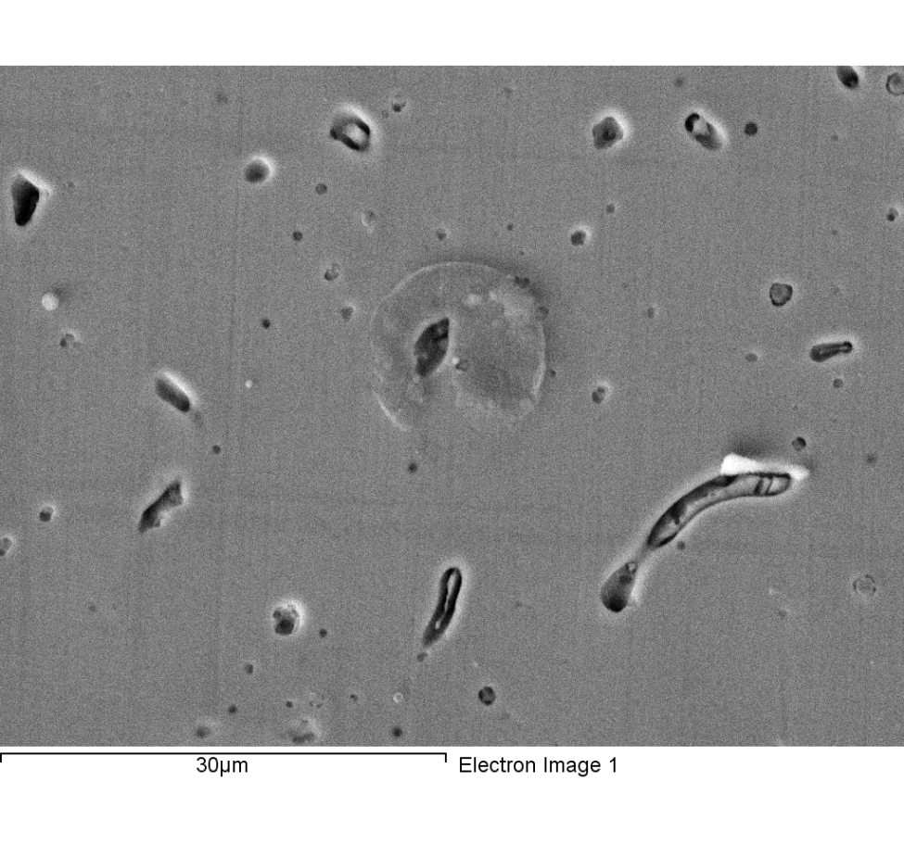

Spectrum processing :

Peaks possibly omitted : 3.685, 12.805 keV

Processing option : All elements analyzed (Normalised)

Number of iterations = 4

Standard :

C CaCO3 1-Jun-1999 12:00 AM

O SiO2 1-Jun-1999 12:00 AM

Al Al2O3 1-Jun-1999 12:00 AM

Si SiO2 1-Jun-1999 12:00 AM

Cr Cr 1-Jun-1999 12:00 AM

Mn Mn 1-Jun-1999 12:00 AM

Fe Fe 1-Jun-1999 12:00 AM

Ni Ni 1-Jun-1999 12:00 AM

|  |  |  |  |
| --- | --- | --- | --- |
| Element | Weight% | Atomic% |  |
|  |  |  |  |
| C K | 18.08 | 46.88 |  |
| O K | 4.34 | 8.46 |  |
| Al K | 0.34 | 0.39 |  |
| Si K | 1.32 | 1.47 |  |
| Cr K | 16.04 | 9.61 |  |
| Mn K | 1.10 | 0.62 |  |
| Fe K | 51.49 | 28.71 |  |
| Ni K | 7.29 | 3.87 |  |
|  |  |  |  |
| Totals | 100.00 |  |  |

Comment:

1/24/2018 7:31:18 PM

Project 9

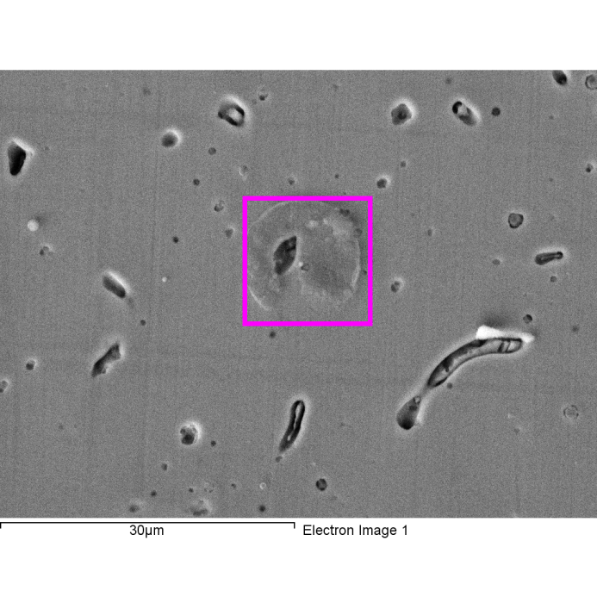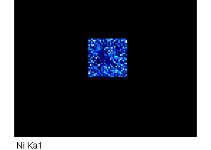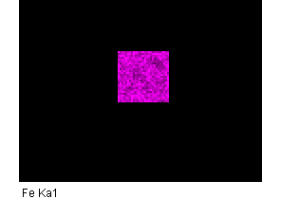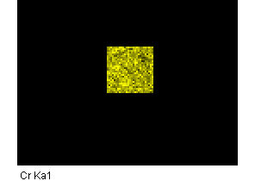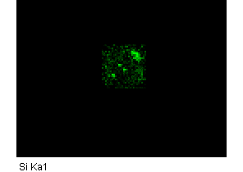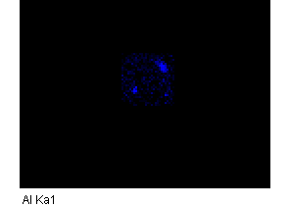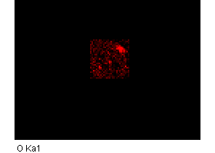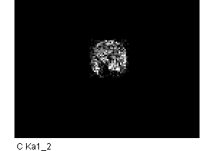

Comment:

1/24/2018 7:31:31 PM

Project 9

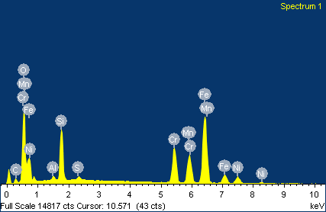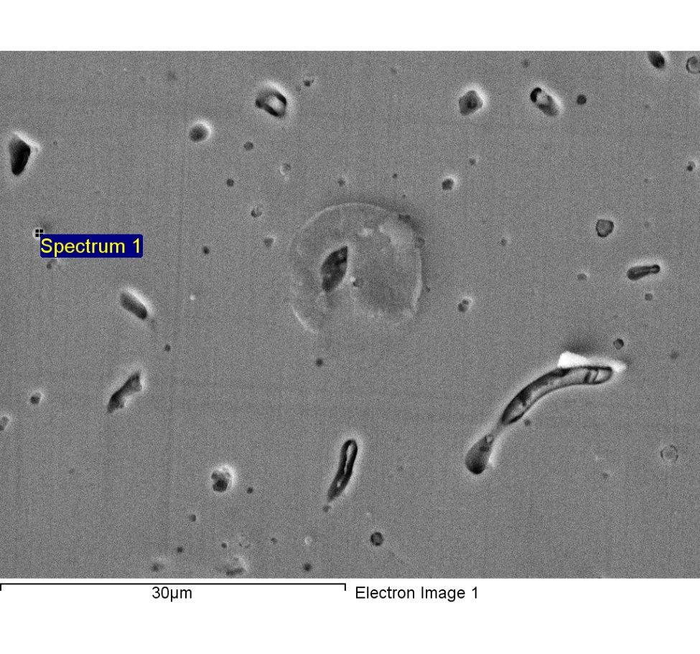

Spectrum processing :

Peak possibly omitted : 11.820 keV

Processing option : All elements analyzed (Normalised)

Number of iterations = 6

Standard :

C CaCO3 1-Jun-1999 12:00 AM

O SiO2 1-Jun-1999 12:00 AM

Al Al2O3 1-Jun-1999 12:00 AM

Si SiO2 1-Jun-1999 12:00 AM

S FeS2 1-Jun-1999 12:00 AM

Cr Cr 1-Jun-1999 12:00 AM

Mn Mn 1-Jun-1999 12:00 AM

Fe Fe 1-Jun-1999 12:00 AM

Ni Ni 1-Jun-1999 12:00 AM

|  |  |  |  |
| --- | --- | --- | --- |
| Element | Weight% | Atomic% |  |
|  |  |  |  |
| C K | 5.99 | 14.94 |  |
| O K | 21.97 | 41.18 |  |
| Al K | 0.64 | 0.72 |  |
| Si K | 7.90 | 8.44 |  |
| S K | 0.50 | 0.47 |  |
| Cr K | 12.06 | 6.95 |  |
| Mn K | 11.04 | 6.03 |  |
| Fe K | 34.58 | 18.57 |  |
| Ni K | 5.31 | 2.71 |  |
|  |  |  |  |
| Totals | 100.00 |  |  |

1/24/2018 7:34:07 PM

Project 9

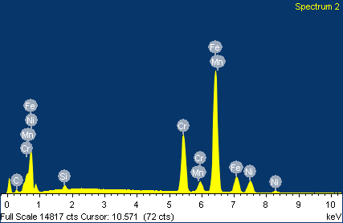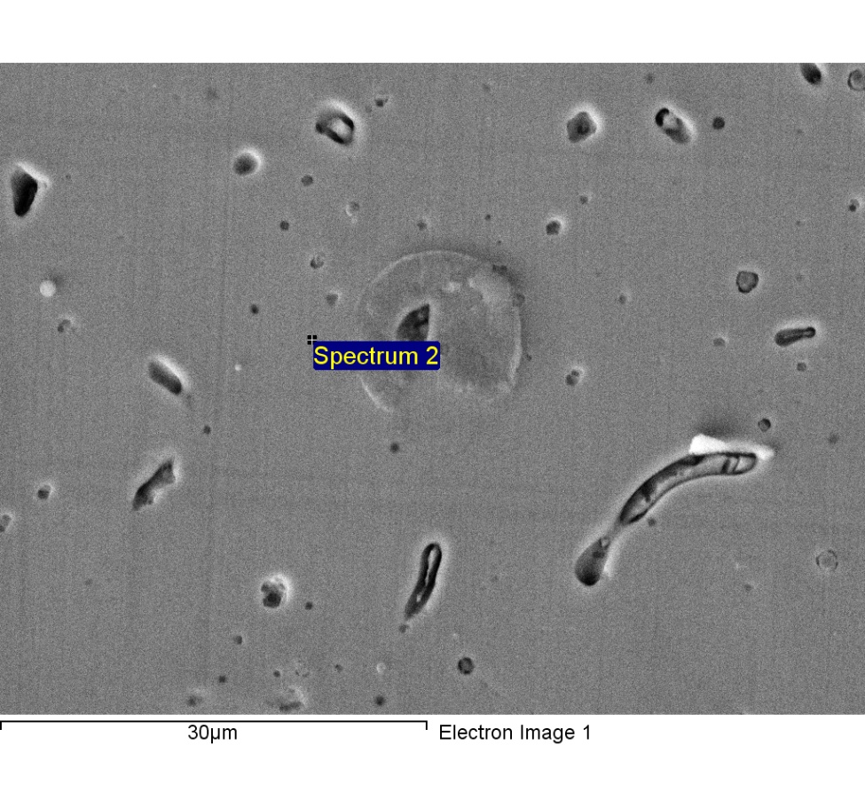

Spectrum processing :

Peaks possibly omitted : 11.828, 12.842 keV

Processing option : All elements analyzed (Normalised)

Number of iterations = 4

Standard :

C CaCO3 1-Jun-1999 12:00 AM

Si SiO2 1-Jun-1999 12:00 AM

Cr Cr 1-Jun-1999 12:00 AM

Mn Mn 1-Jun-1999 12:00 AM

Fe Fe 1-Jun-1999 12:00 AM

Ni Ni 1-Jun-1999 12:00 AM

|  |  |  |  |
| --- | --- | --- | --- |
| Element | Weight% | Atomic% |  |
|  |  |  |  |
| C K | 4.28 | 16.96 |  |
| Si K | 0.72 | 1.22 |  |
| Cr K | 19.00 | 17.40 |  |
| Mn K | 1.37 | 1.18 |  |
| Fe K | 64.51 | 55.02 |  |
| Ni K | 10.12 | 8.21 |  |
|  |  |  |  |
| Totals | 100.00 |  |  |

1/24/2018 7:35:18 PM

Project 9

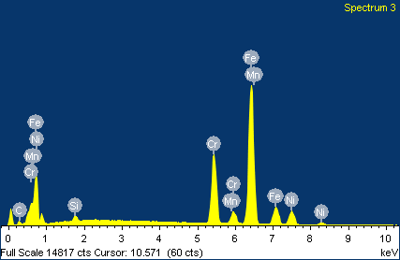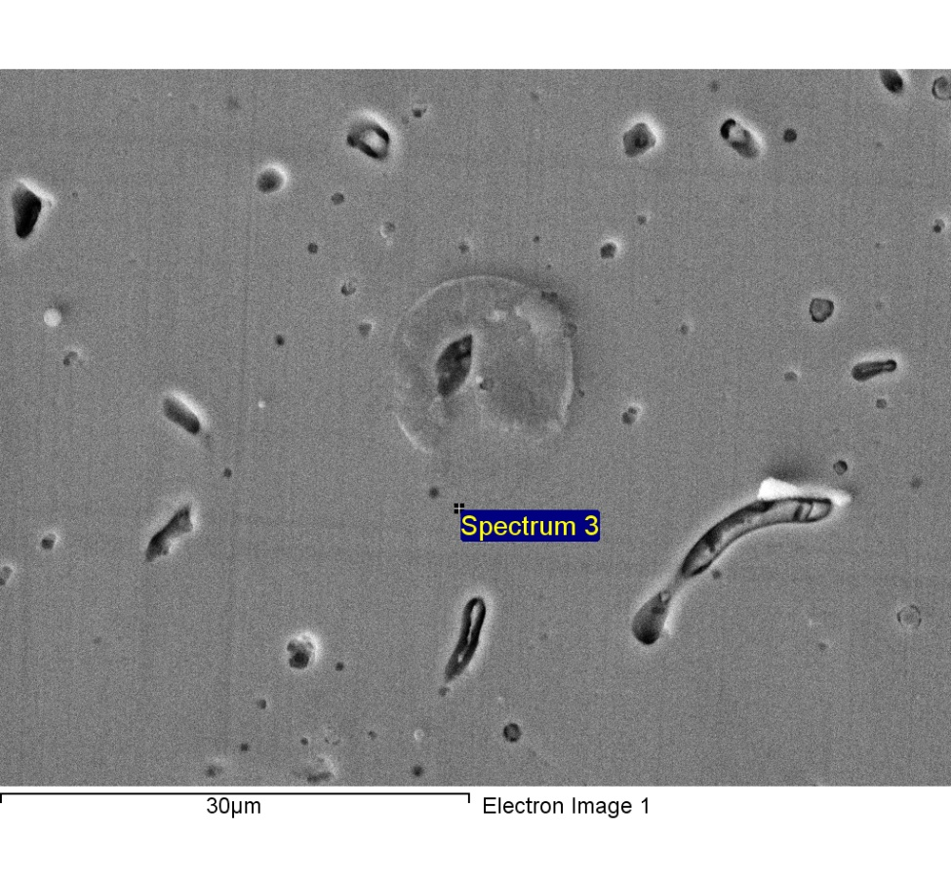

Spectrum processing :

Peak possibly omitted : 12.780 keV

Processing option : All elements analyzed (Normalised)

Number of iterations = 4

Standard :

C CaCO3 1-Jun-1999 12:00 AM

Si SiO2 1-Jun-1999 12:00 AM

Cr Cr 1-Jun-1999 12:00 AM

Mn Mn 1-Jun-1999 12:00 AM

Fe Fe 1-Jun-1999 12:00 AM

Ni Ni 1-Jun-1999 12:00 AM

|  |  |  |  |
| --- | --- | --- | --- |
| Element | Weight% | Atomic% |  |
|  |  |  |  |
| C K | 4.08 | 16.26 |  |
| Si K | 0.80 | 1.37 |  |
| Cr K | 19.59 | 18.04 |  |
| Mn K | 1.63 | 1.42 |  |
| Fe K | 63.68 | 54.59 |  |
| Ni K | 10.22 | 8.33 |  |
|  |  |  |  |
| Totals | 100.00 |  |  |

1/24/2018 7:35:30 PM

Project 9

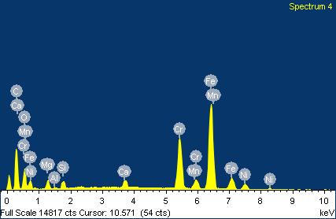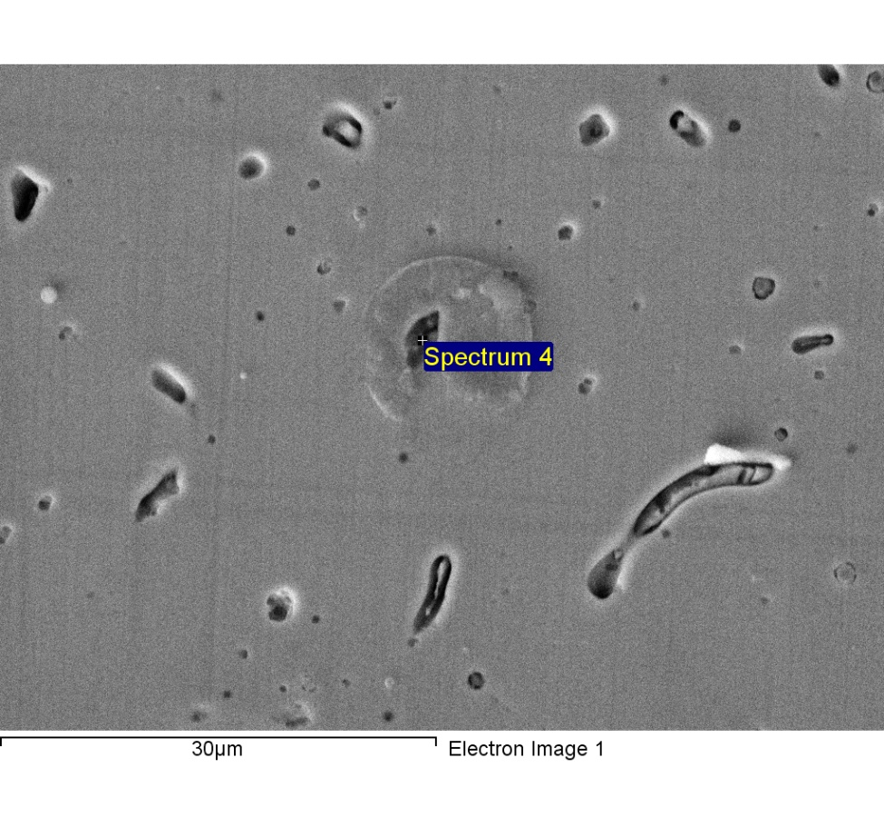

Spectrum processing :

Peaks possibly omitted : 2.302, 11.850 keV

Processing option : All elements analyzed (Normalised)

Number of iterations = 6

Standard :

C CaCO3 1-Jun-1999 12:00 AM

O SiO2 1-Jun-1999 12:00 AM

Mg MgO 1-Jun-1999 12:00 AM

Al Al2O3 1-Jun-1999 12:00 AM

Si SiO2 1-Jun-1999 12:00 AM

Ca Wollastonite 1-Jun-1999 12:00 AM

Cr Cr 1-Jun-1999 12:00 AM

Mn Mn 1-Jun-1999 12:00 AM

Fe Fe 1-Jun-1999 12:00 AM

Ni Ni 1-Jun-1999 12:00 AM

|  |  |  |  |
| --- | --- | --- | --- |
| Element | Weight% | Atomic% |  |
|  |  |  |  |
| C K | 31.34 | 60.70 |  |
| O K | 8.54 | 12.42 |  |
| Mg K | 1.54 | 1.48 |  |
| Al K | 0.18 | 0.16 |  |
| Si K | 0.91 | 0.75 |  |
| Ca K | 1.09 | 0.64 |  |
| Cr K | 14.06 | 6.29 |  |
| Mn K | 1.22 | 0.52 |  |
| Fe K | 37.25 | 15.52 |  |
| Ni K | 3.86 | 1.53 |  |
|  |  |  |  |
| Totals | 100.00 |  |  |

1/24/2018 7:35:42 PM

Project 9

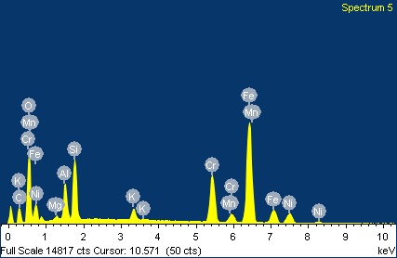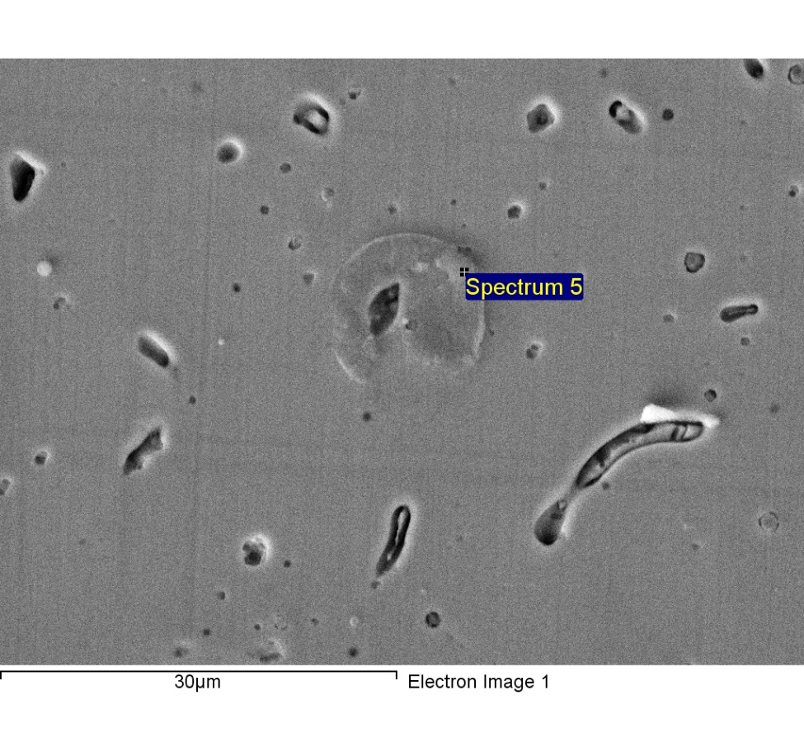

Spectrum processing :

Peak possibly omitted : 12.827 keV

Processing option : All elements analyzed (Normalised)

Number of iterations = 6

Standard :

C CaCO3 1-Jun-1999 12:00 AM

O SiO2 1-Jun-1999 12:00 AM

Mg MgO 1-Jun-1999 12:00 AM

Al Al2O3 1-Jun-1999 12:00 AM

Si SiO2 1-Jun-1999 12:00 AM

K MAD-10 Feldspar 1-Jun-1999 12:00 AM

Cr Cr 1-Jun-1999 12:00 AM

Mn Mn 1-Jun-1999 12:00 AM

Fe Fe 1-Jun-1999 12:00 AM

Ni Ni 1-Jun-1999 12:00 AM

|  |  |  |  |
| --- | --- | --- | --- |
| Element | Weight% | Atomic% |  |
|  |  |  |  |
| C K | 14.12 | 30.86 |  |
| O K | 19.60 | 32.16 |  |
| Mg K | 0.57 | 0.61 |  |
| Al K | 4.00 | 3.89 |  |
| Si K | 6.30 | 5.89 |  |
| K K | 1.30 | 0.88 |  |
| Cr K | 11.11 | 5.61 |  |
| Mn K | 0.82 | 0.39 |  |
| Fe K | 36.85 | 17.32 |  |
| Ni K | 5.33 | 2.39 |  |
|  |  |  |  |
| Totals | 100.00 |  |  |

1/24/2018 7:35:56 PM

Project 9

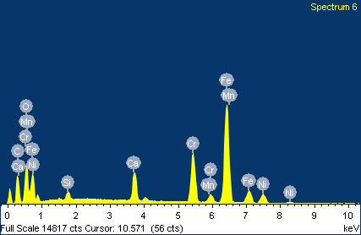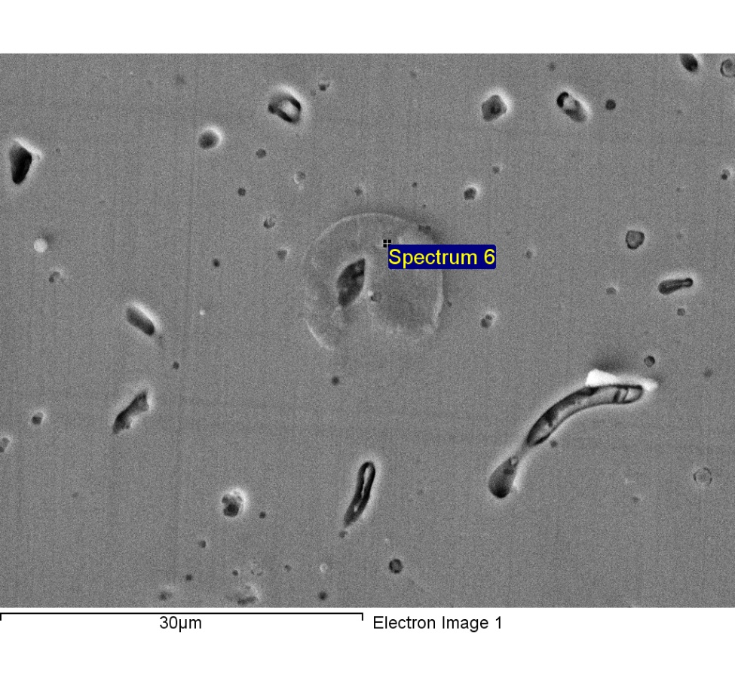

Spectrum processing :

Peak possibly omitted : 12.829 keV

Processing option : All elements analyzed (Normalised)

Number of iterations = 5

Standard :

C CaCO3 1-Jun-1999 12:00 AM

O SiO2 1-Jun-1999 12:00 AM

Si SiO2 1-Jun-1999 12:00 AM

Ca Wollastonite 1-Jun-1999 12:00 AM

Cr Cr 1-Jun-1999 12:00 AM

Mn Mn 1-Jun-1999 12:00 AM

Fe Fe 1-Jun-1999 12:00 AM

Ni Ni 1-Jun-1999 12:00 AM

|  |  |  |  |
| --- | --- | --- | --- |
| Element | Weight% | Atomic% |  |
|  |  |  |  |
| C K | 21.12 | 46.04 |  |
| O K | 13.23 | 21.66 |  |
| Si K | 0.91 | 0.85 |  |
| Ca K | 4.21 | 2.75 |  |
| Cr K | 12.99 | 6.54 |  |
| Mn K | 0.79 | 0.38 |  |
| Fe K | 40.93 | 19.19 |  |
| Ni K | 5.82 | 2.59 |  |
|  |  |  |  |
| Totals | 100.00 |  |  |

1/24/2018 7:36:09 PM

Project 9

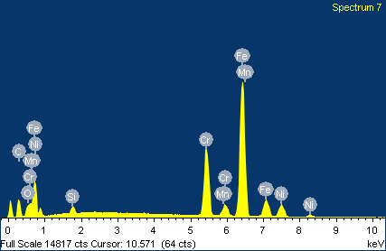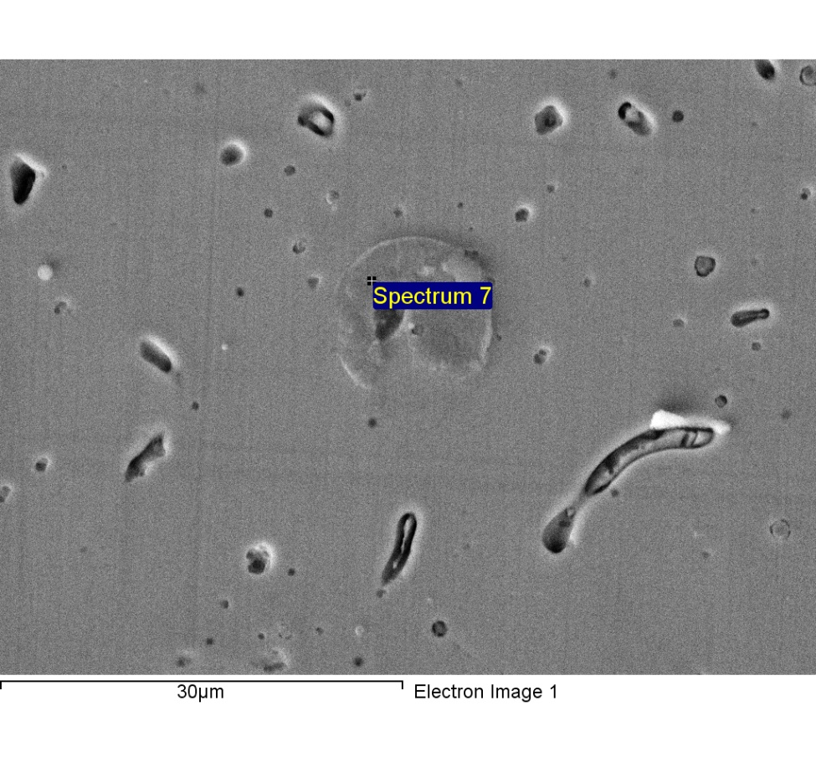

Spectrum processing :

Peaks possibly omitted : 11.843, 12.789 keV

Processing option : All elements analyzed (Normalised)

Number of iterations = 4

Standard :

C CaCO3 1-Jun-1999 12:00 AM

O SiO2 1-Jun-1999 12:00 AM

Si SiO2 1-Jun-1999 12:00 AM

Cr Cr 1-Jun-1999 12:00 AM

Mn Mn 1-Jun-1999 12:00 AM

Fe Fe 1-Jun-1999 12:00 AM

Ni Ni 1-Jun-1999 12:00 AM

|  |  |  |  |
| --- | --- | --- | --- |
| Element | Weight% | Atomic% |  |
|  |  |  |  |
| C K | 16.02 | 44.96 |  |
| O K | 2.18 | 4.60 |  |
| Si K | 0.87 | 1.05 |  |
| Cr K | 17.03 | 11.04 |  |
| Mn K | 1.37 | 0.84 |  |
| Fe K | 54.64 | 32.98 |  |
| Ni K | 7.89 | 4.53 |  |
|  |  |  |  |
| Totals | 100.00 |  |  |

1/24/2018 7:36:23 PM

Project 9

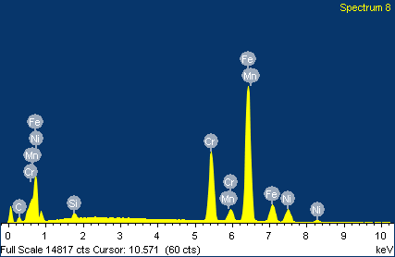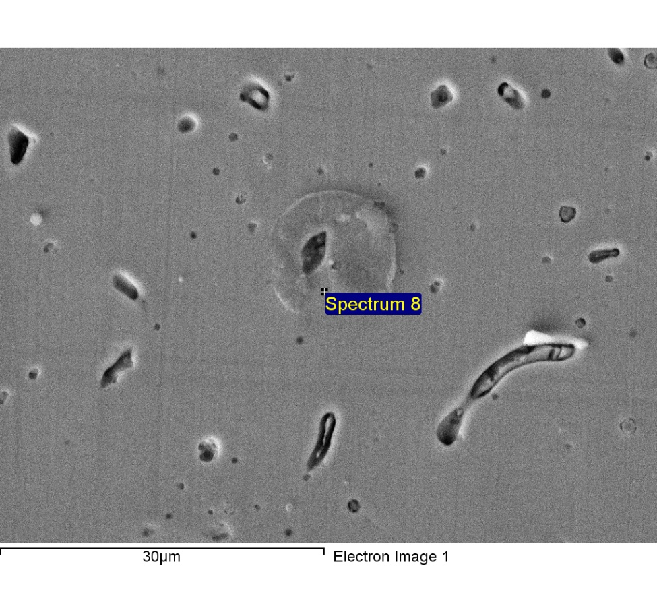

Spectrum processing :

Peak possibly omitted : 12.812 keV

Processing option : All elements analyzed (Normalised)

Number of iterations = 4

Standard :

C CaCO3 1-Jun-1999 12:00 AM

Si SiO2 1-Jun-1999 12:00 AM

Cr Cr 1-Jun-1999 12:00 AM

Mn Mn 1-Jun-1999 12:00 AM

Fe Fe 1-Jun-1999 12:00 AM

Ni Ni 1-Jun-1999 12:00 AM

|  |  |  |  |
| --- | --- | --- | --- |
| Element | Weight% | Atomic% |  |
|  |  |  |  |
| C K | 5.68 | 21.55 |  |
| Si K | 0.83 | 1.35 |  |
| Cr K | 19.63 | 17.20 |  |
| Mn K | 1.57 | 1.30 |  |
| Fe K | 62.72 | 51.17 |  |
| Ni K | 9.57 | 7.42 |  |
|  |  |  |  |
| Totals | 100.00 |  |  |

1/24/2018 7:36:38 PM

Project 9

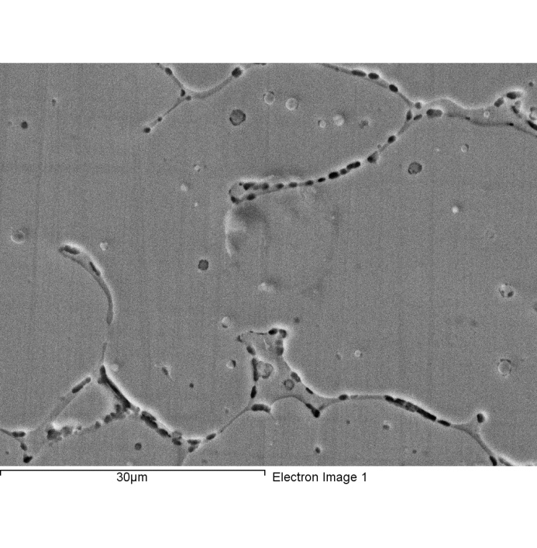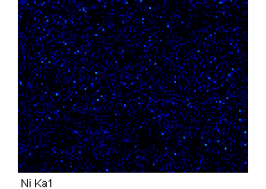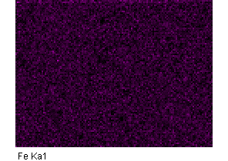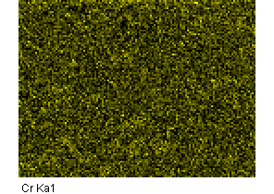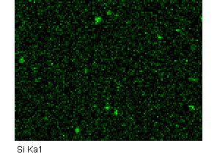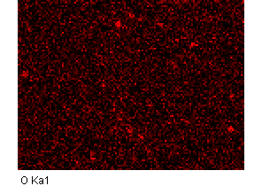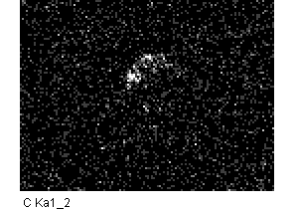

Comment:2-8

1/24/2018 7:46:14 PM

Project 9

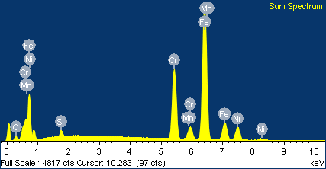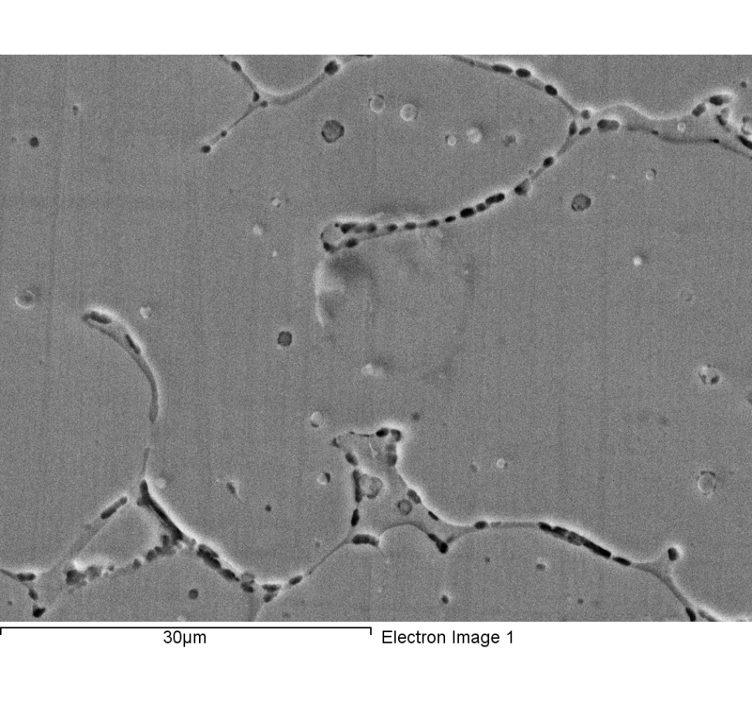

Spectrum processing :

Peaks possibly omitted : 11.818, 12.809, 13.491 keV

Processing option : All elements analyzed (Normalised)

Number of iterations = 3

Standard :

C CaCO3 1-Jun-1999 12:00 AM

Si SiO2 1-Jun-1999 12:00 AM

Cr Cr 1-Jun-1999 12:00 AM

Mn Mn 1-Jun-1999 12:00 AM

Fe Fe 1-Jun-1999 12:00 AM

Ni Ni 1-Jun-1999 12:00 AM

|  |  |  |  |
| --- | --- | --- | --- |
| Element | Weight% | Atomic% |  |
|  |  |  |  |
| C K | 4.96 | 19.19 |  |
| Si K | 0.95 | 1.58 |  |
| Cr K | 20.42 | 18.26 |  |
| Mn K | 1.60 | 1.35 |  |
| Fe K | 62.66 | 52.17 |  |
| Ni K | 9.41 | 7.45 |  |
|  |  |  |  |
| Totals | 100.00 |  |  |

Comment:2-8

1/24/2018 7:46:36 PM

Project 9

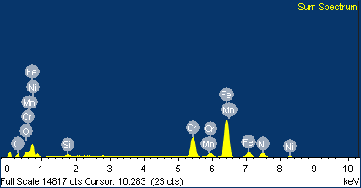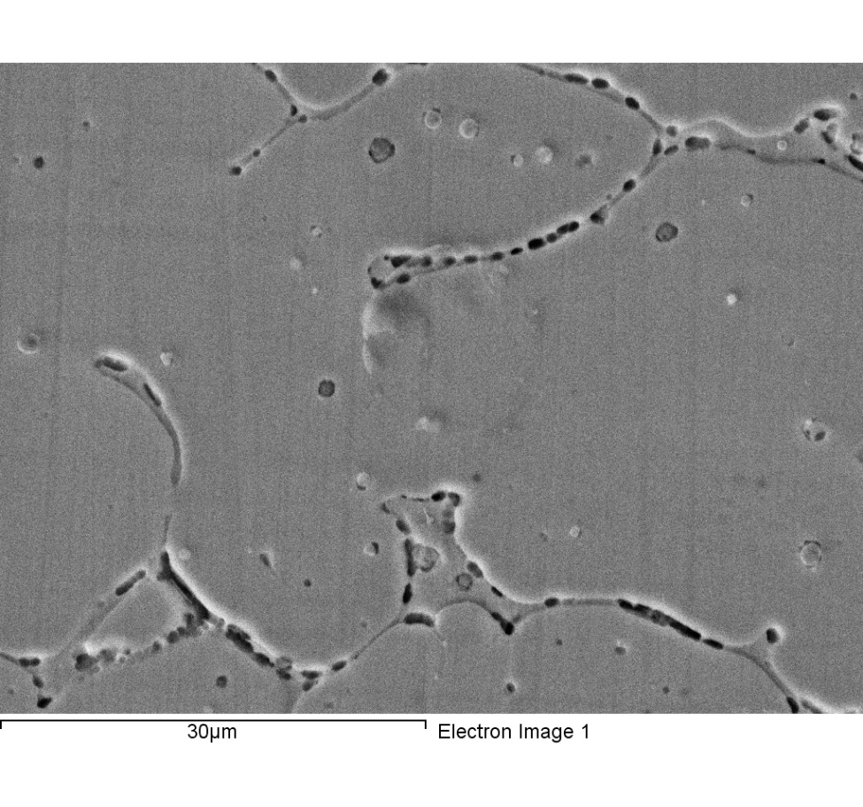

Spectrum processing :

Peaks possibly omitted : 11.875, 12.765 keV

Processing option : All elements analyzed (Normalised)

Number of iterations = 3

Standard :

C CaCO3 1-Jun-1999 12:00 AM

O SiO2 1-Jun-1999 12:00 AM

Si SiO2 1-Jun-1999 12:00 AM

Cr Cr 1-Jun-1999 12:00 AM

Mn Mn 1-Jun-1999 12:00 AM

Fe Fe 1-Jun-1999 12:00 AM

Ni Ni 1-Jun-1999 12:00 AM

|  |  |  |  |
| --- | --- | --- | --- |
| Element | Weight% | Atomic% |  |
|  |  |  |  |
| C K | 10.90 | 34.89 |  |
| O K | 1.47 | 3.54 |  |
| Si K | 0.90 | 1.23 |  |
| Cr K | 18.42 | 13.61 |  |
| Mn K | 1.35 | 0.95 |  |
| Fe K | 57.91 | 39.86 |  |
| Ni K | 9.05 | 5.92 |  |
|  |  |  |  |
| Totals | 100.00 |  |  |

Comment:

1/24/2018 7:49:05 PM

Project 9

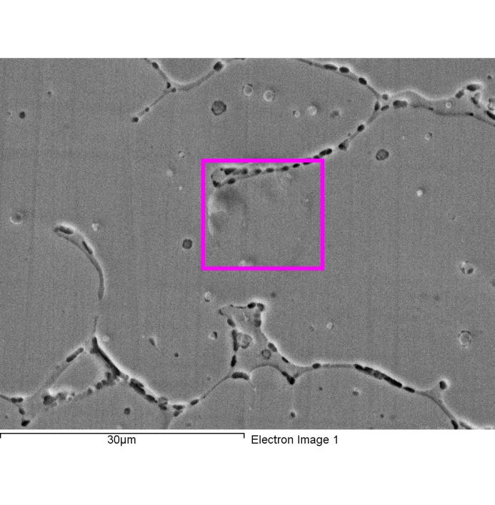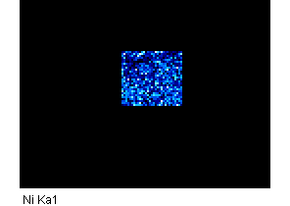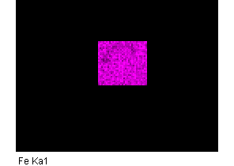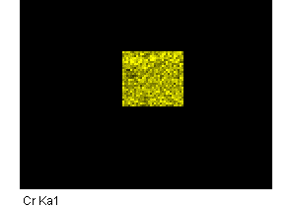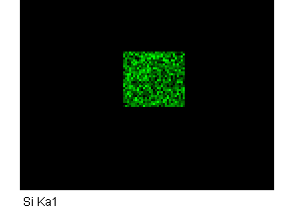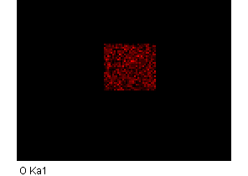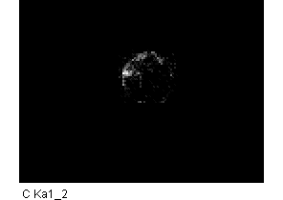

Comment:

1/24/2018 7:49:27 PM

Project 9

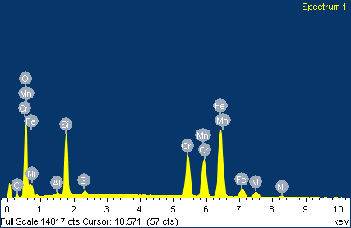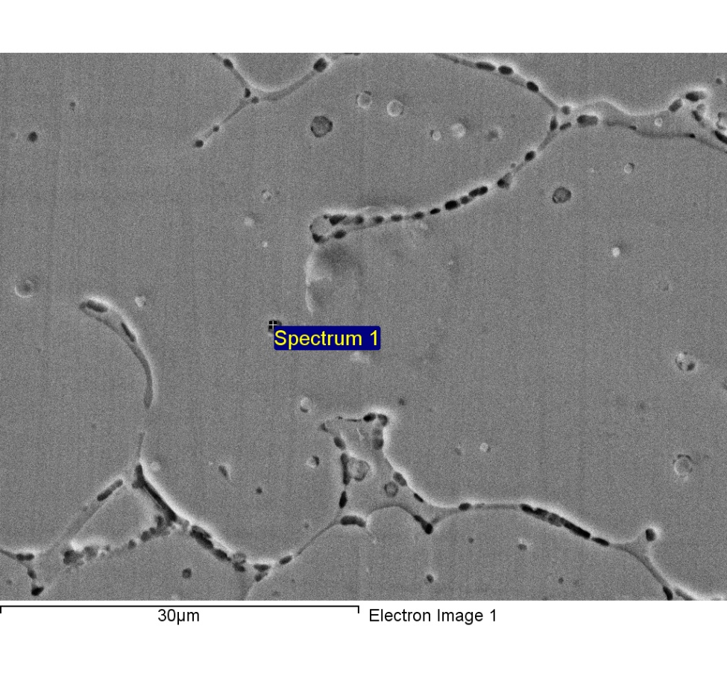

Spectrum processing :

Peaks possibly omitted : 12.280, 12.760 keV

Processing option : All elements analyzed (Normalised)

Number of iterations = 5

Standard :

C CaCO3 1-Jun-1999 12:00 AM

O SiO2 1-Jun-1999 12:00 AM

Al Al2O3 1-Jun-1999 12:00 AM

Si SiO2 1-Jun-1999 12:00 AM

S FeS2 1-Jun-1999 12:00 AM

Cr Cr 1-Jun-1999 12:00 AM

Mn Mn 1-Jun-1999 12:00 AM

Fe Fe 1-Jun-1999 12:00 AM

Ni Ni 1-Jun-1999 12:00 AM

|  |  |  |  |
| --- | --- | --- | --- |
| Element | Weight% | Atomic% |  |
|  |  |  |  |
| C K | 3.93 | 10.21 |  |
| O K | 21.70 | 42.32 |  |
| Al K | 0.38 | 0.44 |  |
| Si K | 8.84 | 9.82 |  |
| S K | 0.59 | 0.58 |  |
| Cr K | 13.30 | 7.98 |  |
| Mn K | 14.24 | 8.09 |  |
| Fe K | 32.40 | 18.11 |  |
| Ni K | 4.61 | 2.45 |  |
|  |  |  |  |
| Totals | 100.00 |  |  |

1/24/2018 7:51:54 PM

Project 9

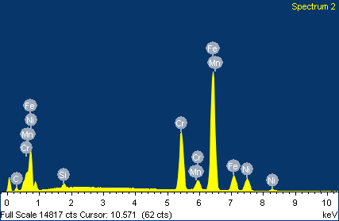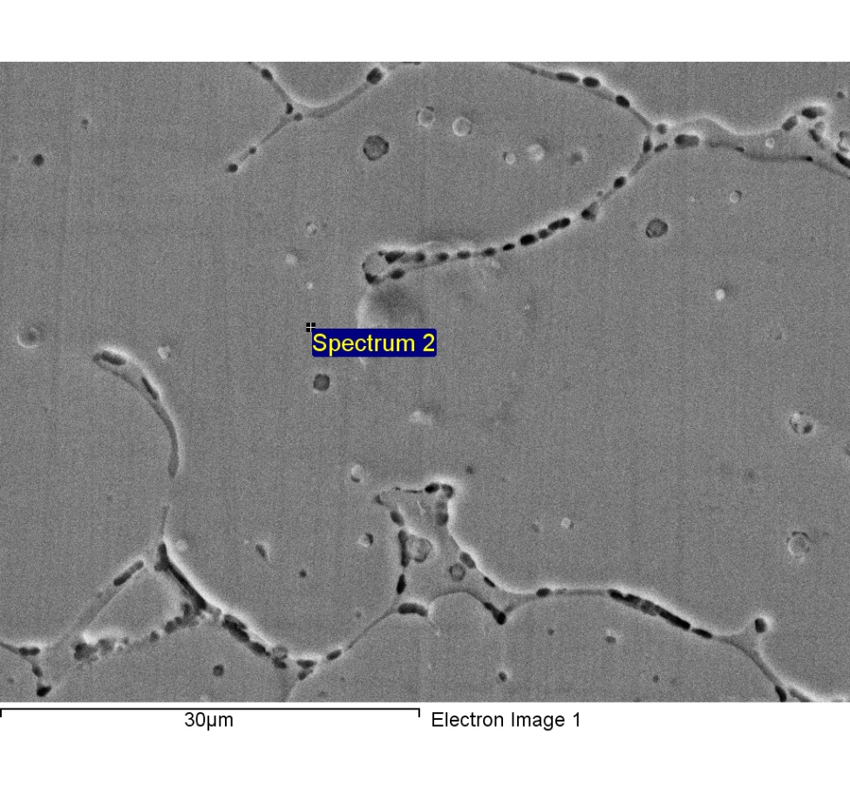

Spectrum processing :

Peaks possibly omitted : 11.831, 12.833 keV

Processing option : All elements analyzed (Normalised)

Number of iterations = 4

Standard :

C CaCO3 1-Jun-1999 12:00 AM

Si SiO2 1-Jun-1999 12:00 AM

Cr Cr 1-Jun-1999 12:00 AM

Mn Mn 1-Jun-1999 12:00 AM

Fe Fe 1-Jun-1999 12:00 AM

Ni Ni 1-Jun-1999 12:00 AM

|  |  |  |  |
| --- | --- | --- | --- |
| Element | Weight% | Atomic% |  |
|  |  |  |  |
| C K | 4.56 | 17.91 |  |
| Si K | 0.74 | 1.24 |  |
| Cr K | 19.18 | 17.42 |  |
| Mn K | 1.38 | 1.18 |  |
| Fe K | 63.54 | 53.72 |  |
| Ni K | 10.60 | 8.52 |  |
|  |  |  |  |
| Totals | 100.00 |  |  |

1/24/2018 7:52:09 PM

Project 9

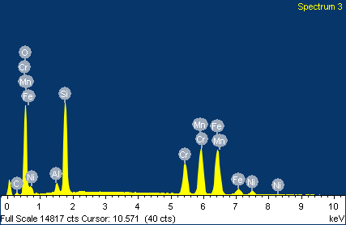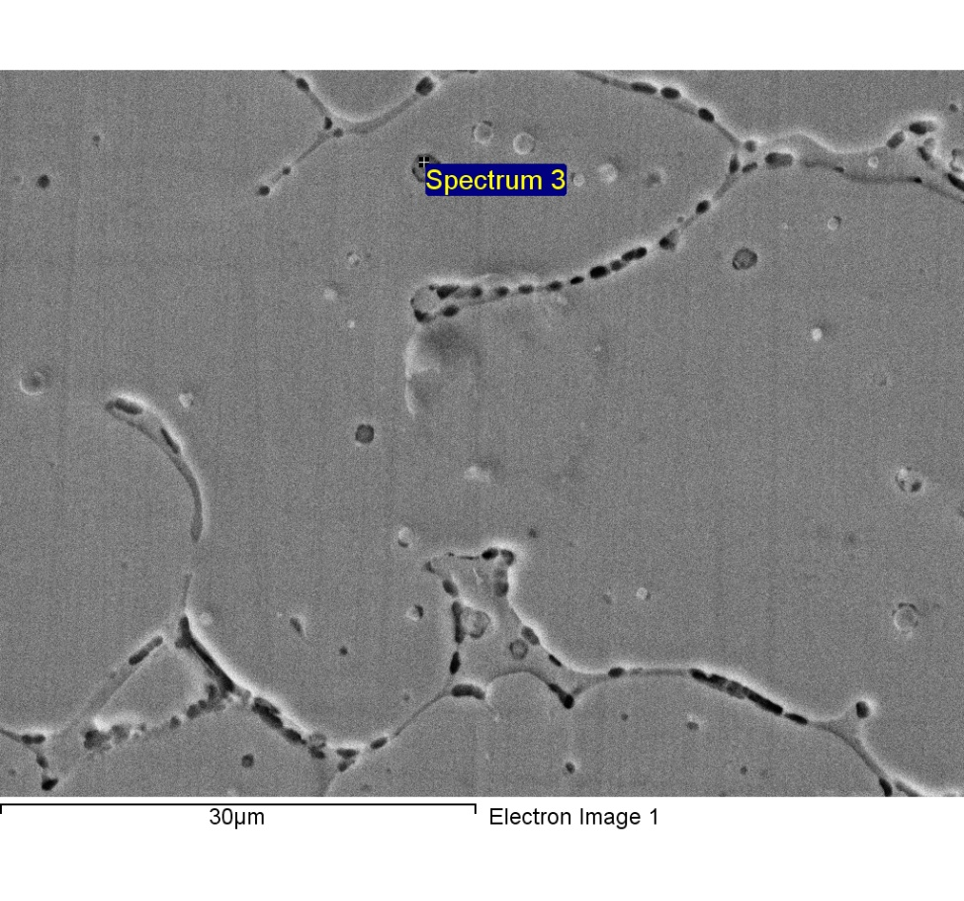

Spectrum processing :

Peak possibly omitted : 11.840 keV

Processing option : All elements analyzed (Normalised)

Number of iterations = 5

Standard :

C CaCO3 1-Jun-1999 12:00 AM

O SiO2 1-Jun-1999 12:00 AM

Al Al2O3 1-Jun-1999 12:00 AM

Si SiO2 1-Jun-1999 12:00 AM

Cr Cr 1-Jun-1999 12:00 AM

Mn Mn 1-Jun-1999 12:00 AM

Fe Fe 1-Jun-1999 12:00 AM

Ni Ni 1-Jun-1999 12:00 AM

|  |  |  |  |
| --- | --- | --- | --- |
| Element | Weight% | Atomic% |  |
|  |  |  |  |
| C K | 3.19 | 7.63 |  |
| O K | 27.03 | 48.51 |  |
| Al K | 1.42 | 1.51 |  |
| Si K | 13.21 | 13.51 |  |
| Cr K | 10.85 | 5.99 |  |
| Mn K | 19.18 | 10.02 |  |
| Fe K | 22.17 | 11.40 |  |
| Ni K | 2.95 | 1.44 |  |
|  |  |  |  |
| Totals | 100.00 |  |  |

1/24/2018 7:52:23 PM

Project 9

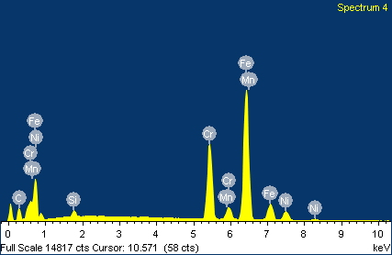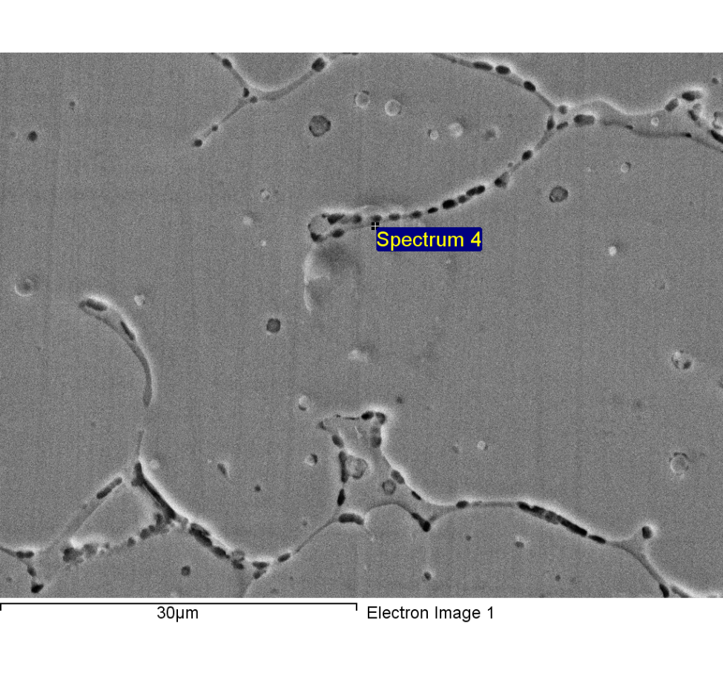

Spectrum processing :

Peak possibly omitted : 11.810 keV

Processing option : All elements analyzed (Normalised)

Number of iterations = 4

Standard :

C CaCO3 1-Jun-1999 12:00 AM

Si SiO2 1-Jun-1999 12:00 AM

Cr Cr 1-Jun-1999 12:00 AM

Mn Mn 1-Jun-1999 12:00 AM

Fe Fe 1-Jun-1999 12:00 AM

Ni Ni 1-Jun-1999 12:00 AM

|  |  |  |  |
| --- | --- | --- | --- |
| Element | Weight% | Atomic% |  |
|  |  |  |  |
| C K | 12.34 | 39.01 |  |
| Si K | 0.85 | 1.14 |  |
| Cr K | 21.08 | 15.38 |  |
| Mn K | 1.47 | 1.02 |  |
| Fe K | 57.69 | 39.20 |  |
| Ni K | 6.57 | 4.25 |  |
|  |  |  |  |
| Totals | 100.00 |  |  |

1/24/2018 7:52:38 PM

Project 9

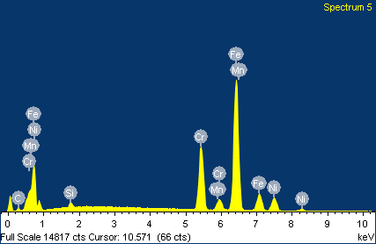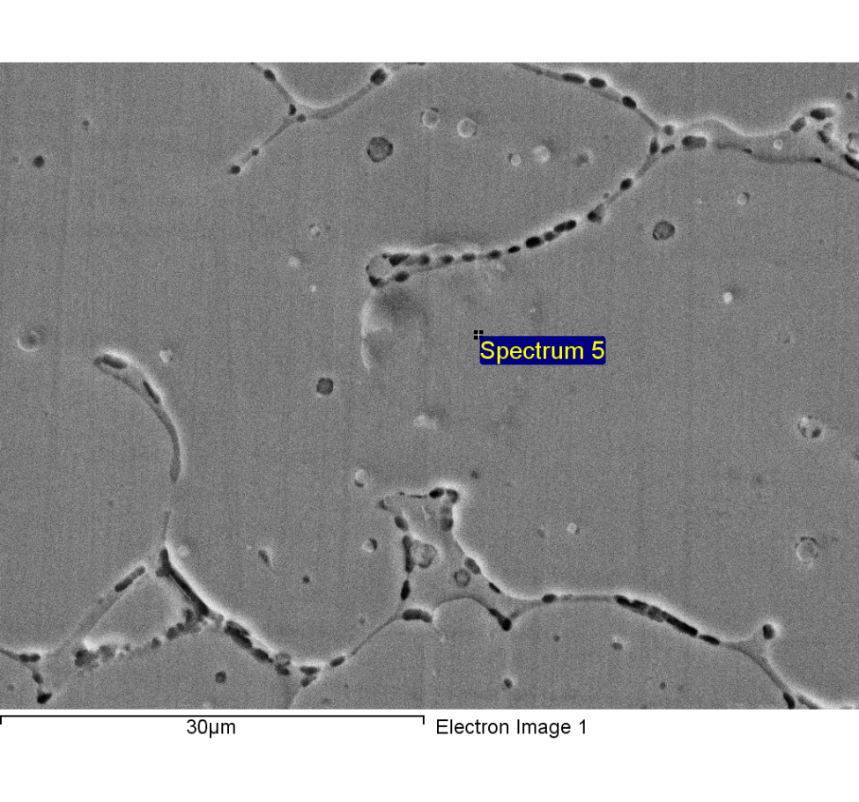

Spectrum processing :

Peaks possibly omitted : 2.180, 11.790, 12.840 keV

Processing option : All elements analyzed (Normalised)

Number of iterations = 4

Standard :

C CaCO3 1-Jun-1999 12:00 AM

Si SiO2 1-Jun-1999 12:00 AM

Cr Cr 1-Jun-1999 12:00 AM

Mn Mn 1-Jun-1999 12:00 AM

Fe Fe 1-Jun-1999 12:00 AM

Ni Ni 1-Jun-1999 12:00 AM

|  |  |  |  |
| --- | --- | --- | --- |
| Element | Weight% | Atomic% |  |
|  |  |  |  |
| C K | 4.05 | 16.17 |  |
| Si K | 0.77 | 1.31 |  |
| Cr K | 19.38 | 17.87 |  |
| Mn K | 1.68 | 1.46 |  |
| Fe K | 63.82 | 54.77 |  |
| Ni K | 10.30 | 8.41 |  |
|  |  |  |  |
| Totals | 100.00 |  |  |

1/24/2018 7:52:53 PM

Project 9

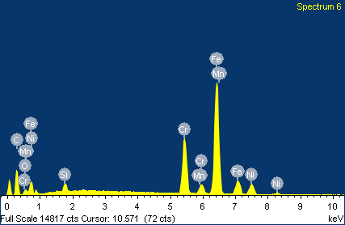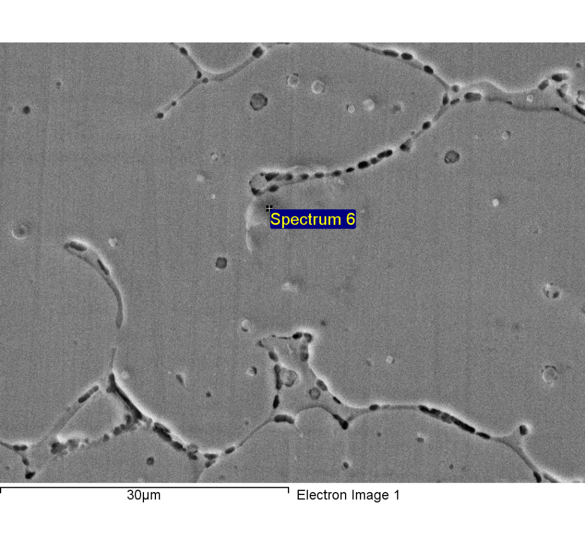

Spectrum processing :

Peaks possibly omitted : 12.800, 12.850 keV

Processing option : All elements analyzed (Normalised)

Number of iterations = 4

Standard :

C CaCO3 1-Jun-1999 12:00 AM

O SiO2 1-Jun-1999 12:00 AM

Si SiO2 1-Jun-1999 12:00 AM

Cr Cr 1-Jun-1999 12:00 AM

Mn Mn 1-Jun-1999 12:00 AM

Fe Fe 1-Jun-1999 12:00 AM

Ni Ni 1-Jun-1999 12:00 AM

|  |  |  |  |
| --- | --- | --- | --- |
| Element | Weight% | Atomic% |  |
|  |  |  |  |
| C K | 23.02 | 56.02 |  |
| O K | 2.08 | 3.79 |  |
| Si K | 1.08 | 1.13 |  |
| Cr K | 15.60 | 8.77 |  |
| Mn K | 1.07 | 0.57 |  |
| Fe K | 49.89 | 26.11 |  |
| Ni K | 7.26 | 3.62 |  |
|  |  |  |  |
| Totals | 100.00 |  |  |

1/24/2018 7:53:08 PM

Project 9

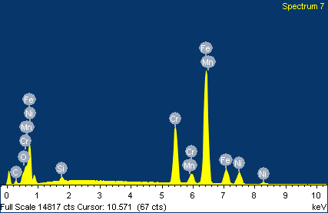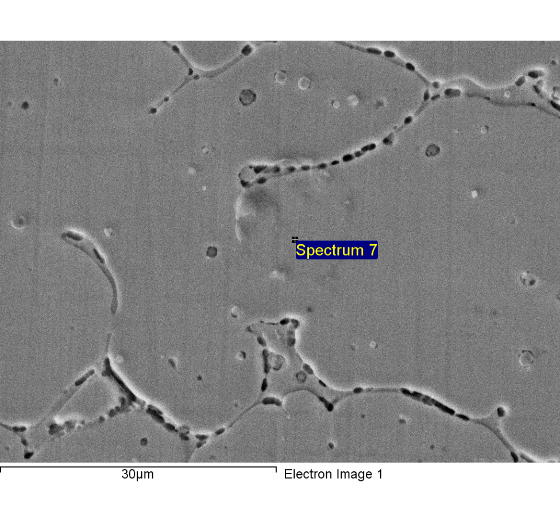

Spectrum processing :

Peaks possibly omitted : 11.780, 12.813 keV

Processing option : All elements analyzed (Normalised)

Number of iterations = 4

Standard :

C CaCO3 1-Jun-1999 12:00 AM

O SiO2 1-Jun-1999 12:00 AM

Si SiO2 1-Jun-1999 12:00 AM

Cr Cr 1-Jun-1999 12:00 AM

Mn Mn 1-Jun-1999 12:00 AM

Fe Fe 1-Jun-1999 12:00 AM

Ni Ni 1-Jun-1999 12:00 AM

|  |  |  |  |
| --- | --- | --- | --- |
| Element | Weight% | Atomic% |  |
|  |  |  |  |
| C K | 4.56 | 17.49 |  |
| O K | 1.17 | 3.38 |  |
| Si K | 0.73 | 1.19 |  |
| Cr K | 19.29 | 17.09 |  |
| Mn K | 1.54 | 1.29 |  |
| Fe K | 62.54 | 51.58 |  |
| Ni K | 10.17 | 7.98 |  |
|  |  |  |  |
| Totals | 100.00 |  |  |

1/24/2018 7:53:24 PM

Project 9